|  |
| --- |
|  |

Jordan National Semiconductor Design Competition (JOSDC’2023)

Pipeline MIPS 32 bit

By

Omar AL-khasawneh & Omar Salah & Moayyad Abu Mallouh

Amman, Jordan

October 2023





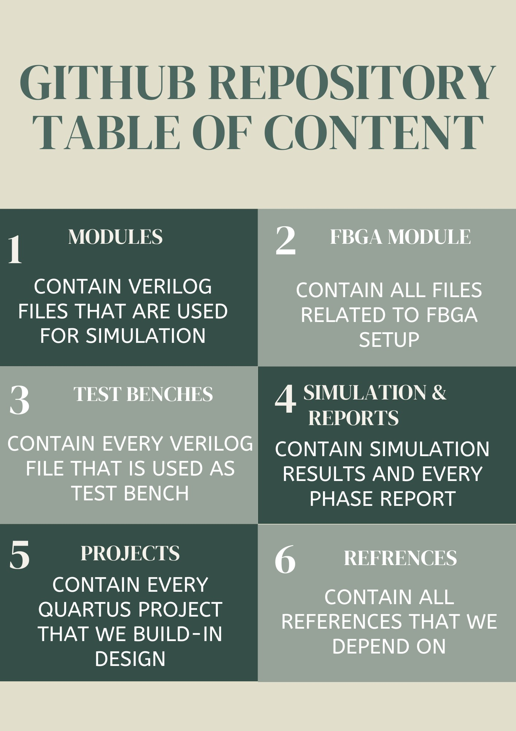

GitHub link 🡪

# Acknowledgments

It"It is with immense gratitude that I acknowledge the support and guidance of Professor Mohammad A. Alshboul during the intricate process of designing the pipeline CPU. His profound expertise and deep understanding of the subject were pivotal in navigating the complexities inherent in such an endeavor.

Professor Alshboul's meticulous attention to detail, patience, and hands-on approach were instrumental in every phase of the design. He consistently provided insightful feedback, ensuring that our design met the highest standards of precision and efficiency. His unwavering belief in the project's potential and my capabilities were a constant source of motivation, pushing me to delve deeper and refine our work further.

In parallel, the assistance and insights from Professor Osama have been equally vital to the success of this project. His expertise in complementary areas provided a broader perspective, enhancing our design's robustness and applicability. Professor Osama's enthusiasm for innovation and his strategic advice helped overcome several challenges, making our journey not just educational but also exceptionally rewarding.

Beyond the technical aspects, Professor Alshboul's dedication to nurturing creativity and fostering a spirit of inquiry has been truly inspirational. Similarly, Professor Osama's commitment to academic excellence and his encouragement to pursue novel solutions have significantly enriched my learning experience. Both have not only been mentors but also beacons of encouragement, instilling in me a passion for design and a commitment to excellence.

To Professor Alshboul and Professor Osama, I extend my heartfelt appreciation for your invaluable support, guidance, and mentorship. Your influence on this project, and on my academic journey as a whole, cannot be overstated. Thank you both for being the cornerstones of this achievement."

I am immensely grateful for the guidance, expertise, and unwavering support provided by Husam A. Suleiman. His contribution has been a cornerstone of the project's success.

For his invaluable contributions, steadfast support, and inspiring mentorship, I extend my deepest thanks to Husam A. Suleiman.

# Abstract

This project explores the design, implementation, and evaluation of a pipelined MIPS CPU, utilizing Verilog for the hardware description language. The objective was to create a processor architecture that enhances computational throughput and efficiency by introducing a pipelined approach to instruction execution. Unlike traditional single-cycle CPUs where each instruction is executed in one complete cycle, our pipelined MIPS CPU breaks down instruction execution into distinct stages, allowing multiple instructions to be processed simultaneously at different stages of execution.

The architecture is structured around five key stages: instruction fetch, instruction decode, execution, memory access, and write-back. This division enables the CPU to begin processing a new instruction at the fetch stage while previously fetched instructions progress through the subsequent stages, significantly improving instruction throughput compared to a single-cycle architecture.

A meticulous emphasis was placed on the modular design and scalability of the processor to facilitate future expansions and optimizations. Preliminary testing demonstrates that the pipelined MIPS CPU operates successfully, executing instructions with increased efficiency and speed. This project serves not only as a valuable educational resource for understanding pipelined CPU architectures but also lays a solid foundation for further research into optimizing pipeline performance and implementing advanced features such as branch prediction and hazard detection.

Future work will focus on enhancing the pipeline's efficiency through the integration of these advanced mechanisms, aiming to minimize stalls and improve the overall performance of the MIPS processor. Through this project, we contribute to the ongoing evolution of CPU design, highlighting the potential for significant advancements in processing speed and efficiency offered by the pipelined approach.

**Table of Contents**

Abstract iv

Introduction 8

1.1 Introduction 8

1.2 The Importance of the Design 8

1.3 Motivation 8

1.4 Why This Topic is Important for Students 8

1.5 Objectives of the Project: 9

1.6 Description of Design Achieved: 9

1.7 Design Requirements: 10

1.8 The team’s member responsibility 10

1.8.1 Omar AL-khasawneh (Leader) 11

1.8.2 Omar AL-salah 11

1.8.3 Moayyad Abu Mallouh 11

1.9 Organization of the rest of the documentation. 12

Design 12

1.10 Hardware Design and Implementation 13

1.10.1 Component 13

1.11 MIPS DATAPATH 17

1.11.1 Before – phase1 17

1.11.2 now 17

1.12 mips instruction execution phase 18

1.13 Coding and Software Development 19

1.13.1 Tools 19

1.13.2 Challenging 19

1.13.3 Biggest challenge 20

1.13.4 Instruction set architecture 22

Results 24

1.14 Benchmark 24

**1.14.1** **Test case one** 24

**1.15** **Test case 2** 28

1.15.1 Data memory and instruction memory 28

1.15.2 First instruction LW R1 ,8(R0) 29

1.15.3 Third instruction SW R1, 4(R0) 31

1.15.4 fifth Instruction LW R3, 16(R0) with the result of previous instruction in R2 LW R2, 4(R0) 32

1.15.5 After execution final values 32

**1.16** **Test case 3** 33

1.16.1 Instruction memory and data memory 33

1.16.2 First Instruction (ADD R28,R0,R0) 33

1.16.3 Third Instruction SW R1, 4(R0) 35

**1.16.4** **Fiveth Instruction (LW R10, 8(R28)** 36

1.16.5 the last Instruction (SUB R8 , R0 , R8) 36

1.16.6 the cpu after execution 37

**1.17** **Test case 4** 37

1.17.1 Instruction memory and data memory 37

1.17.2 First Instruction ADD R8, R0, R0 CPU Status before execution 38

1.17.3 seventh Instruction JUMP LOOP First Iteration. 41

1.17.4 Branch Taken BGT R8, R9, 42

1.17.5 Instruction JUMP LOOP the Last Iteration 42

1.17.6 CPU Status after execution 43

**1.18** **Test case 5** 43

1.18.1 Instruction memory and data memory 44

**No need for RAM** 44

1.18.2 When a =2 47

1.18.3 When a =6 49

**1.19** **Test case 6** 51

1.19.1 Instruction memory 51

1.19.2 First Instruction ADD R1, R0, R0 CPU Status before execution 51

1.19.3 Fourth Instruction BEQ R1, R9, EXIT 53

1.19.4 . Branch Taken to Instruction BEQ R1, R9, EXIT 54

1.19.5 Instruction JUMP START First turn. 54

1.19.6 The second Iteration first Instruction BEQ R1, R9, EXIT after the firt jump execute. 55

1.19.7 The CPU Status After execution 55

**1.20** **Clock testing** 56

Conclusion 57

1.20.1 Key Findings and Implications 57

1.20.2 Project’s objectives achieved. 57

Appendix A: CODE 58

1.21 PC (finite state machine) 58

1.22 ALU 59

1.23 Control unit 62

1.24 Register file 74

1.25 Sign extend 79

1.26 Main 79

1.27 ALU control 88

1.28 Adder 90

1.29 Branch control 91

1.30 RAM 91

1.31 instruction memory 95

# Introduction

## Introduction

In the ever-evolving landscape of computer science and engineering, the design and implementation of central processing units (CPUs) continue to be a focal point of innovation and exploration. Among the various CPU architectures, the development of a pipeline CPU, akin to the revered MIPS, stands as a compelling and vital undertaking. This project represents our endeavor to grasp and engineer a fundamental yet pivotal component of modern computing systems.

## The Importance of the Design

The importance of designing and understanding single-cycle CPUs is multifaceted and integral to the field of computer science and engineering. In a world where processing power and efficiency are at the forefront of technological advancement, the design of CPUs becomes an arena where every microarchitectural decision counts. The single-cycle CPU, characterized by its simplicity and transparency, holds particular significance. It offers a clear and unambiguous model for comprehending the inner workings of a CPU. By its nature, it encapsulates the essence of instruction execution in a single clock cycle, thereby facilitating a straightforward understanding of processor operations. In this project, we dive into this simplicity to harness its educational and practical merits.

## Motivation

The motivation behind this project stems from a shared passion for learning and a profound curiosity about the architecture of modern computers. Understanding the CPU, often referred to as the "brain" of a computer, is a fundamental step in comprehending how computers execute instructions, process data, and perform complex operations. As students in the field of computer science and engineering, our motivation is twofold. Firstly, we aim to deepen our knowledge of CPU design, enabling us to demystify the underlying mechanisms of computing systems. Secondly, we aspire to create a resource for students and enthusiasts alike to embark on a journey of discovery, employing our project as an educational tool.

## Why This Topic is Important for Students

For students, the significance of exploring the design and implementation of a single-cycle CPU lies in the educational value it holds. It serves as a comprehensive learning experience, bridging theory and practice in the field of computer architecture. As an educational endeavor, our project offers students the opportunity to delve into the intricacies of CPU design, to comprehend the essence of instruction execution, and to witness the tangible results of their efforts. This not only enhances their academic knowledge but also fosters a deeper appreciation for the technologies that underpin our modern world. By providing a practical and accessible entry point into CPU architecture, our project empowers students to become proficient problem solvers, critical thinkers, and innovative engineers.

## Objectives of the Project:

1. **Pipelined CPU Architecture:** The primary goal of this initiative is to develop and deploy a pipelined CPU, deeply rooted in MIPS architectural concepts. This CPU is designed to efficiently process a series of essential instructions across multiple stages within each clock cycle.
2. **Educational Resource:** We aim to create an educational resource that not only serves our learning goals but also benefits other students and enthusiasts in the field of computer science and engineering. The project aims to offer a clear, step-by-step insight into CPU design and facilitate a deeper understanding of the architectural choices involved.
3. **Comprehensive Understanding:** To achieve a comprehensive understanding of computer architecture, we will delve into the intricacies of various CPU components, including the control unit, ALU, registers, and memory hierarchy. This understanding will enable us to articulate the rationale behind design decisions.
4. **Performance Analysis:** The project seeks to analyze the performance of the single-cycle CPU in terms of execution speed, resource utilization, and comparison with other CPU architectures. This analysis will help in assessing the practical implications and limitations of the design.

## Description of Design Achieved:

In pursuit of these objectives, we have successfully designed a single-cycle CPU model with the following characteristics:

* **MIPS-Inspired Architecture:** Our CPU design is heavily influenced by the MIPS architecture, renowned for its simplicity and elegance. This architecture served as a valuable reference point in shaping our CPU's instruction set, control unit, and data path.
* **RISC (Reduced Instruction Set Computer) Principles:** Our CPU follows the RISC principles by focusing on a limited set of simple and frequently used instructions. This design choice enhances the CPU's efficiency and ease of understanding.
* **Pipelined Processing:** Our CPU architecture is engineered to handle instructions across multiple stages, each occurring in successive clock cycles. This pipelined approach streamlines instruction fetch, decode, execution, and the writing of results to registers, enhancing throughput and efficiency in contrast to single-cycle execution models..
* **Control Unit:** We have implemented a control unit that generates control signals to direct the CPU's operations based on the current instruction. This control unit is responsible for managing the flow of data within the CPU.
* **ALU and Registers:** The Arithmetic Logic Unit (ALU) performs arithmetic and logical operations, while the registers store data. Our CPU features a specific number of registers, and the ALU is capable of executing a variety of operations.
* **Memory Hierarchy:** We have incorporated a memory hierarchy with separate instruction and data memory. This design choice aligns with modern CPU architectures and offers an accurate representation of how instructions and data are stored and accessed.

## Design Requirements:

Our CPU design adheres to the following key requirements:

* **Simplicity:** The design should prioritize simplicity and clarity to serve as an educational tool. It should be comprehensible to students and enthusiasts with a basic understanding of digital logic and computer architecture.
* **Pipelined Execution:** Instructions progress through multiple stages within the CPU, with each stage completing in a single clock cycle, illustrating the essential mechanics of a pipelined CPU architecture.
* **Instruction Set:** The CPU should support a defined instruction set, inspired by the MIPS architecture. This instruction set should include fundamental operations such as arithmetic, logic, and data movement instructions.
* **Efficiency:** The design should strive for efficiency by optimizing the use of resources and minimizing redundancy.

## Timeline project

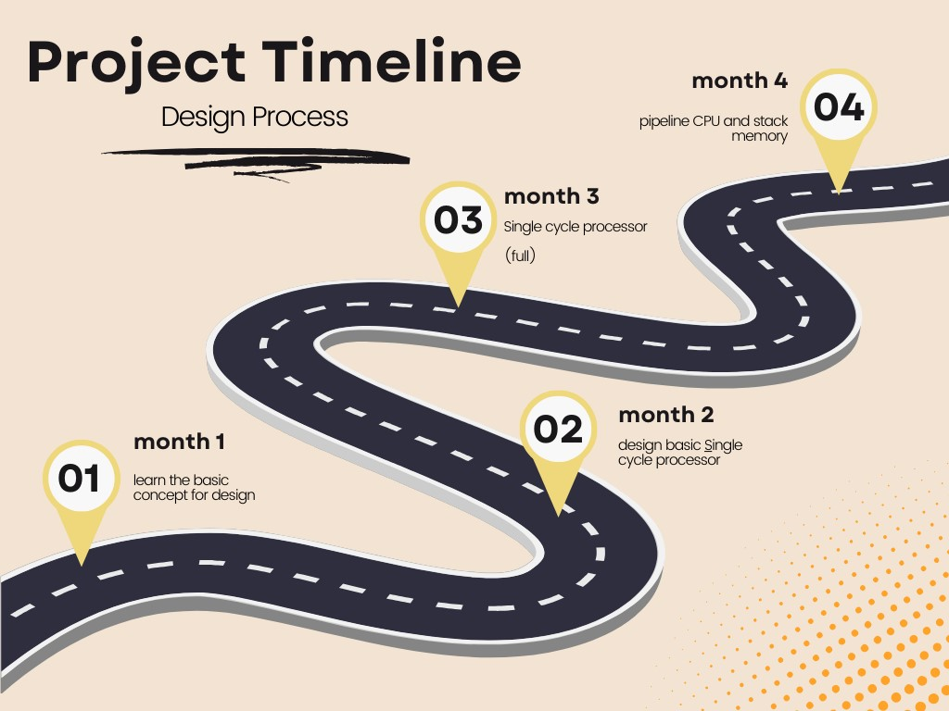

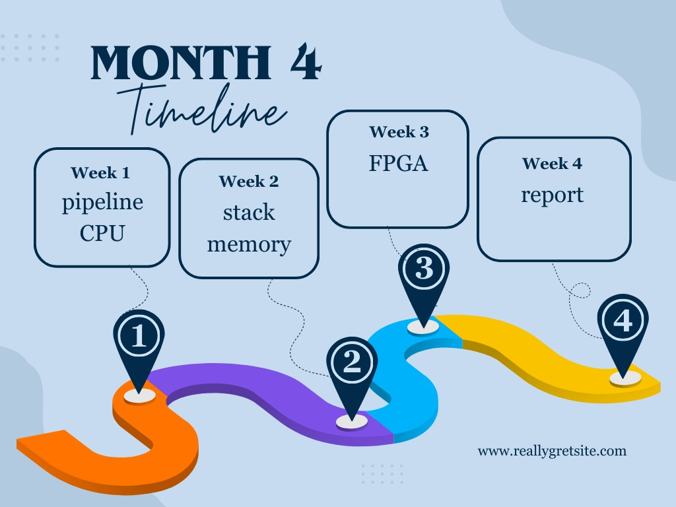

## The team’s member responsibility

### Omar AL-khasawneh (Leader)

* ALU design
* ALU control design
* PC design
* Forwarding
* Writing report

### Omar AL-salah

* Register file
* Control unit
* Hazard unit
* Stack

### Moayyad Abu Mallouh

* Instruction memory
* Data memory
* Mux between component
* FPGA

Each member is help other in some tasks

## Organization of the rest of the documentation.

# Design

## Hardware Design and Implementation

We are used this component in our project:

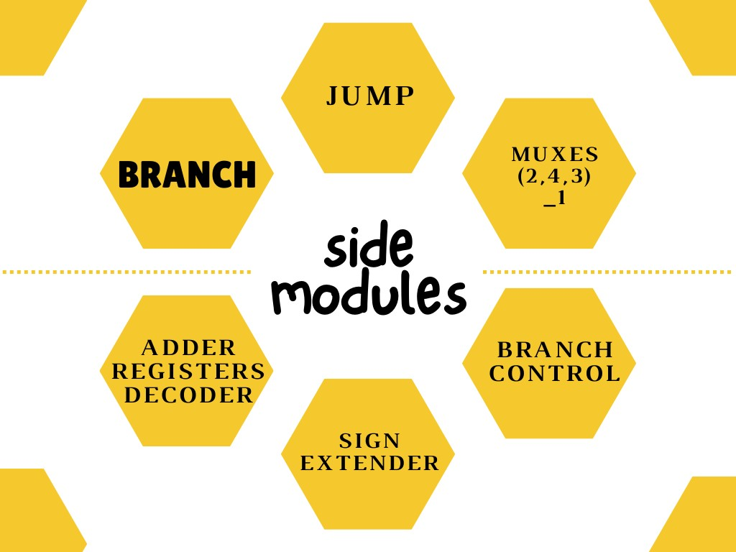

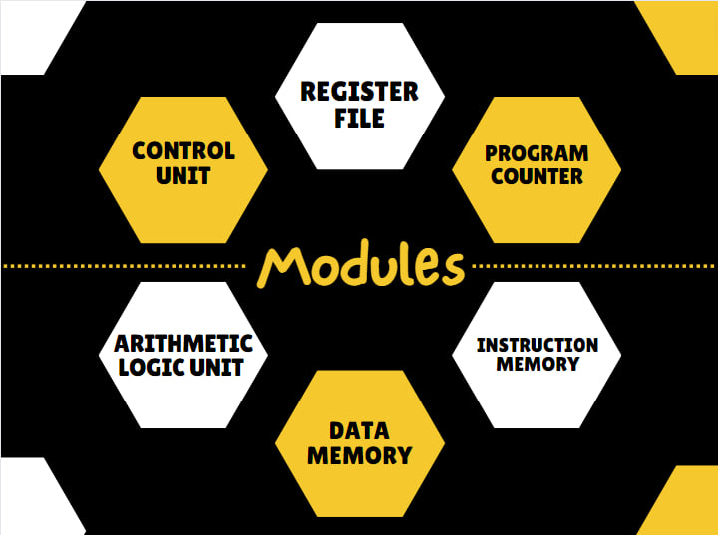

Extra module in phase 3

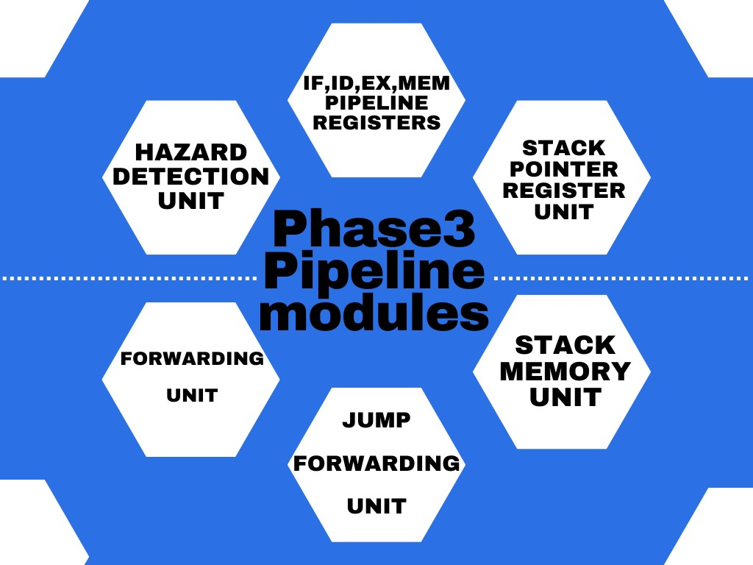

## Component

**Data Memory :** in the context of computer architecture and digital systems, is a component that stores and retrieves data during the execution of programs. It serves as a storage medium for variables, arrays, and other data structures used by a computer's central processing unit (CPU) to perform calculations and operations.

**Instruction memory**: also known as the Instruction Cache or Code Memory, is a component in a computer's architecture that stores the machine code instructions that the CPU (Central Processing Unit) fetches, decodes, and executes to perform various tasks and operations. These instructions are part of the computer program or software being run on the CPU. Instruction memory is essential for the operation of a computer because it holds the program's instructions in a format that the CPU can understand and execute sequentially.

### Arithmetic logic unit: (ALU)

is a crucial component of a computer's central processing unit (CPU). It performs arithmetic and logic operations on data, such as addition, subtraction, multiplication, division, and comparisons.

The ALU is designed to perform a variety of arithmetic and logical operations, dictated by a 4-bit control signal (ALUControl). It processes 32-bit inputs (A and B), handling basic arithmetic operations like addition, subtraction, multiplication, and division, as well as logical operations including AND, OR, XOR, and NOR. Additionally, it supports shift operations (logical left and right shifts) which are controlled by a 5-bit shift amount.

One of the notable features of this ALU is its ability to respond to different branch types, determined by a 3-bit signal (branch_type). This enables the ALU to participate in decision-making processes, fundamental in computational logic, by setting a Zero flag based on specific conditions (like equal, not equal, greater than, or less than comparisons).

Furthermore, the ALU includes an internal mechanism to handle overflow and carry-out scenarios, which are critical in signed arithmetic operations. These scenarios are managed through dedicated blocks that set the Overflow and CarryOut flags under specific conditions, like during addition or subtraction when the sign bit (most significant bit) might be incorrectly set or unset due to the arithmetic operation.

Overall, this ALU module illustrates the complexity and versatility of digital logic designs in performing essential computational tasks. It is a quintessential example of how various arithmetic and logical operations are implemented at a hardware level in computing systems.

### Forwarding :

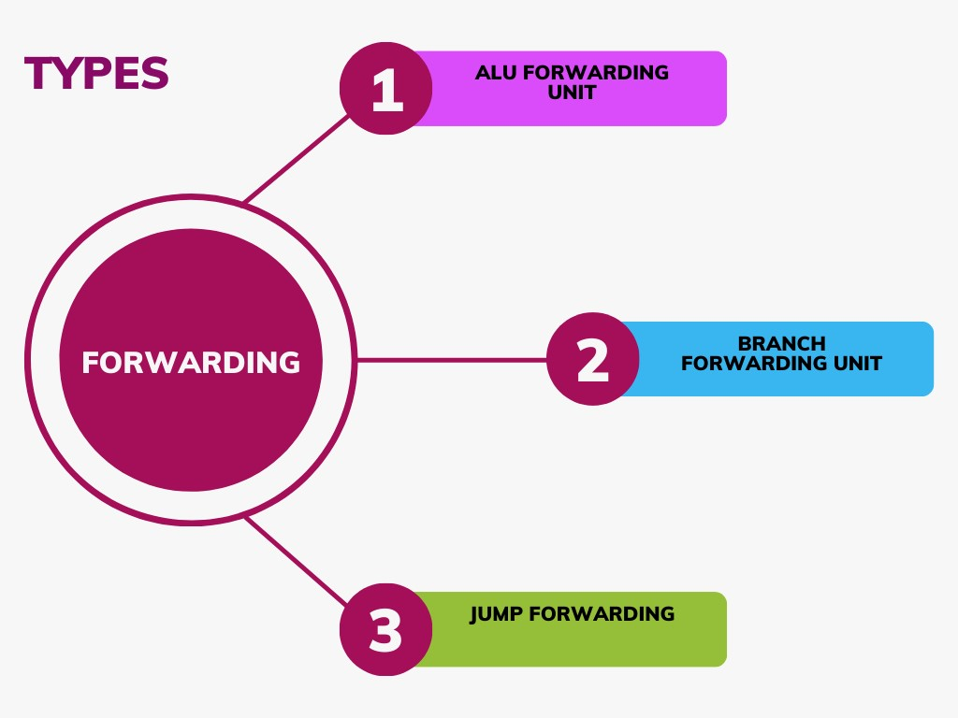

The Forwarding Unit in MIPS (Microprocessor without Interlocked Pipeline Stages) architecture plays a crucial role in optimizing the performance of pipelined processors by addressing data hazards that naturally occur due to the overlap of instruction execution. Data hazards arise when instructions that are close together in the execution sequence need to access the same data but are scheduled to do so in a way that the required data might not be written back in time for the next instruction's use. The Forwarding Unit, also known as the Data Forwarding Unit, mitigates these hazards by creating shortcuts in the pipeline that allow data to be "forwarded" from later stages to earlier stages where it is needed, effectively bypassing the normal data flow and register write-back sequences.

By enabling data forwarding, the MIPS architecture significantly reduces the number of stalls that occur due to data hazards, thereby improving the overall throughput of the processor.

We handle double data hazard by forwarding.

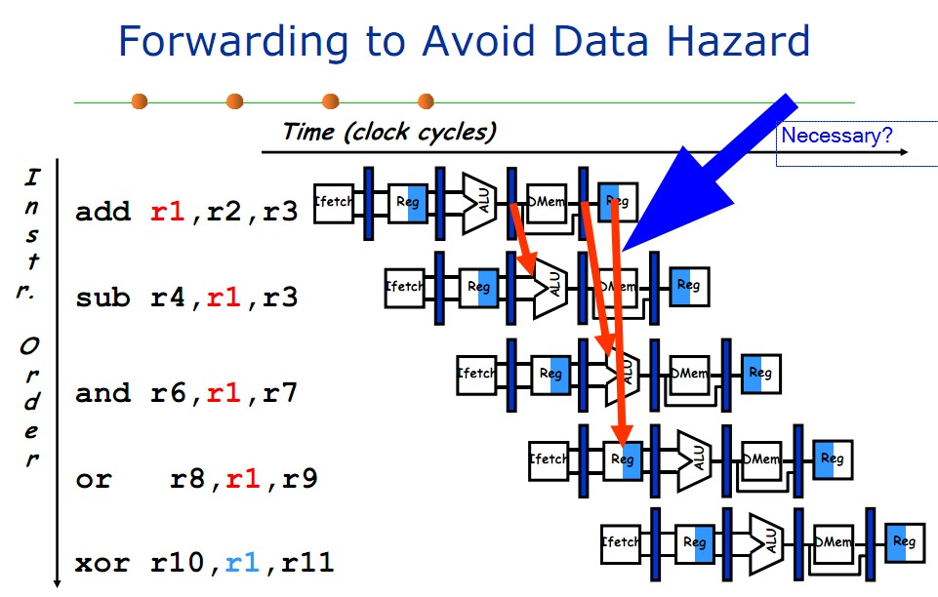

### Program counter **:**

also known as the instruction pointer (IP) in some architectures, is a special-purpose register in a computer's central processing unit (CPU). It holds the memory address of the next instruction to be fetched and executed in a program. The PC is automatically incremented after each instruction is fetched, allowing the CPU to sequence through the program's instructions in order.

**we use state machine to make the design better and easy to upgrade .**

### Hazard unit

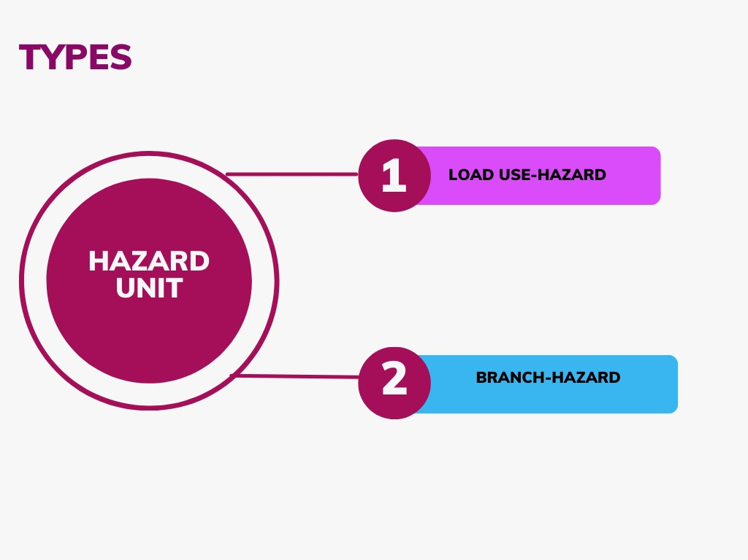

### Register file:

is a collection of registers that are used for temporary data storage and manipulation within a central processing unit (CPU). Registers are small, high-speed storage locations that are an integral part of the CPU. They store operands, intermediate results, and control information needed for executing instructions.

The Register File module stands as a cornerstone in the MIPS architecture, and in our CPU design, we have meticulously crafted a RegisterFile module to fulfill the essential role of managing registers efficiently. The module declaration encompasses standard signals, aligning with the MIPS convention, **including Clock, ReadReg1, ReadReg2, WriteReg, WriteData, Reg_write_Control, ReadData1, and ReadData2.**

Our design extends beyond the conventional MIPS Register File by incorporating additional signals to tailor the functionality to our specific requirements:

**Reset Signal:**

The Reset signal serves as a mechanism to reset all registers to a don’t care (rubbish value) when activated. This feature ensures a clean and controlled initialization, contributing to the reliability and predictability of the system.

**PC_Store Signal:**

The PC_Store signal is a custom addition to our Register File module, specifically designed to interact with register number 31. This signal, initiated by the control unit, enables register 31 to store a value from the write bus. The stored value represents the program counter value and plays a crucial role in the execution of instructions that involve branching, such as Jump And Link and Jump And Link Register.

In addition to these custom signals, we have implemented special-purpose registers to enhance the versatility and efficiency of the Register File:

**First Register (Register Number 0):**

This register is designed to always maintain a value of zero. It serves as a constant reference point and is exclusively readable. No instruction is permitted to write to this register, ensuring its consistency as a zero value register.

**Last Register (Register Number 31):**

Register 31 has been specially configured to serve a unique purpose in our design. It is enabled by the PC_Store signal from the control unit, allowing it to store the program counter value. This functionality is essential for instructions like Jump And Link and Jump And Link Register, where the program counter value is stored in register 31, facilitating the management of subroutine calls and returns.

By incorporating these features, our Register File module not only adheres to MIPS standards but also offers enhanced functionality and customization tailored to the specific requirements of our CPU design

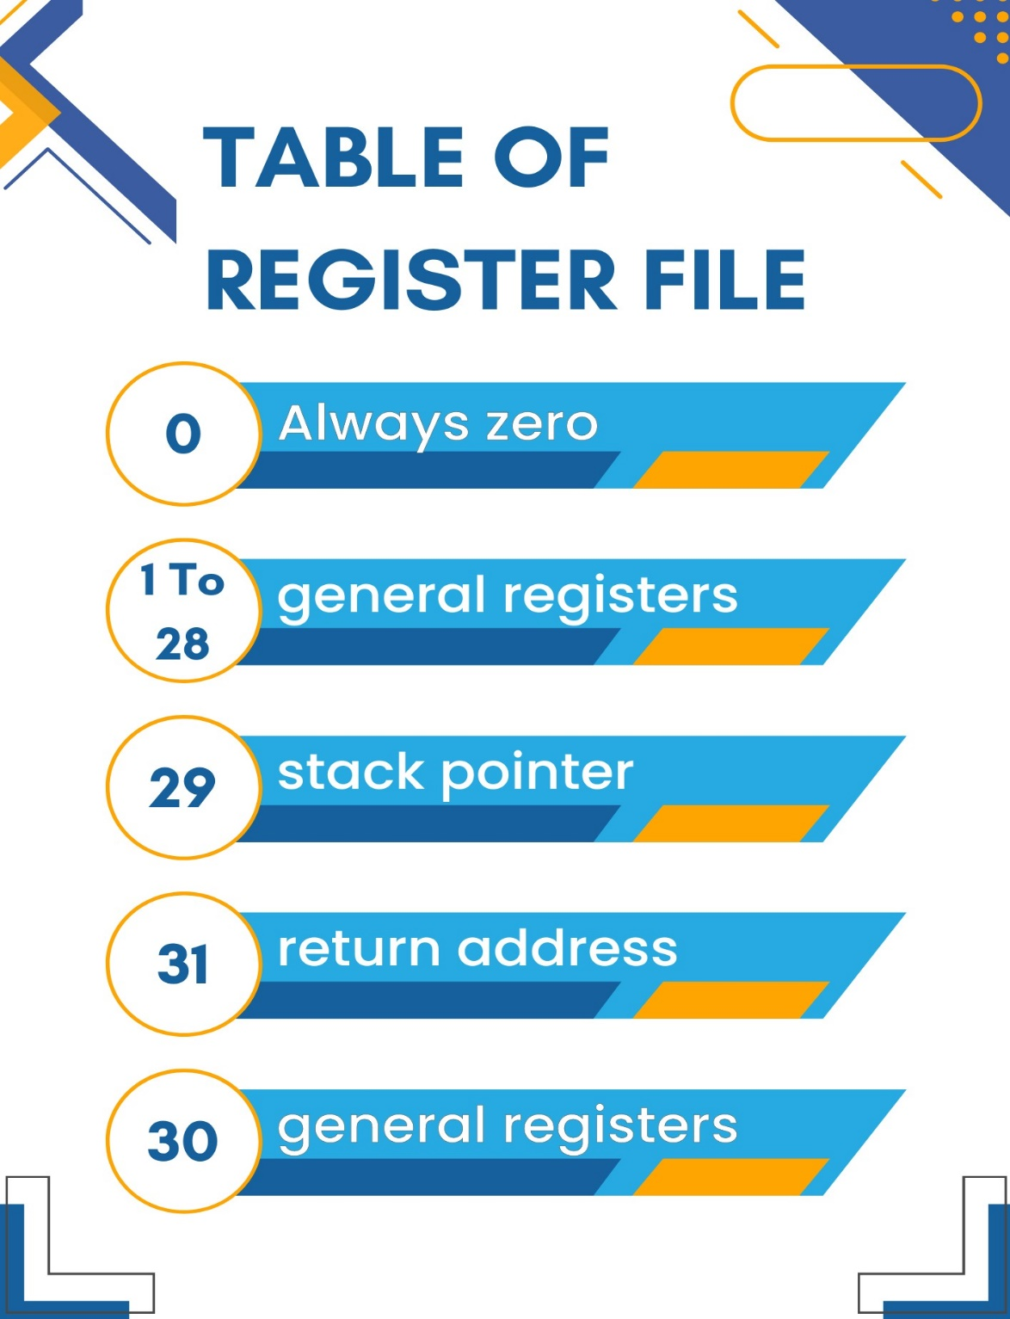

**Control unit:** s a crucial component of a computer's central processing unit (CPU) or any computational device. It coordinates the activities of all the other hardware components in the system. Essentially, the control unit fetches instructions from memory and decodes and executes them, sending signals to the other components of the computer to control data flow and processing operations. It acts as a central manager, directing the operation of the processor and its interaction with other hardware components.

The control unit serves as the central intelligence of our CPU design, acting as the pivotal module that orchestrates the various operations within the processor. At the core of this module lies the ControlUnit entity, taking essential input signals such as Clock, Reset, opcode, RegDst, ALUSrc, MemtoReg, MemWrite, MemRead, ALUOp, RegWrite, Branch, Jump, funct, pc_load, and PC_Store.

In aligning with the standard MIPS architecture, we have implemented familiar control signals such as Clock, RegDst, ALUSrc, MemtoReg, MemWrite, MemRead, ALUOp, RegWrite, Branch, Jump, and funct. These signals are crucial for directing the flow of data and control within the CPU.

Additionally, we have introduced new signals to tailor our design for specific functionalities:

**Reset Signal:**

The Reset signal serves as a mechanism to reset the control unit, initiating a no-operation (nop) instruction. This feature ensures a controlled start or restart of the CPU, enhancing the robustness and reliability of the system.

**PC_Store Signal:**

The PC_Store signal is a unique addition designed to interact with the register file. Its purpose is to enable the register associated with register 31 to store a specific value. This value corresponds to the current program counter value that we intend to preserve. This feature allows for strategic storage of program counter values for future reference or manipulation.

By incorporating these new signals, our control unit not only adheres to established MIPS standards but also offers a level of customization that enhances the adaptability and efficiency of our CPU design. The combination of standard and bespoke control signals ensures a versatile

and finely-tuned control mechanism, making our CPU well-suited for a variety of computing tasks.

### ID_EX register

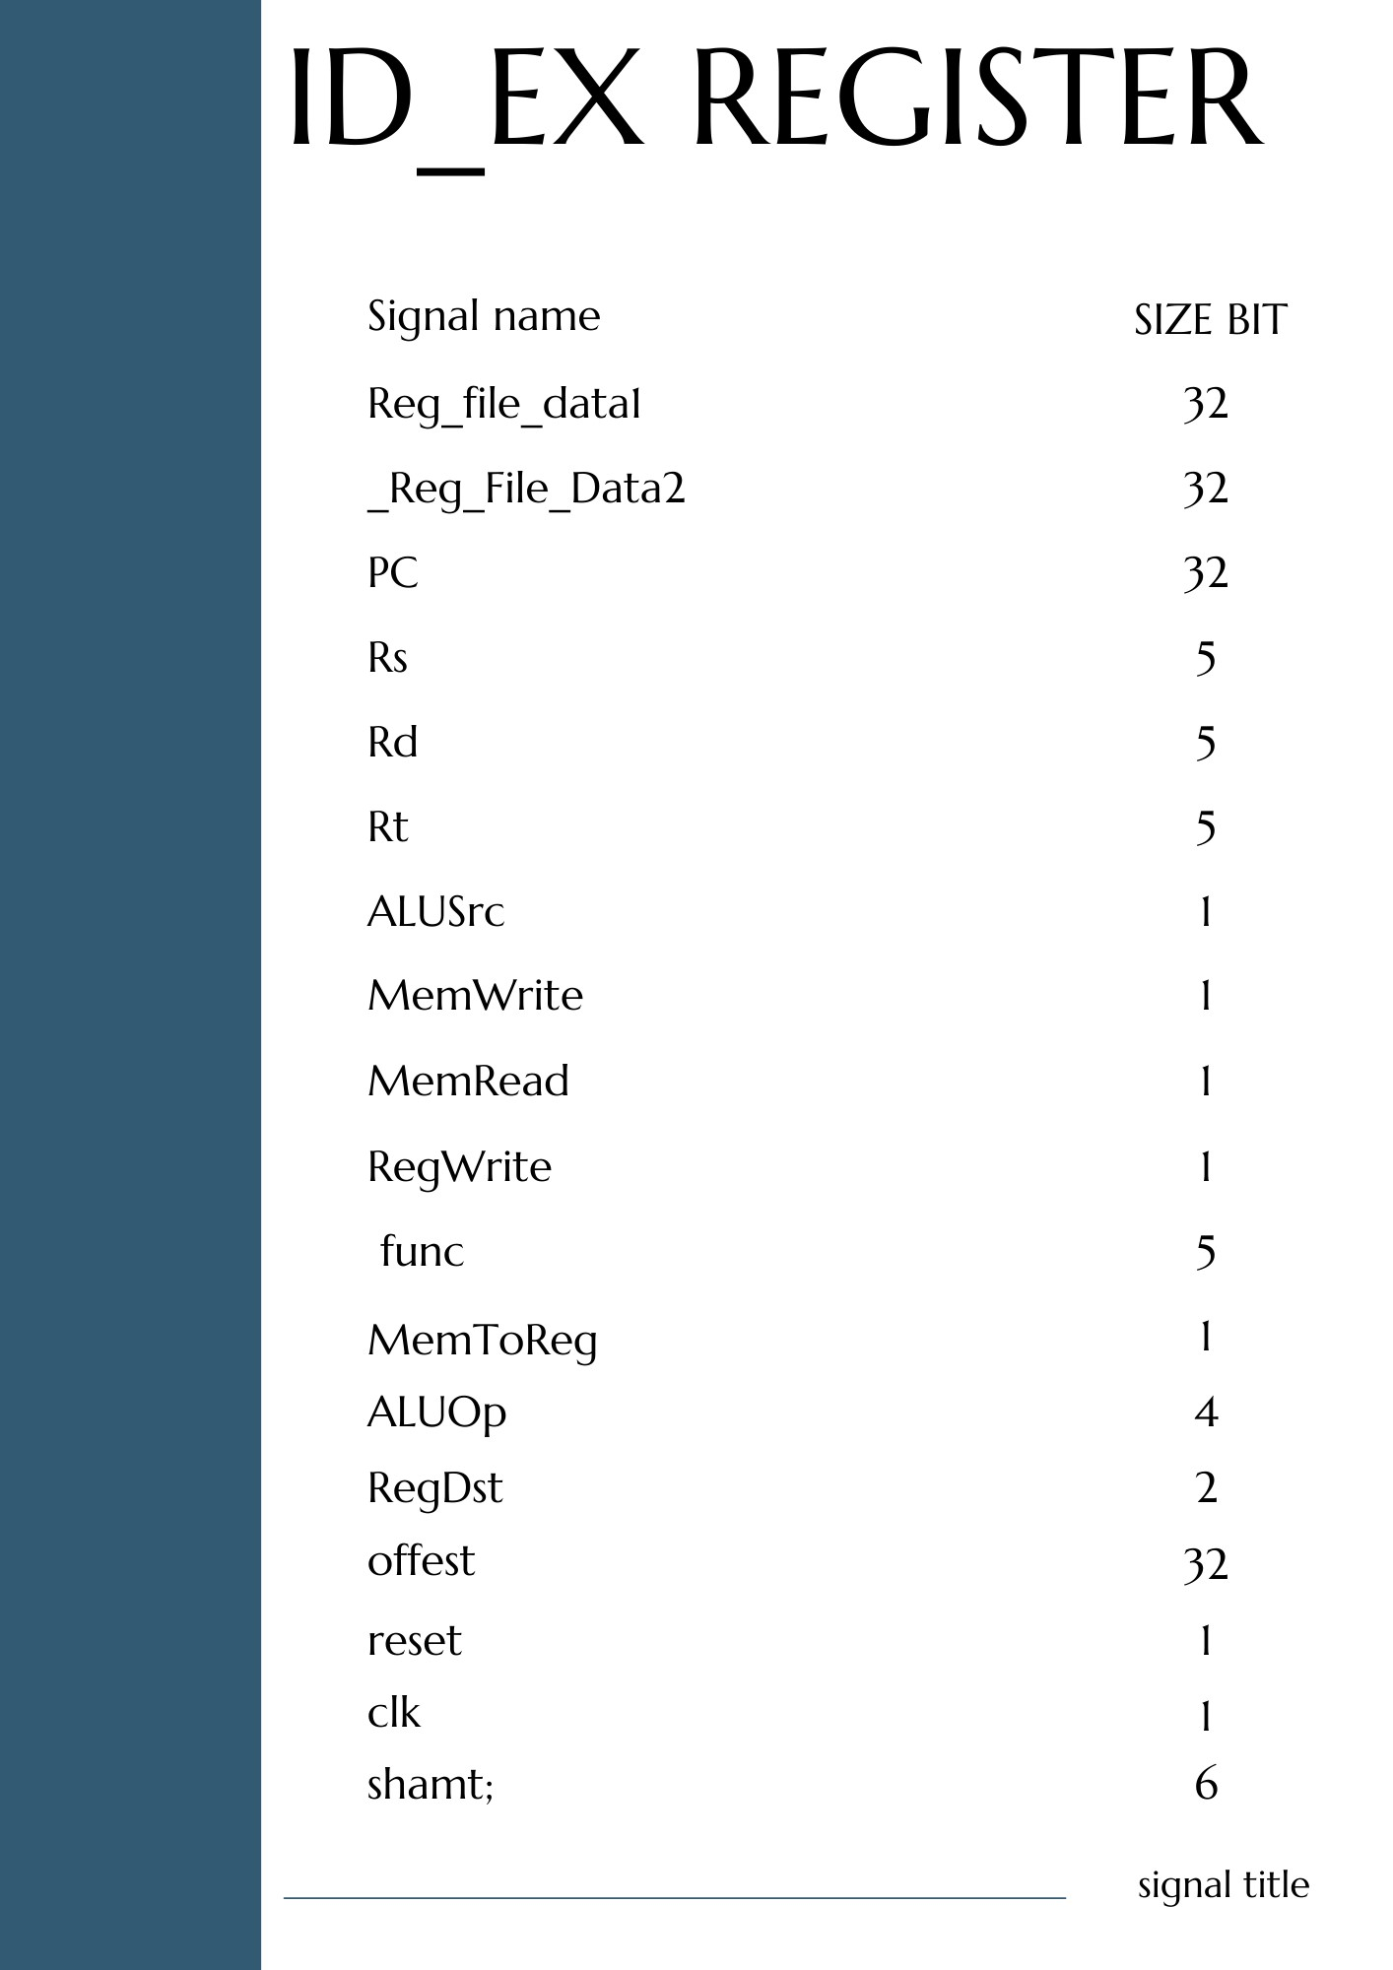

### EX_MEM register

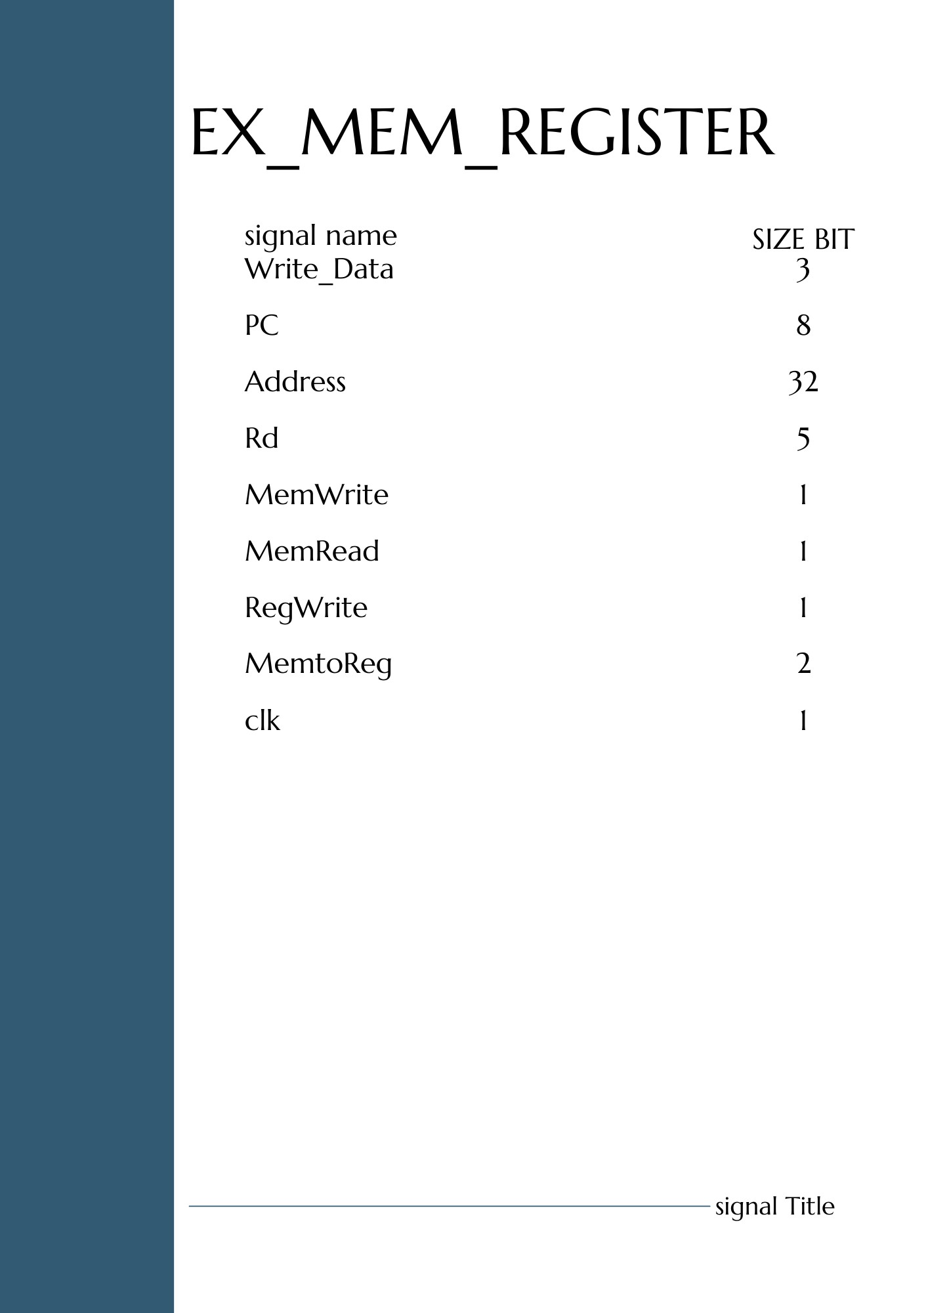

### MEM_WB register

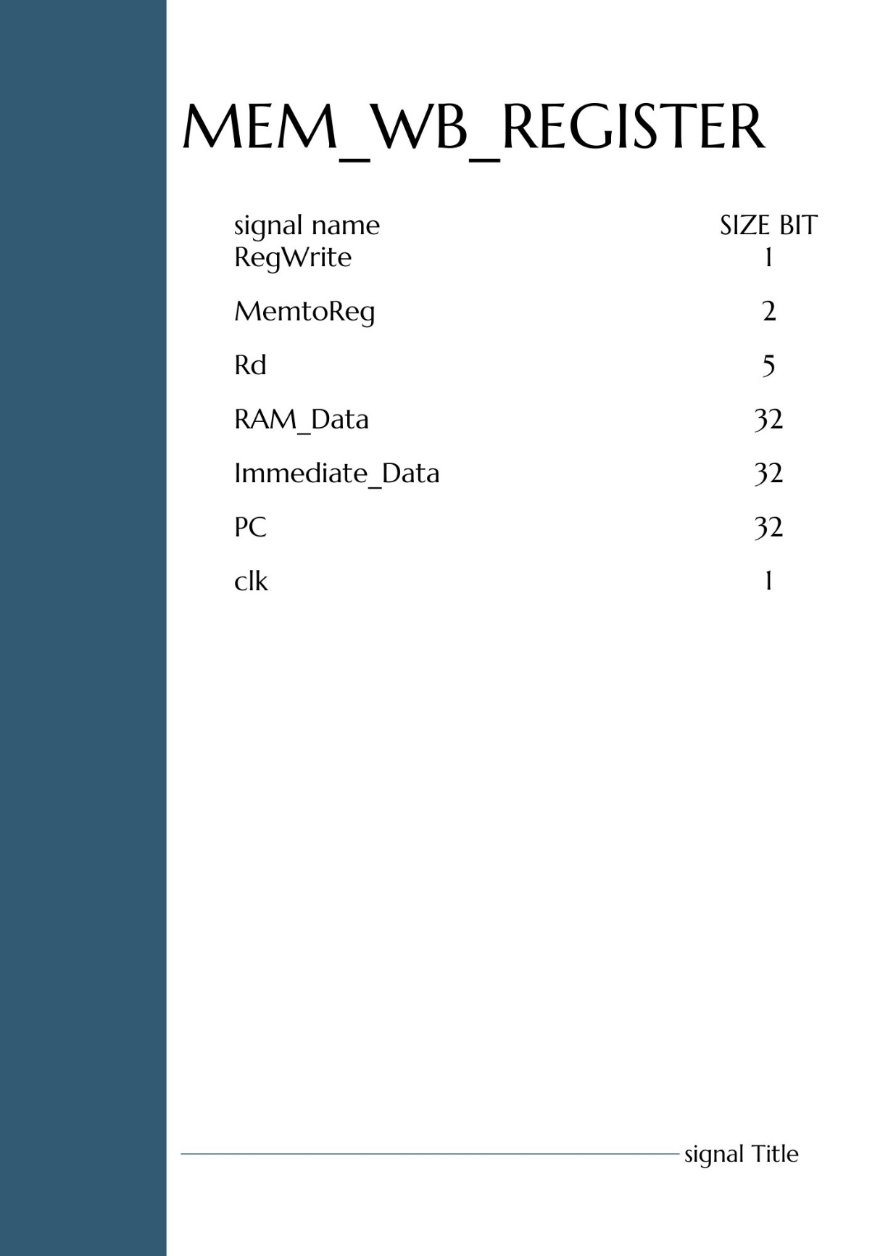

## MIPS DATAPATH

### Before – phase1

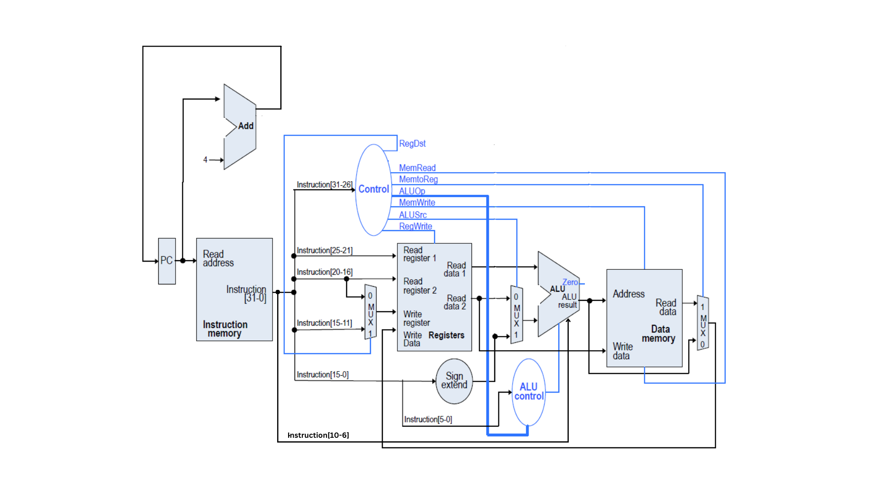

### Phase 2

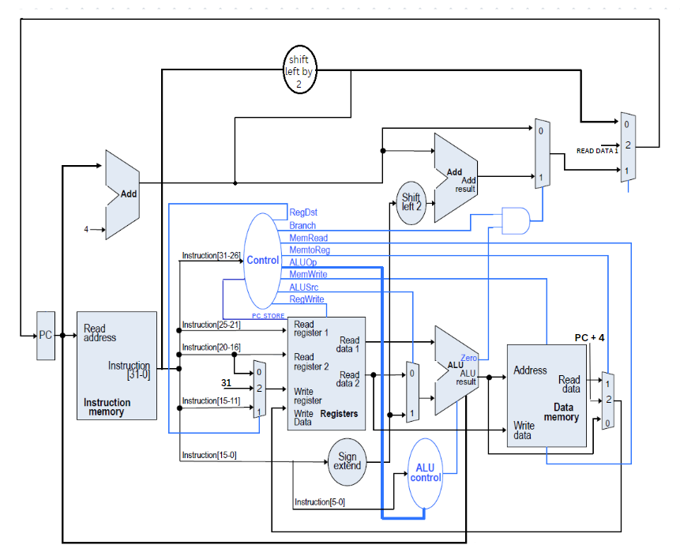

### Phase 3

## mips instruction execution phase

## Coding and Software Development

### Tools

### In the development and verification of our single cycle CPU, we employed a combination of industry-standard tools to ensure accuracy, efficiency, and compatibility. We used **Verilog** as our hardware description language, a popular choice for its expressive syntax and powerful capabilities in modeling complex digital systems. Verilog facilitated a clear representation of our design, allowing for systematic testing and debugging of individual modules and their integration. Complementing this, **Quartus** served as our primary platform for synthesis, placement, routing, and simulation. Its comprehensive suite of tools enabled us to transform our Verilog code into gate-level representations, ensuring that our design meets the desired performance and resource criteria. Furthermore, Quartus provided a conducive environment for iterative design optimization, ensuring that our CPU design was not only functional but also efficient in terms of resource usage and speed. The synergy between Verilog and Quartus was instrumental in realizing a robust and reliable single cycle CPU.

### Challenging

1. . We face challenges due to limited online learning resources and the complexities of optimization. To address this, we seek guidance from our university professors.
2. We improved the performance of our design by 1. increasing the clock speed and 2. minimizing the area.
3. Detecting overflow in the ALU and providing the correct overflow output, **Detection of Overflow in the ALU**:
   * **For Addition**:
     + Overflow occurs if:
       - Both operands are positive, but the result is negative.
       - Both operands are negative, but the result is positive.
     + In terms of bit operations, consider the sign bits (most significant bit, MSB) of operands A and B and the result R. Overflow is detected if:
       - A's MSB is 0, B's MSB is 0, but R's MSB is 1.
       - A's MSB is 1, B's MSB is 1, but R's MSB is 0.
   * **For Subtraction**: Since subtraction is the same as adding a negative number in two's complement arithmetic, the rules for addition apply here too.

**Handling Overflow in the ALU**:

* + **Overflow Flag**: The ALU can set an overflow flag (often denoted as the 'V' flag in many architectures) whenever overflow occurs. This flag can be checked by subsequent instructions, and based on its value, certain actions can be taken, such as branching to error-handling routines.

1. **Timing Violation in MIPS 32-bit Architecture Single Cycle CPU**

A timing violation in a MIPS 32-bit architecture single cycle CPU occurs when a signal does not arrive at its destination within the required time window. This can happen for a number of reasons, including:

* Clock skew: Clock skew is the variation in the arrival time of the clock signal at different parts of the CPU. This can be caused by differences in the length of the clock wires or by variations in the manufacturing process.
* Hold time violation: A hold time violation occurs when a signal does not remain stable for the required amount of time before the clock edge. This can be caused by a slow signal driver or by a long signal path.
* Setup time violation: A setup time violation occurs when a signal does not arrive at its destination within the required amount of time before the clock edge. This can be caused by a fast signal driver or by a short signal path.
* Glitches: A glitch is a short-duration, spurious pulse that can occur on a signal line. Glitches can be caused by noise or by crosstalk between signal lines.

Types of Timing Violations

There are two main types of timing violations:

* 1. Combinational timing violations: Combinational timing violations occur in combinational logic circuits, such as adders and multipliers. These circuits are designed to produce an output signal within a certain amount of time after the input signals arrive. If the input signals do not arrive within the required time window, or if the circuit is not designed properly, the output signal may not be correct.
  2. Sequential timing violations: Sequential timing violations occur in sequential logic circuits, such as registers and flip-flops. These circuits are designed to store a state signal and then update it on the next clock edge. If the clock edge arrives before the state signal has settled, or if the circuit is not designed properly, the state signal may not be updated correctly.

Consequences of Timing Violations

Timing violations can lead to a number of problems, including:

Incorrect results: Timing violations can cause the CPU to produce incorrect results. This can lead to errors in programs and data corruption.

System instability: Timing violations can cause the CPU to become unstable. This can lead to system crashes and other problems.

Increased power consumption: Timing violations can cause the CPU to consume more power. This can lead to overheating and reduced battery life.

Preventing Timing Violations

There are a number of things that can be done to prevent timing violations, including:

Careful design: The CPU should be designed carefully to minimize clock skew and signal path delays.

Use of buffers: Buffers can be used to reduce signal path delays.

Use of clock gating: Clock gating can be used to disable the clock to unused circuits, which can reduce power consumption and improve timing performance.

Testing: The CPU should be thoroughly tested to ensure that it meets all timing requirements.

Conclusion

Timing violations are a serious problem in MIPS 32-bit architecture single cycle CPUs. They can lead to incorrect results, system instability, and increased power consumption. There are a number of things that can be done to prevent timing violations, including careful design, the use of buffers, clock gating, and testing.

1. **FPGA**

1. Our university currently lacks access to the latest FPGA units, resulting in extended waiting periods until new FPGA resources are made available through competition allocations.

2. We had no idea how to implement our design on an FPGA, so if consume a lot of time to only know how implement our design in FPGA

1. **Stack (Jump and link)**

### Instruction set architecture

The our instruction set architecture, it will improve in the future.

#### Before (phase one)

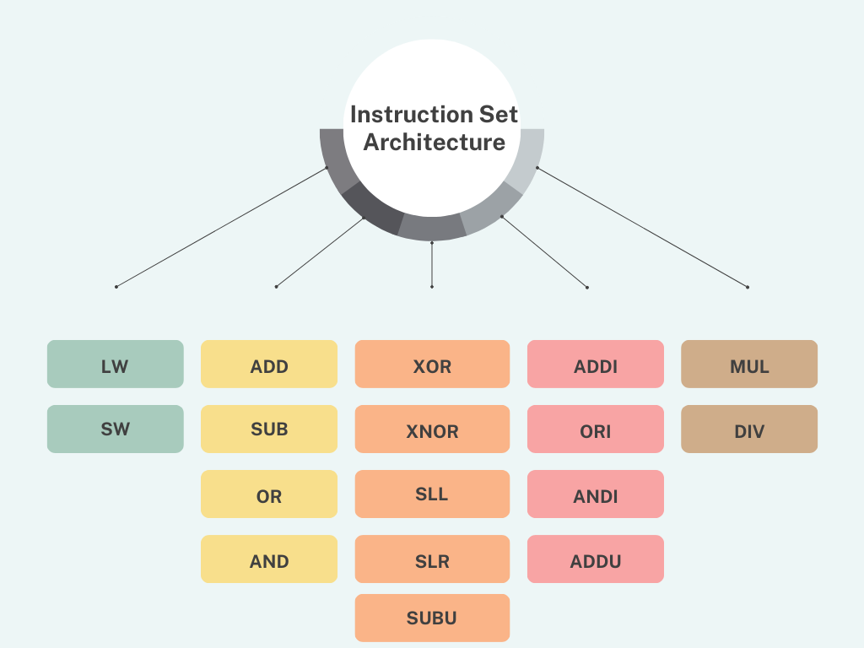

#### phase two

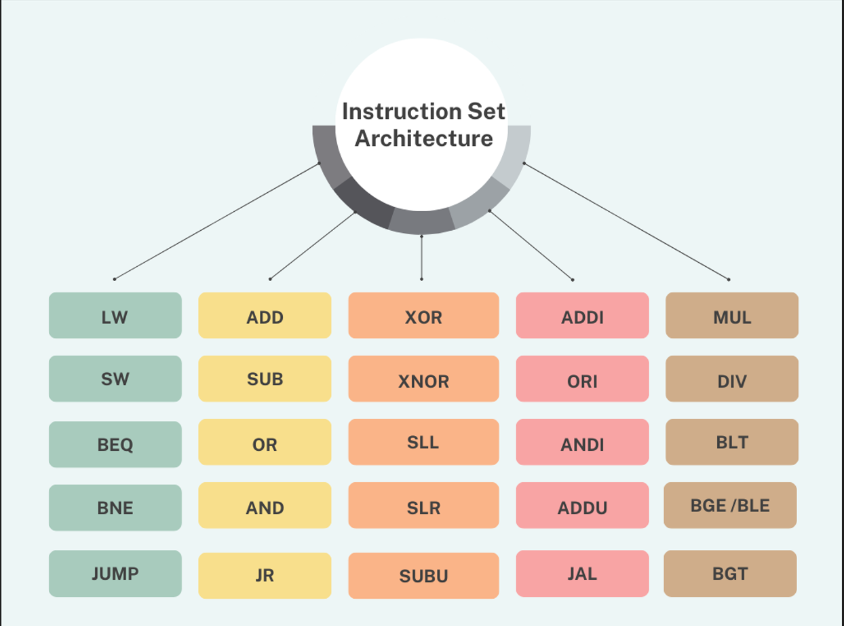

#### phase 3

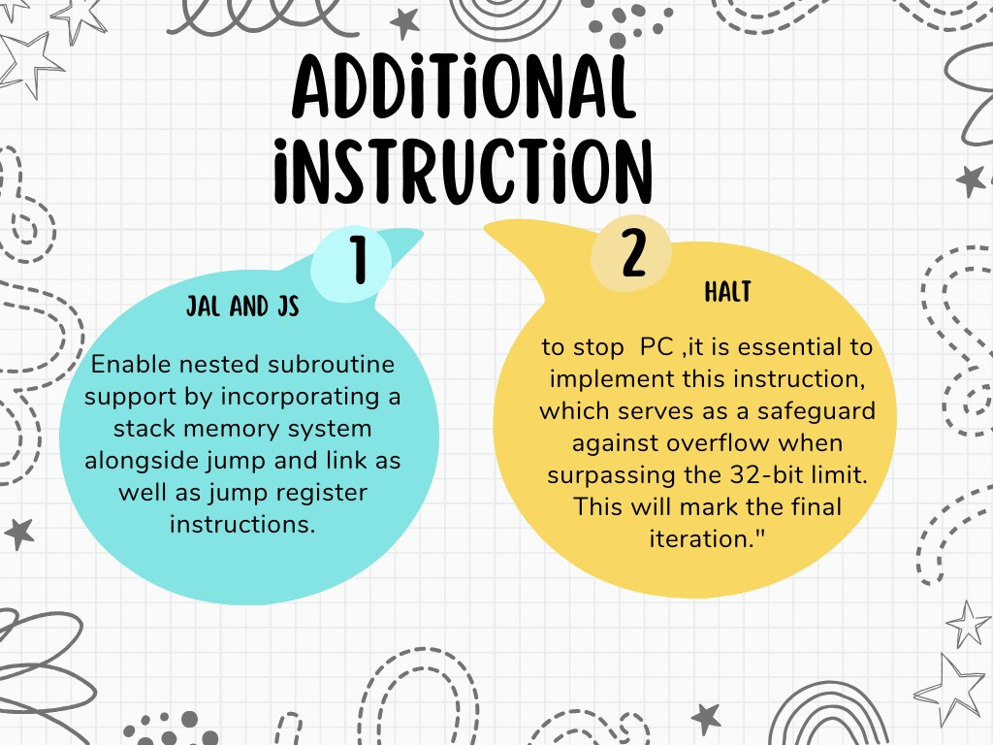

# Results

## FPGA

### Testcase one

#### Register 10 ( the first two bit is register number ,other is register value)

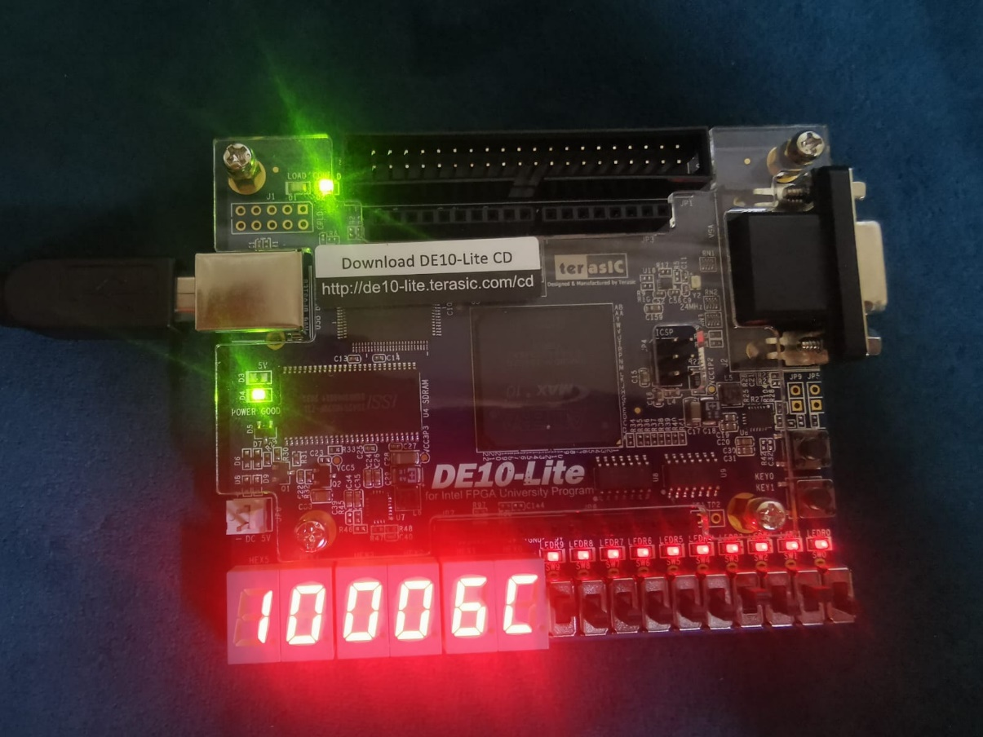

#### Register 8

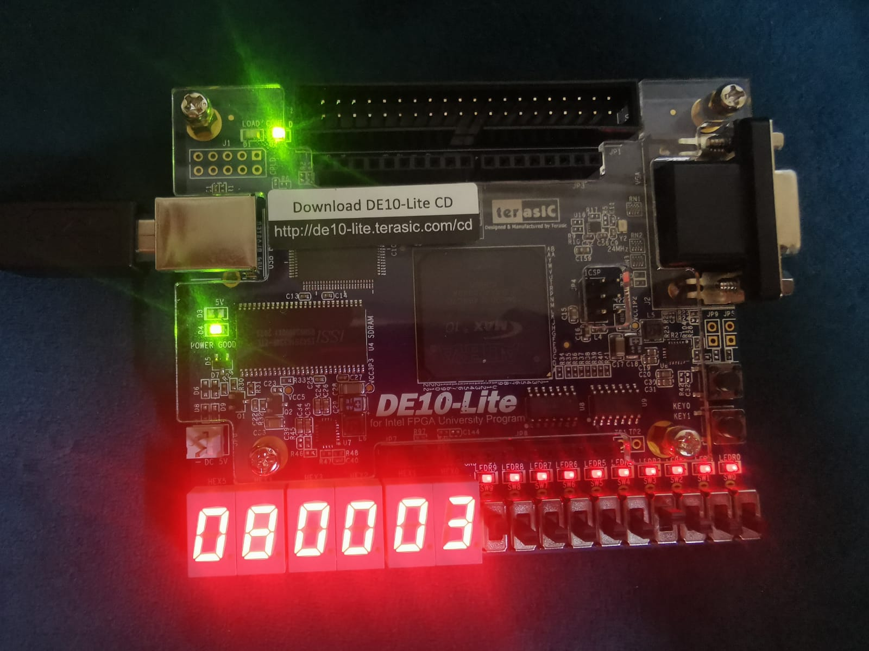

#### Register 9

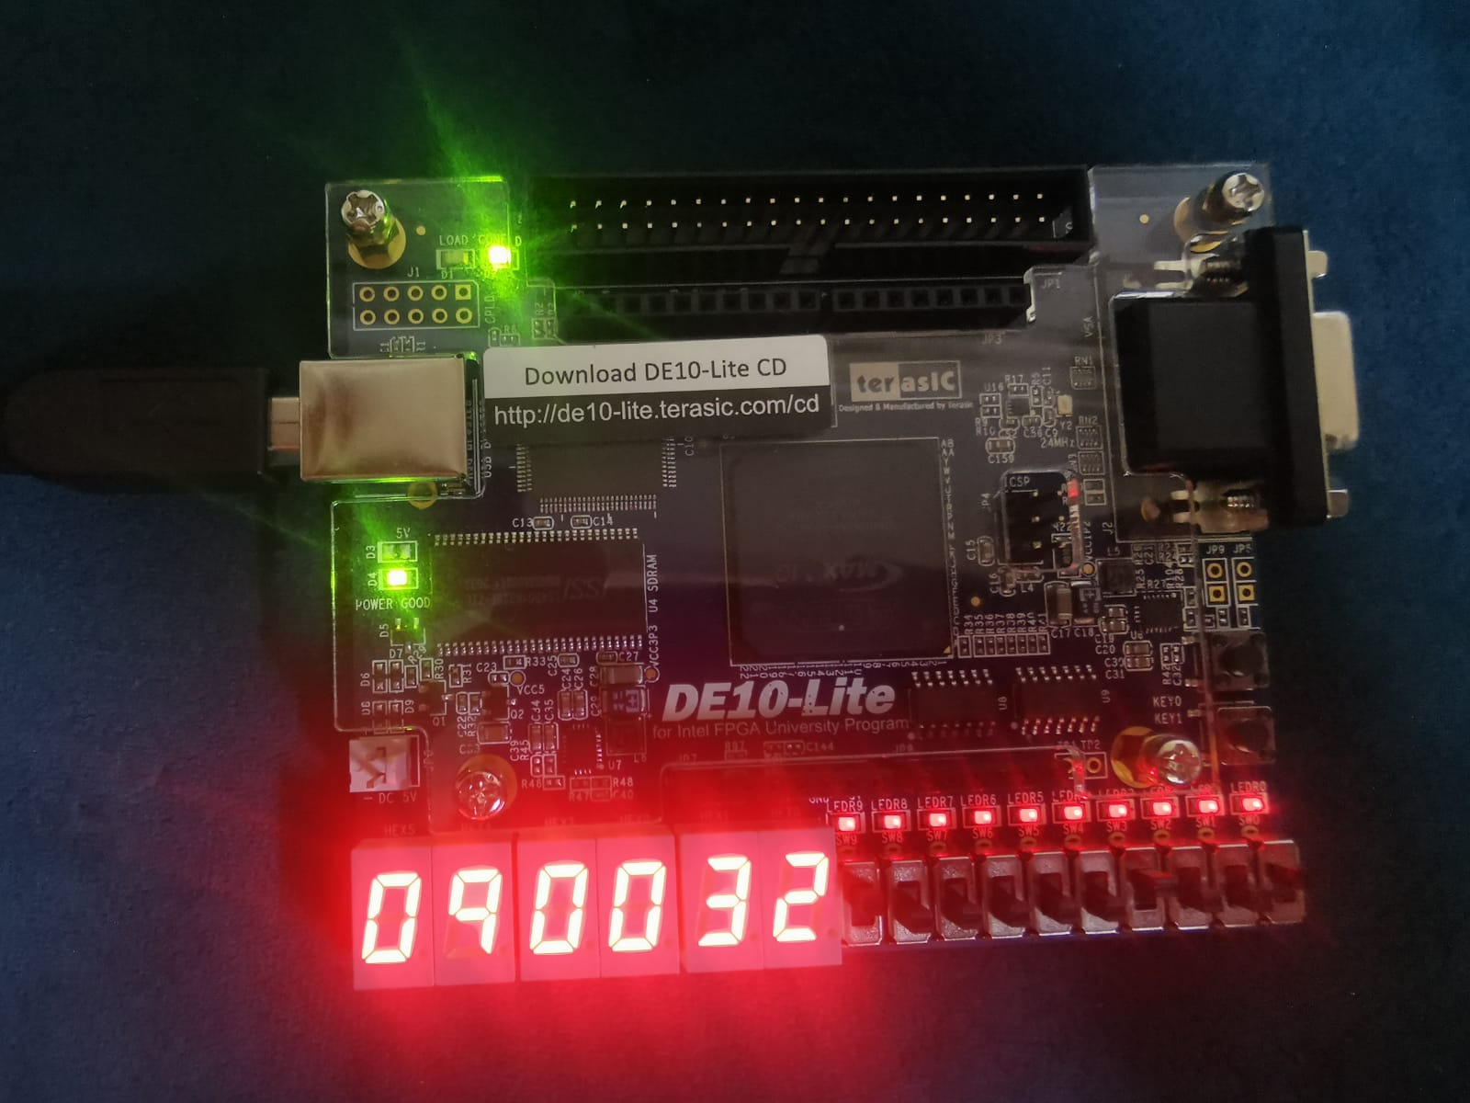

#### Register 11

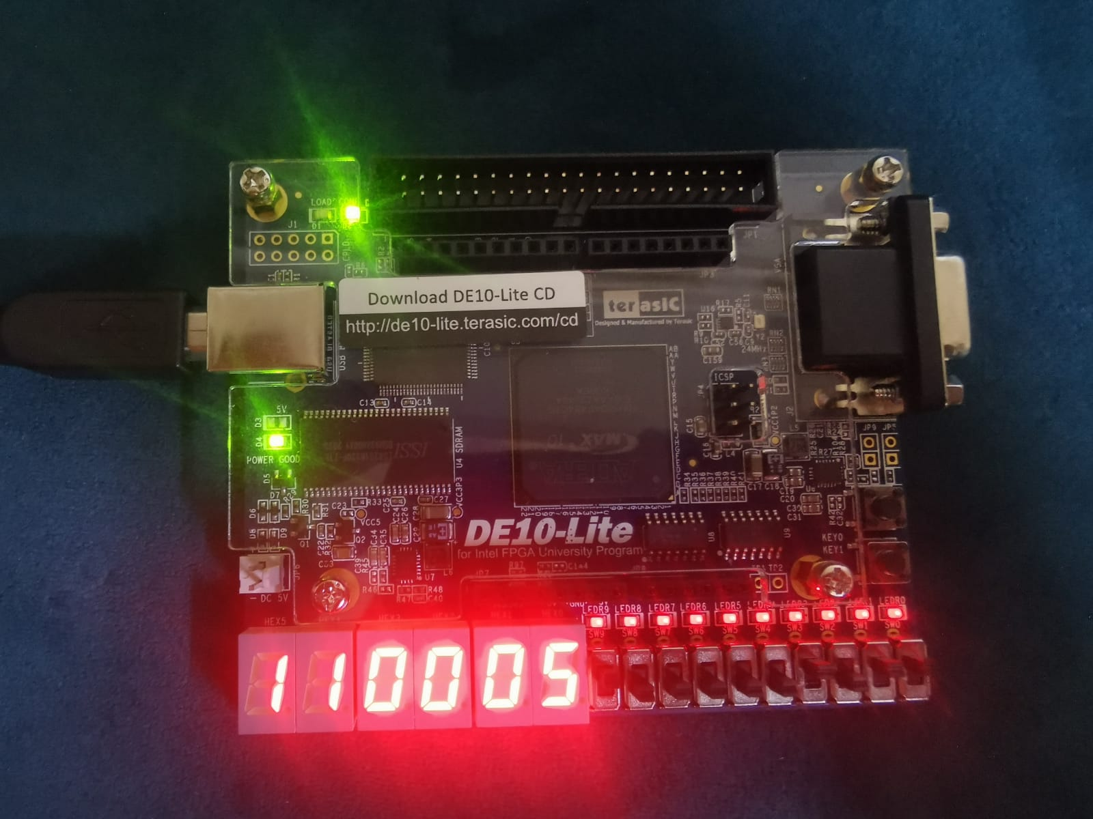

### Testcase 2

#### Register 1

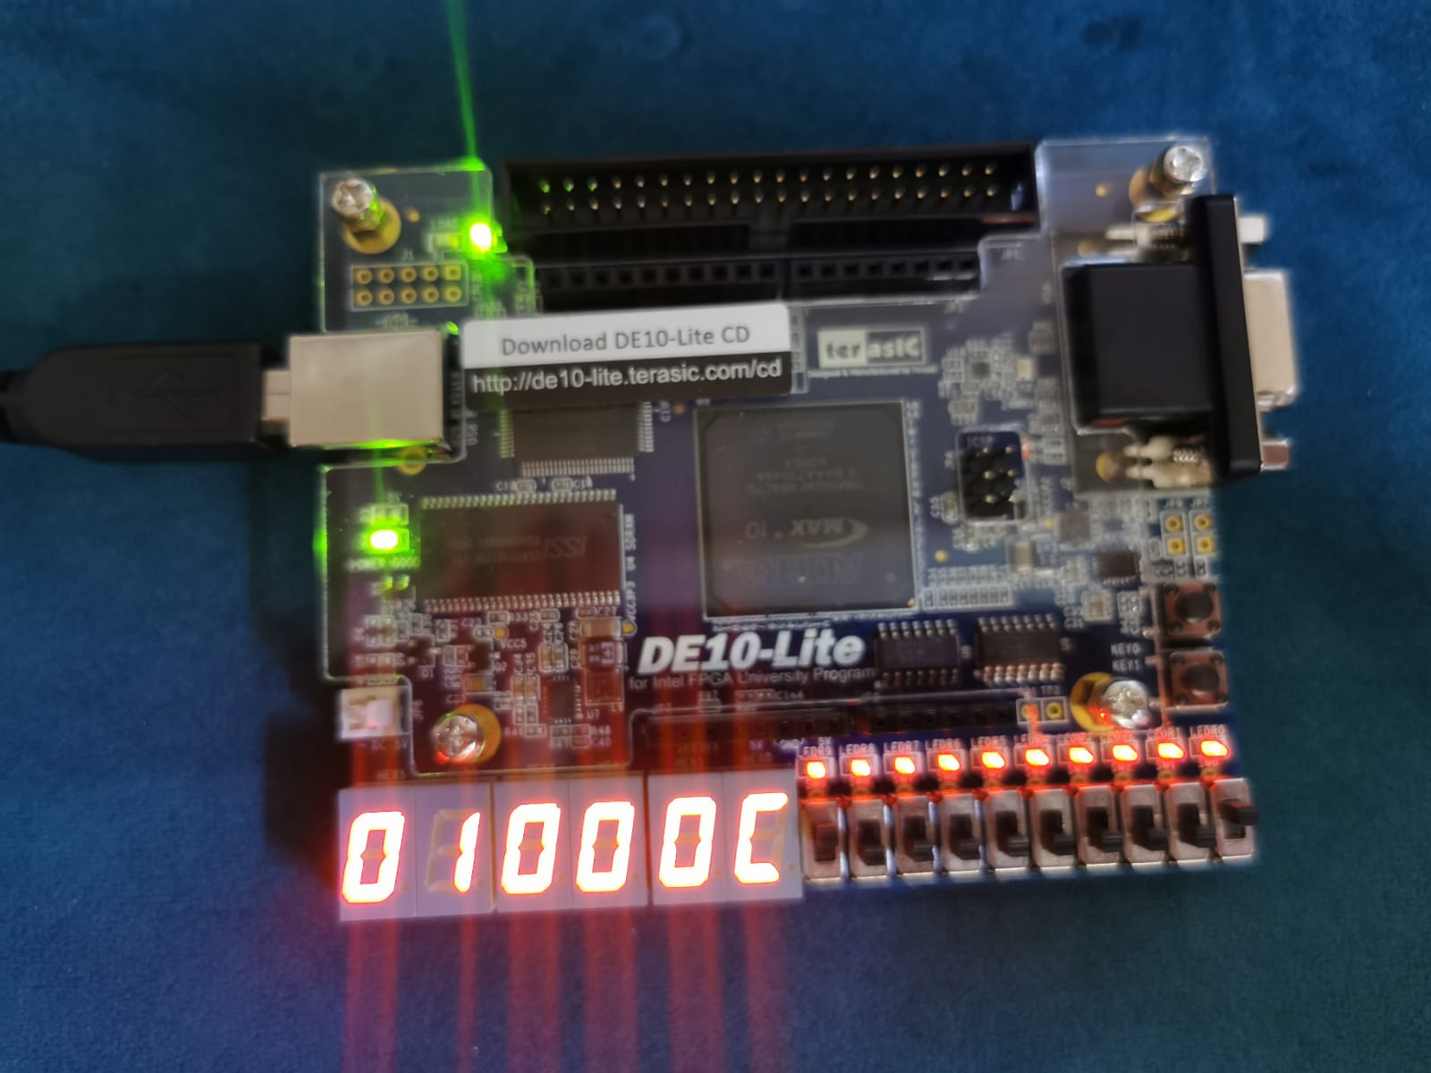

#### Register 2

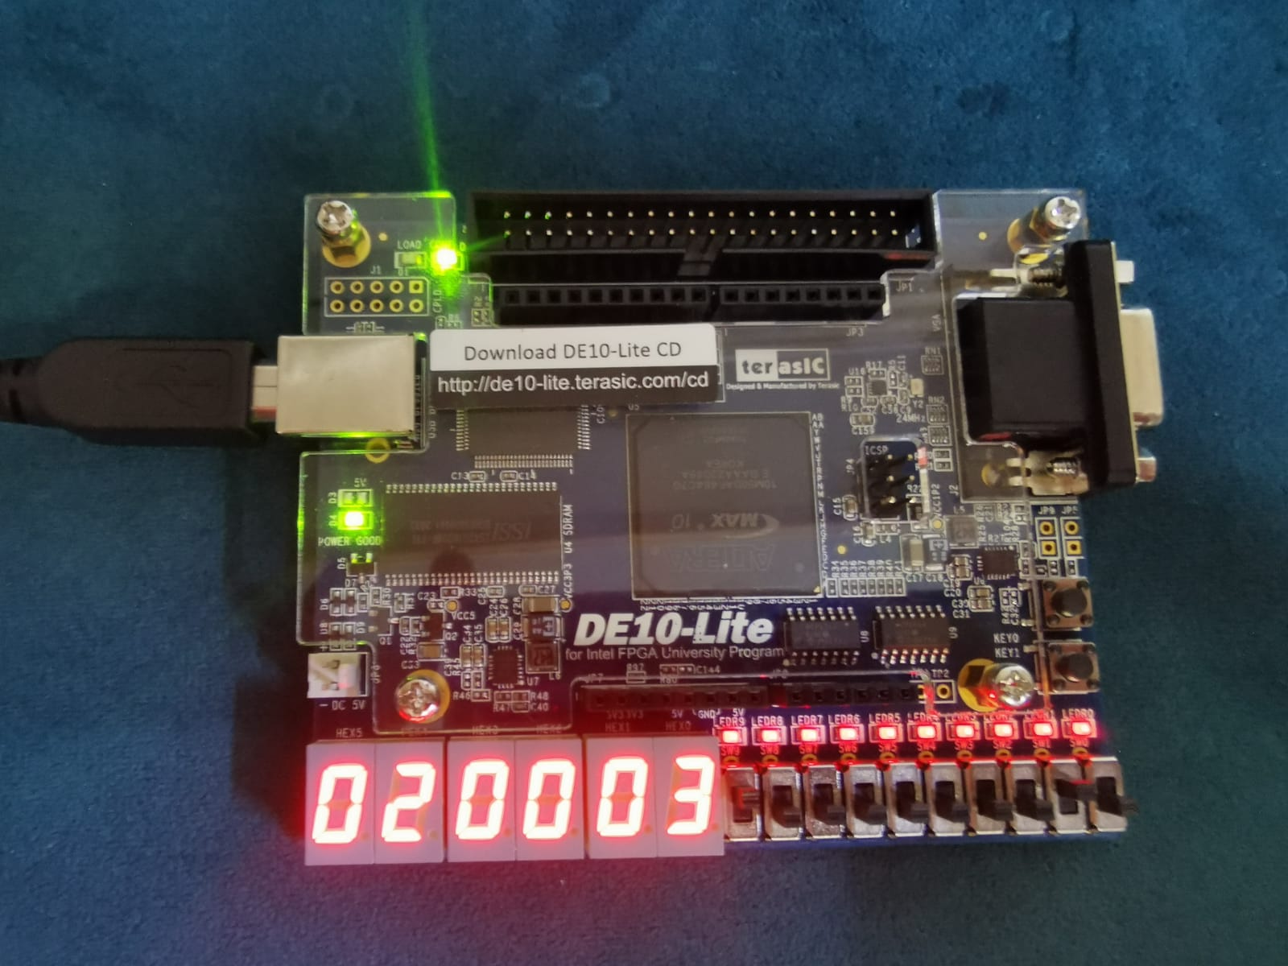

#### Register 3

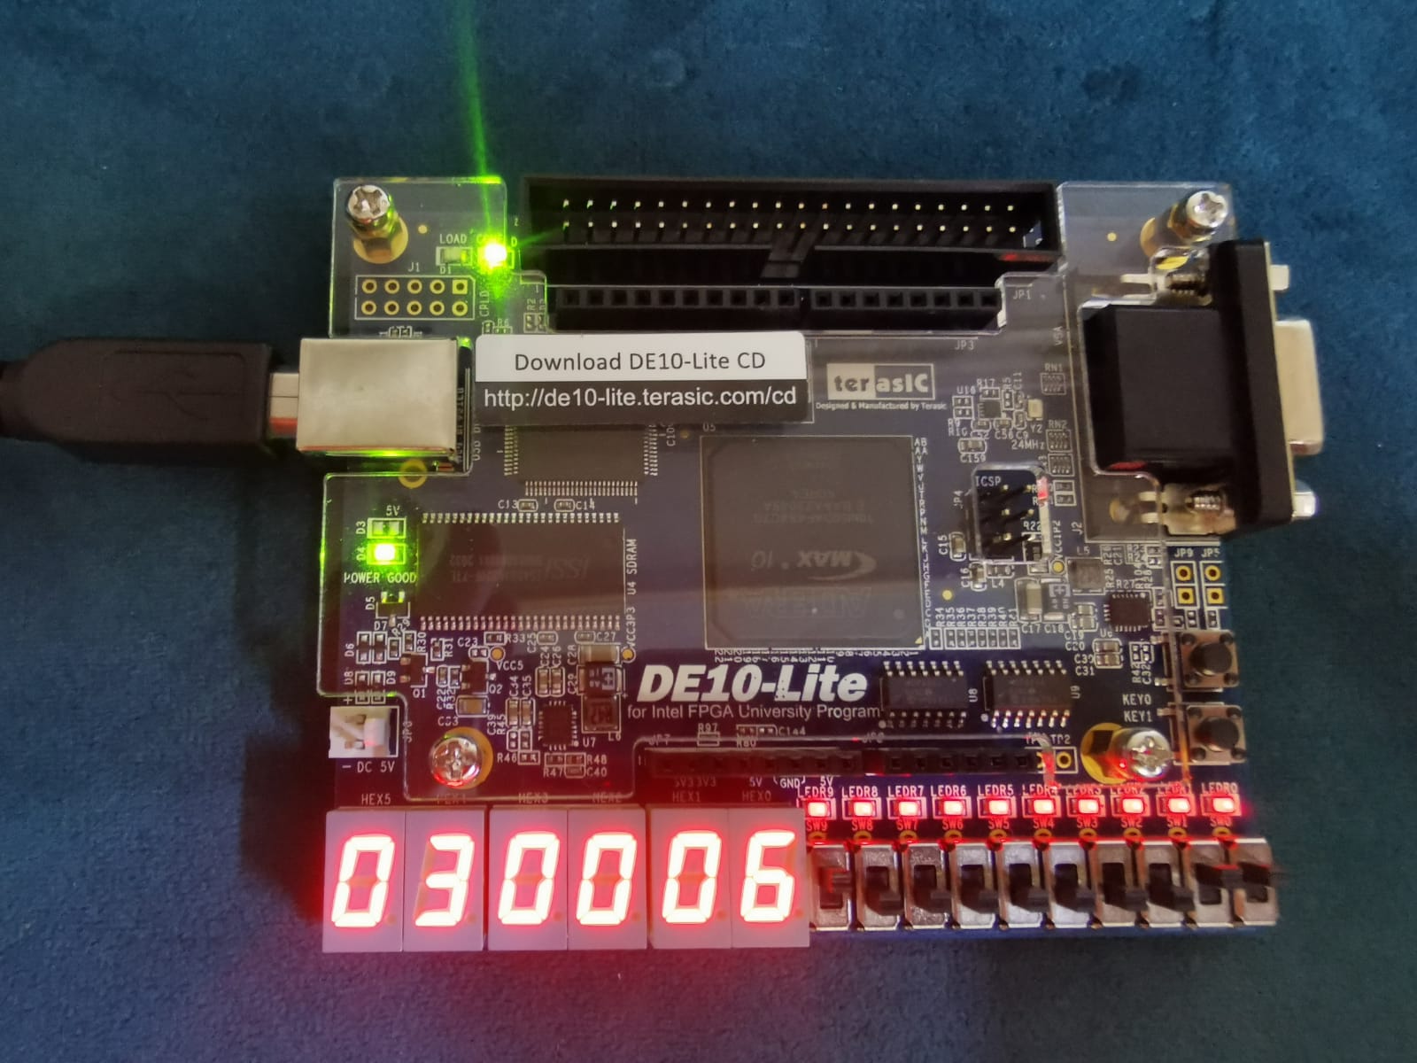

#### Register 4

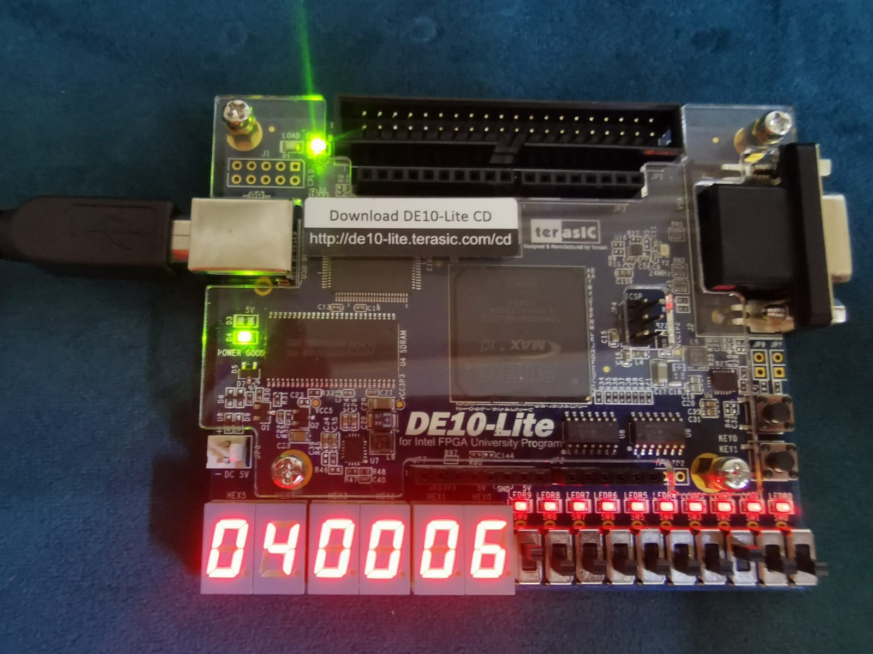

### Testcase 3

#### Register 10

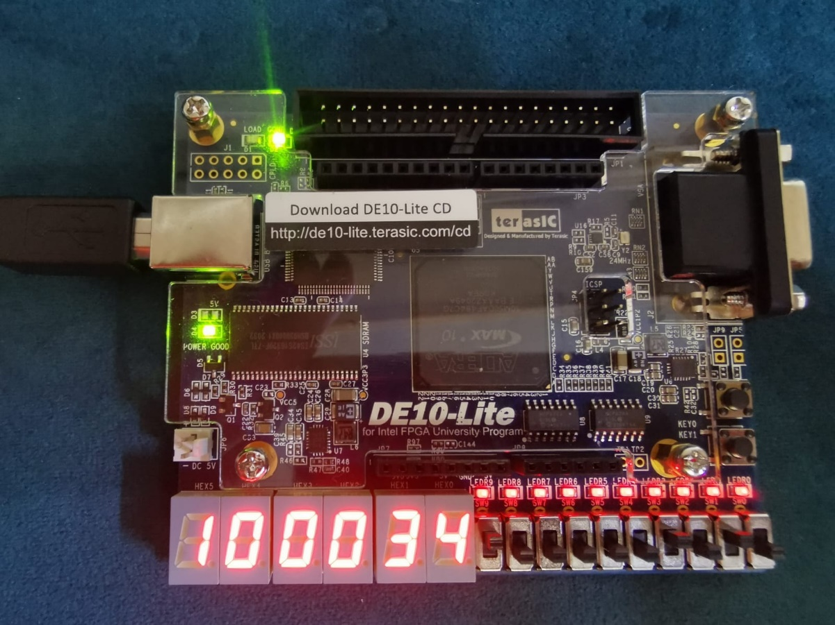

#### Register 28

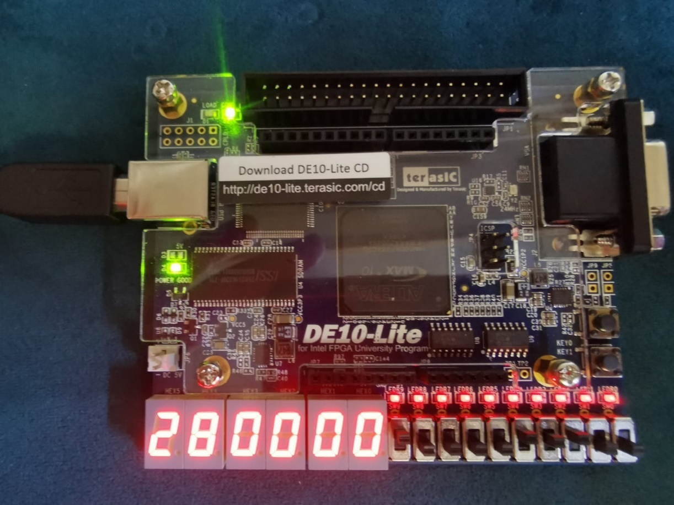

#### Register 8

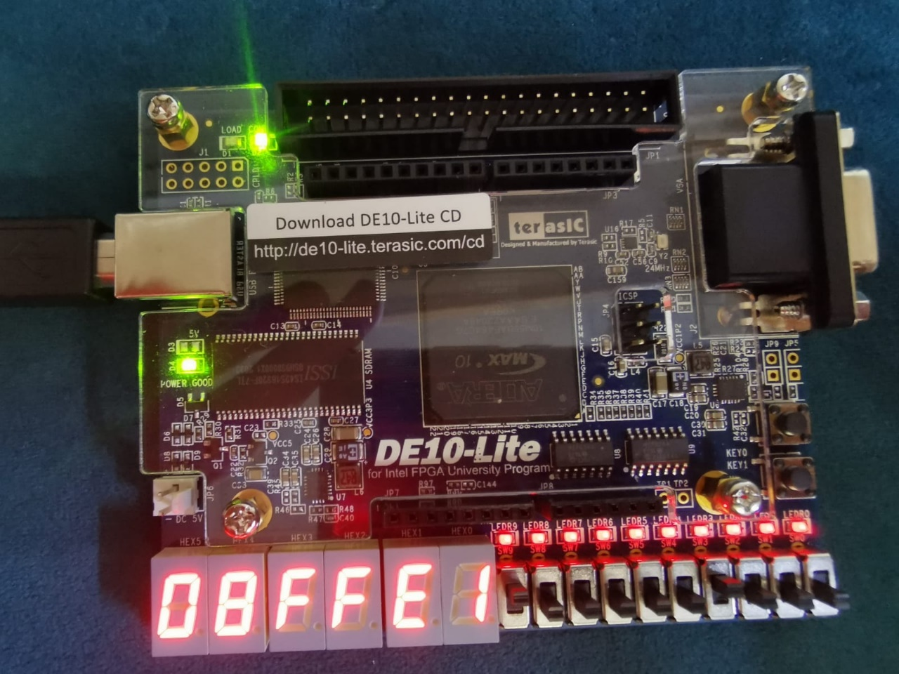

#### Register 8 upper

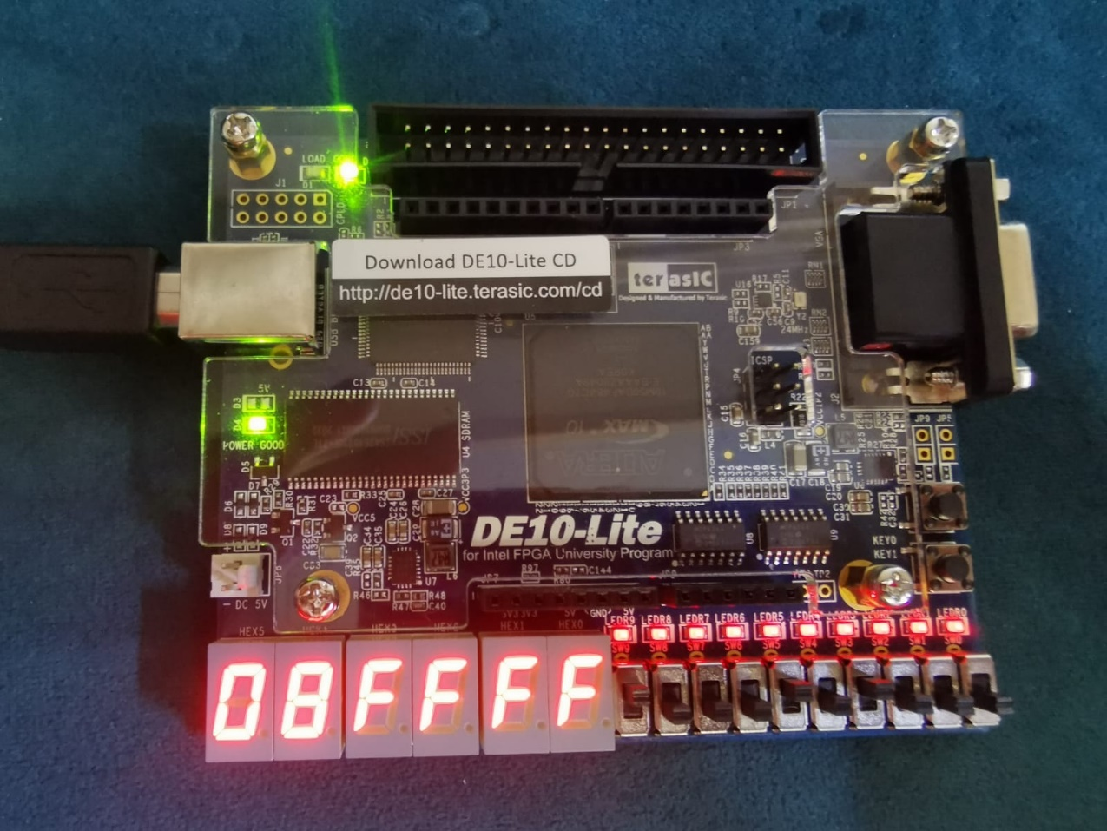

#### Register 9

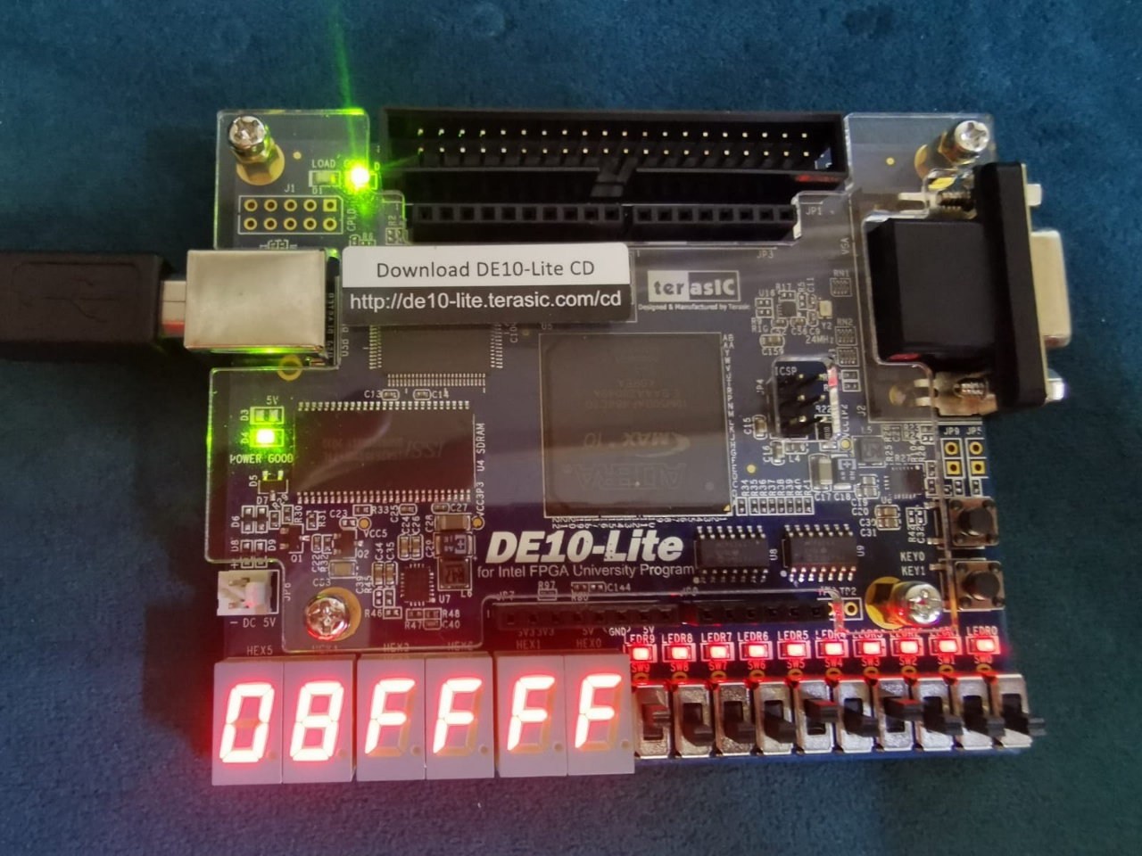

### Testcase 4

#### Register 10

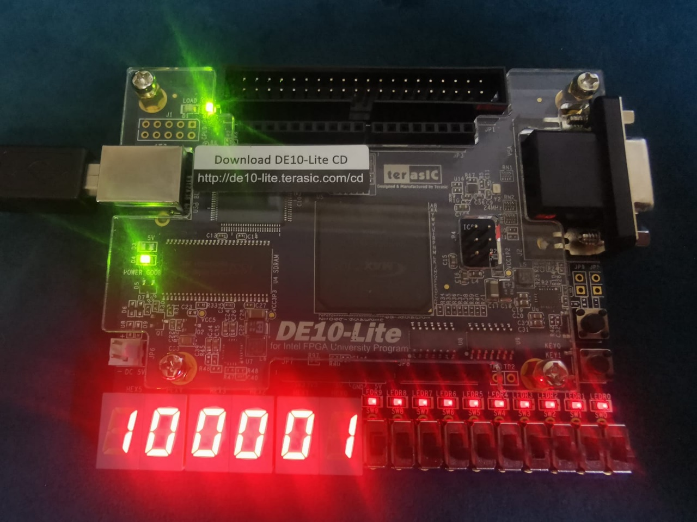

#### Register 12

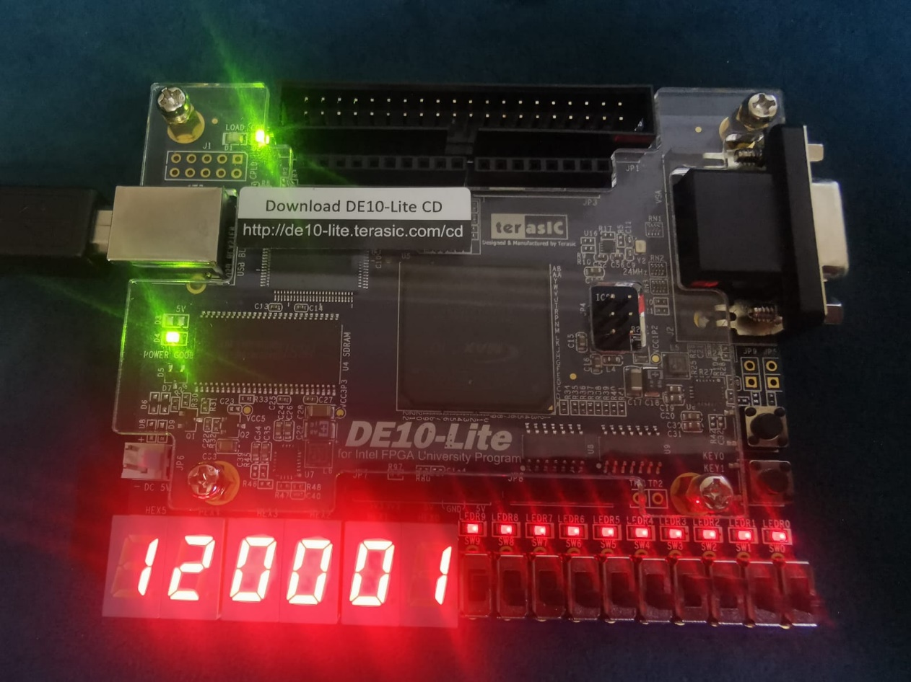

#### Register 13

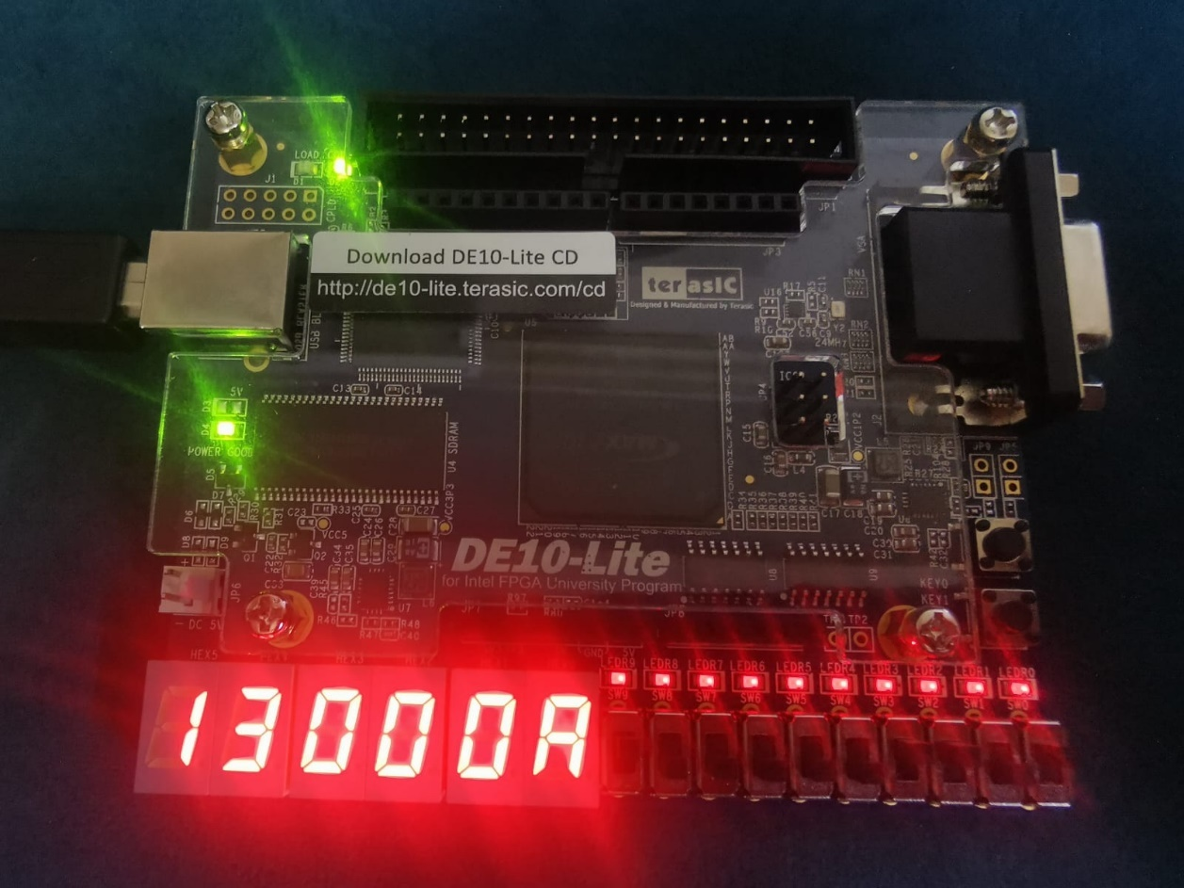

#### Register 14

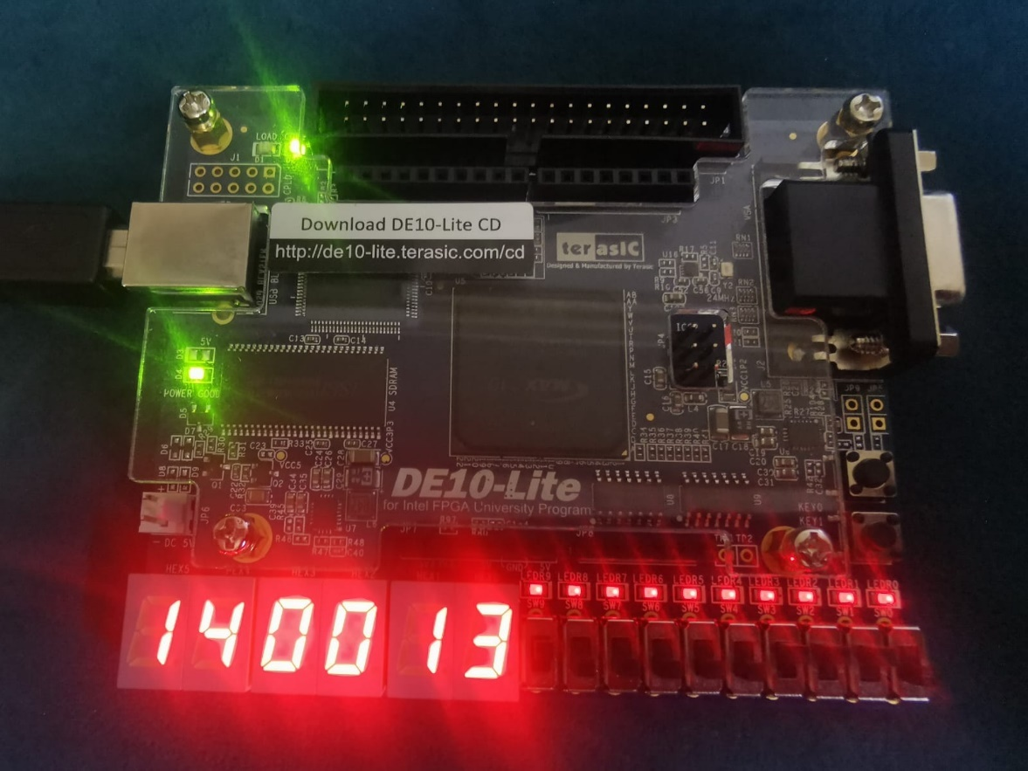

#### Register 8

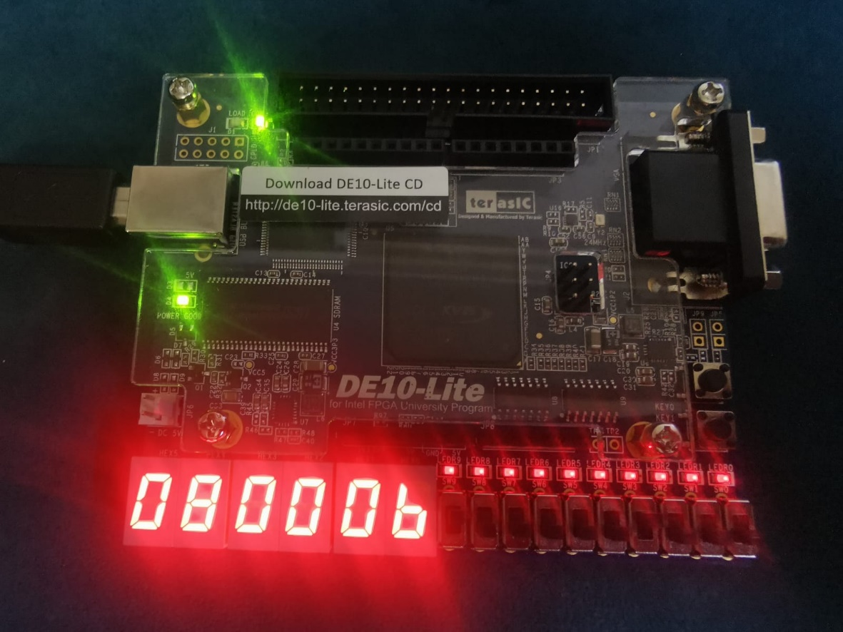

#### Register 9

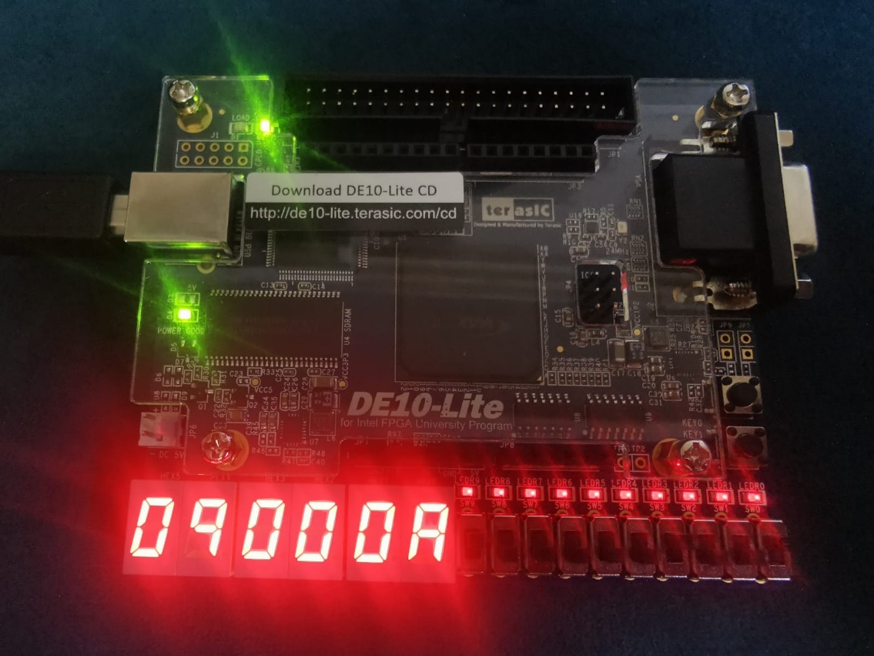

### Testcase 5

**When a=2**

#### Register 1

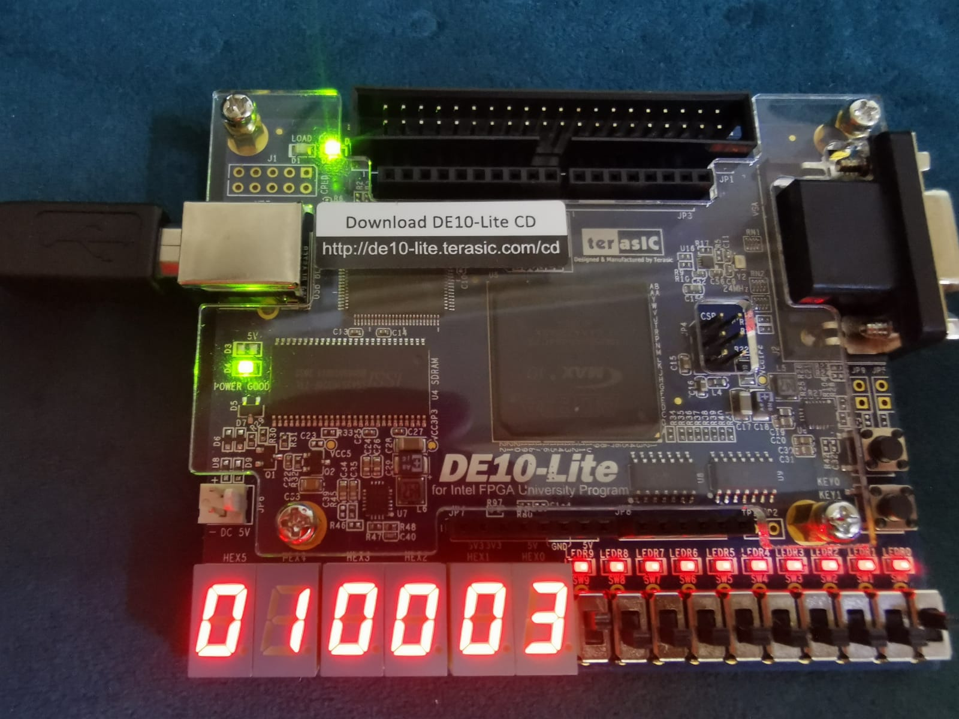

#### Register 2

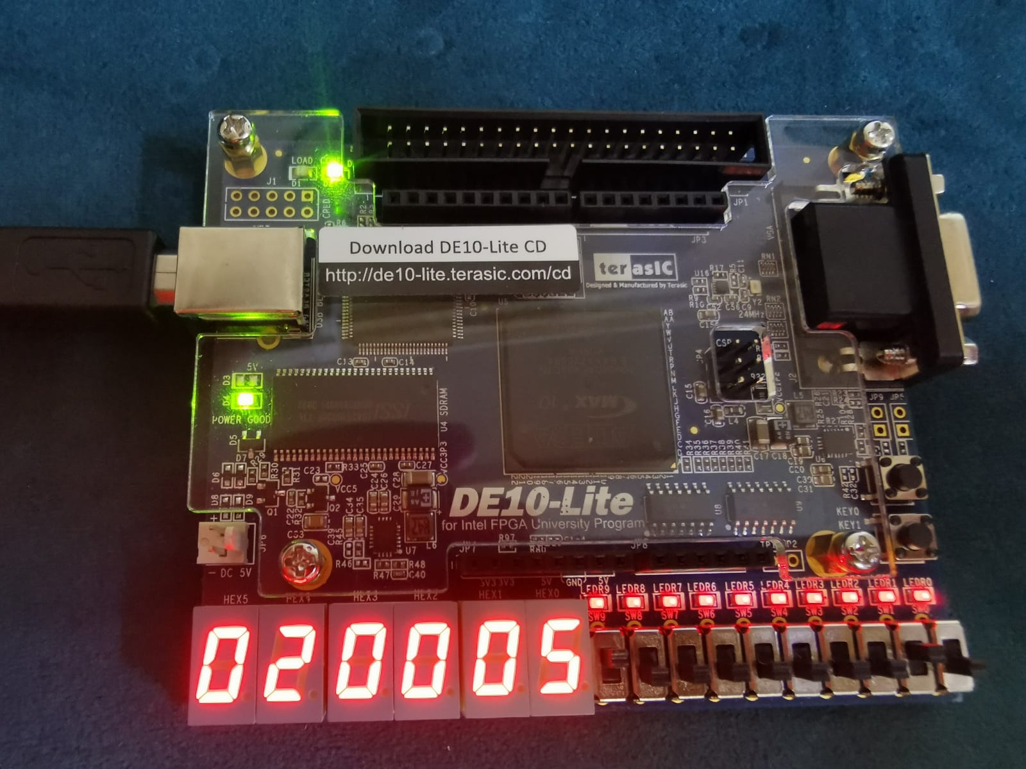

#### Register 3

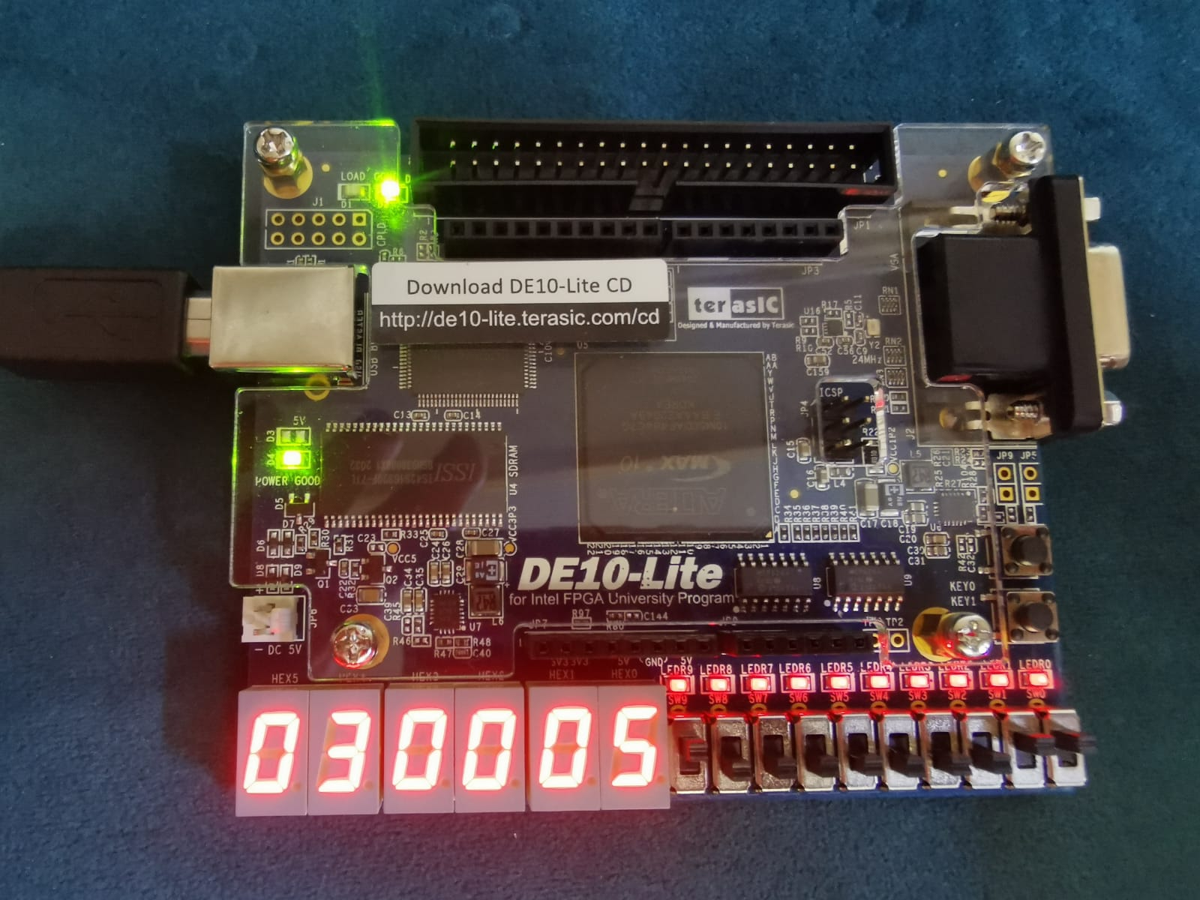

**When a =6**

#### Register 1

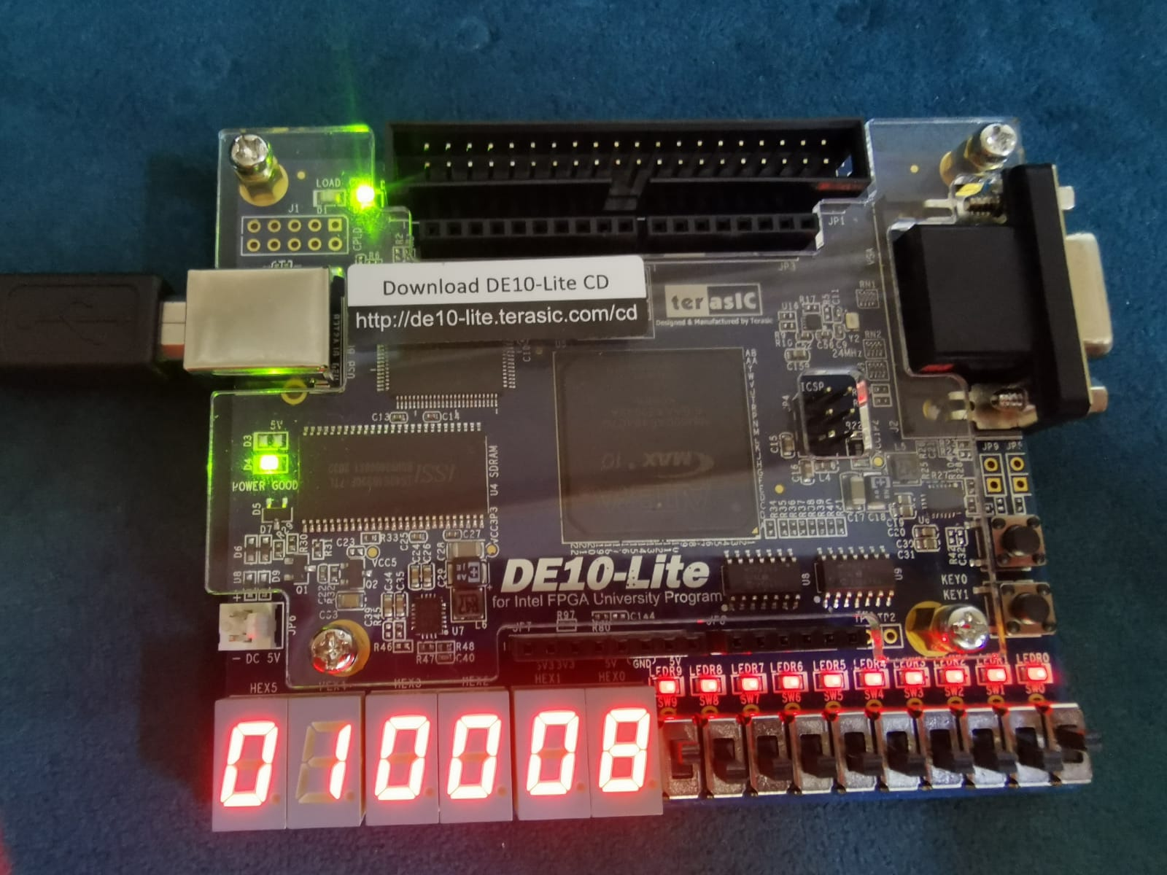

#### Register 2

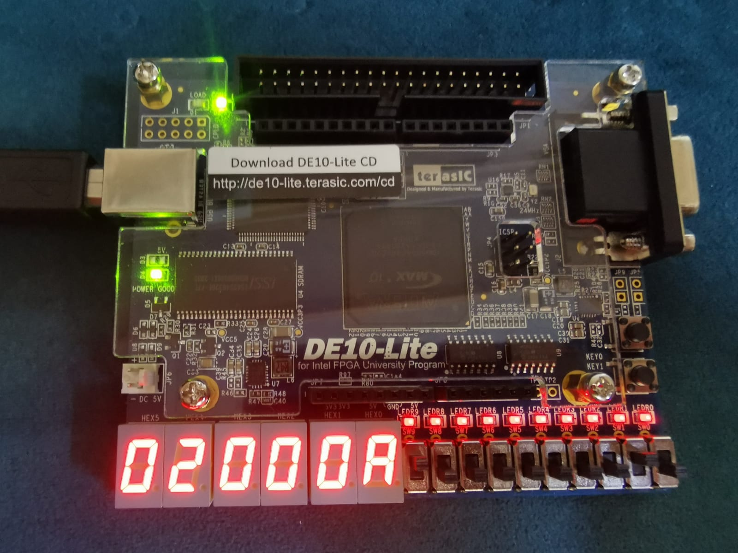

#### Register 3

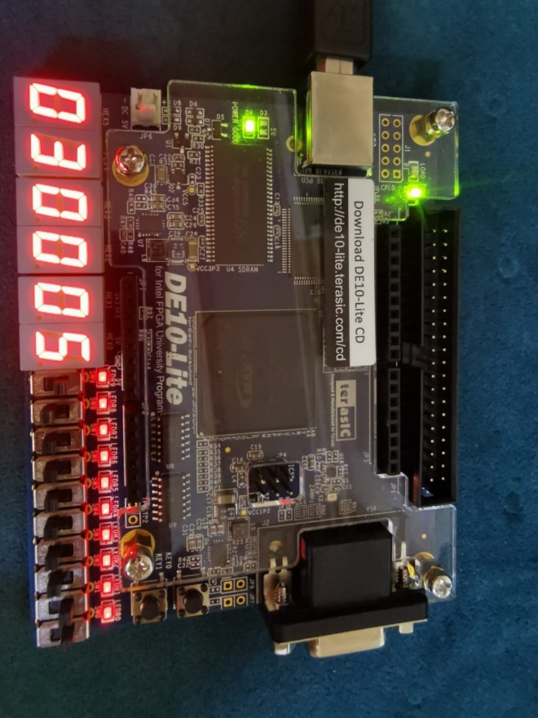

### Testcase 6

#### Register 1

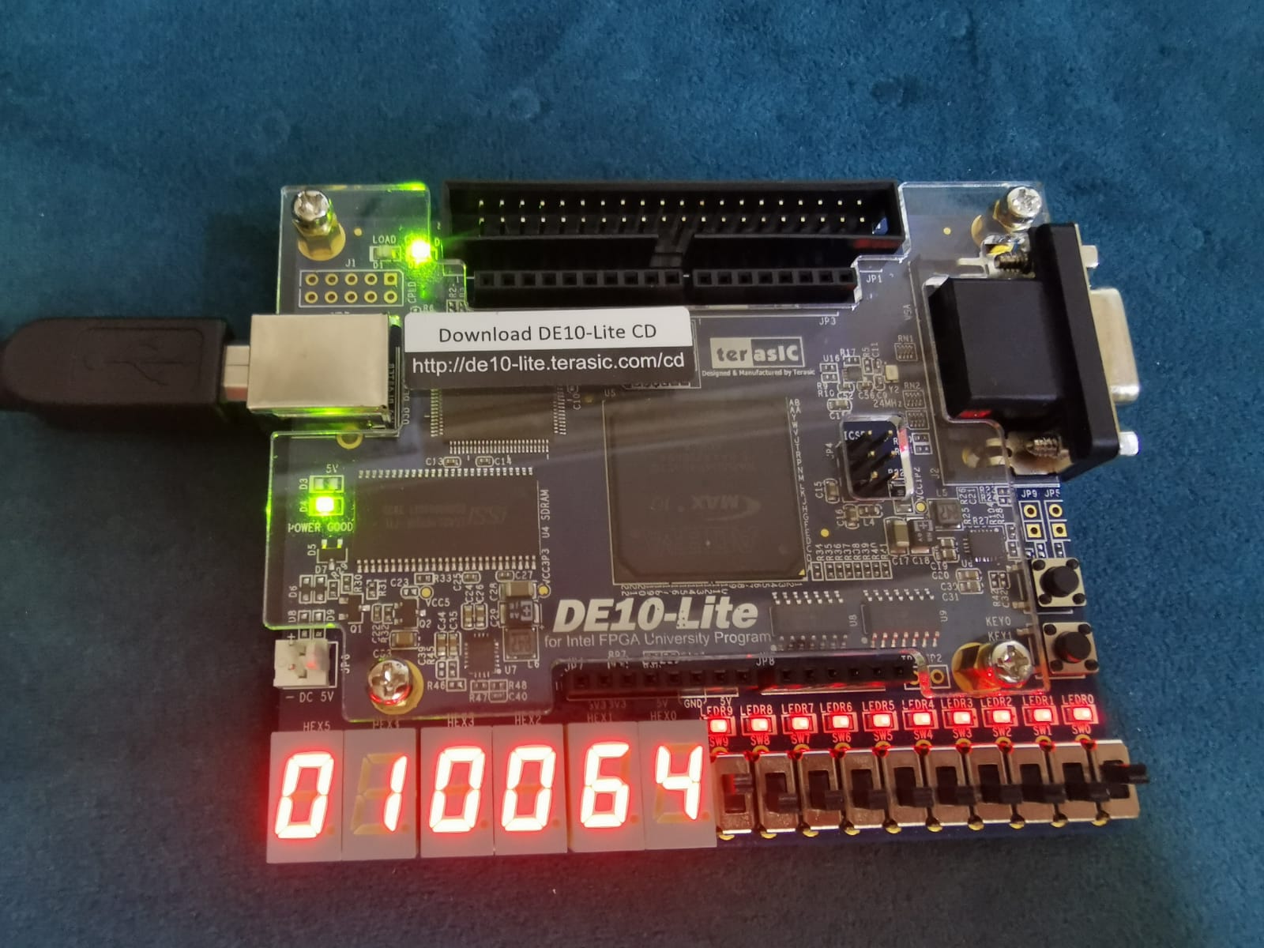

#### Register 3

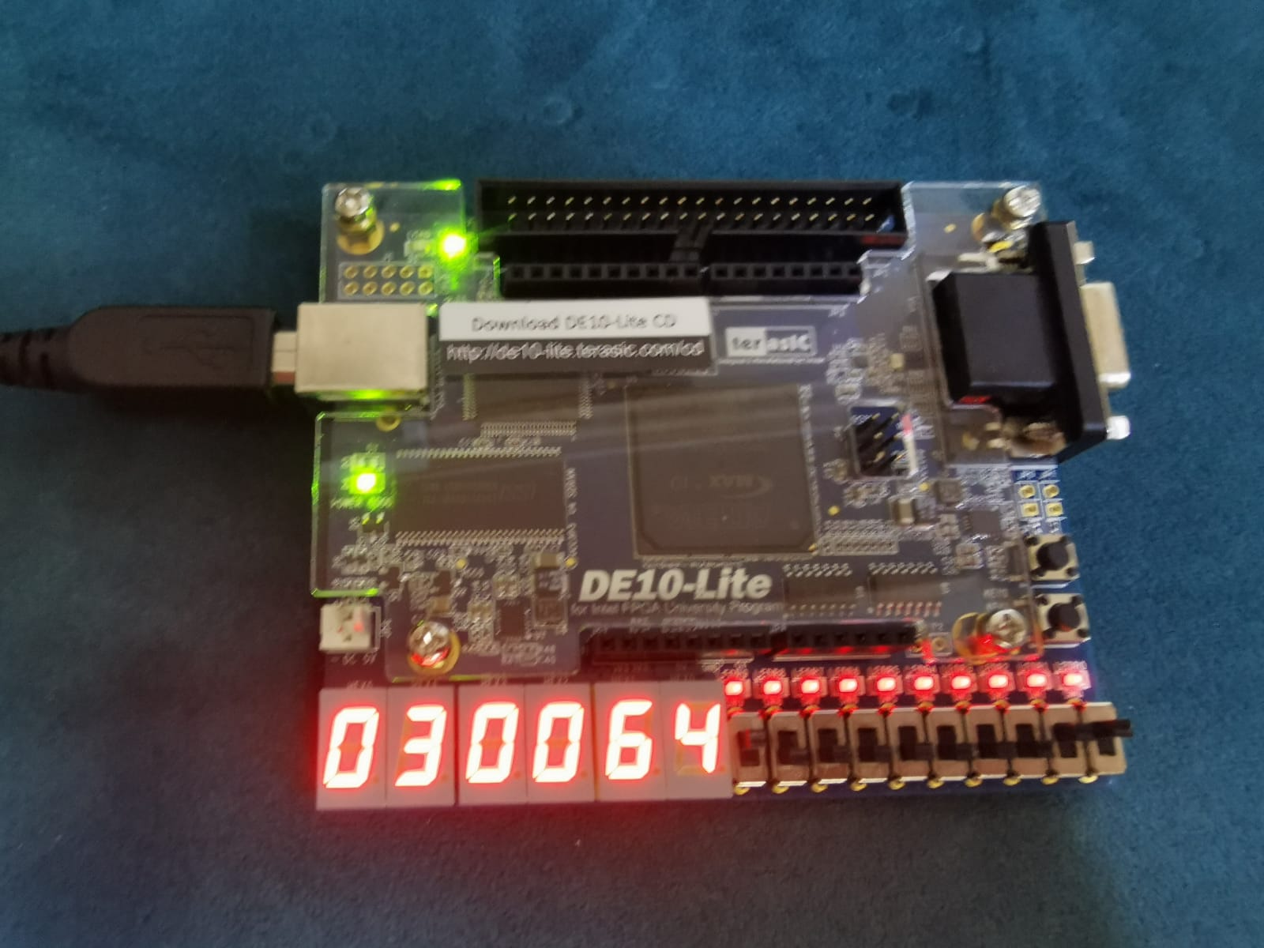

#### Register 9

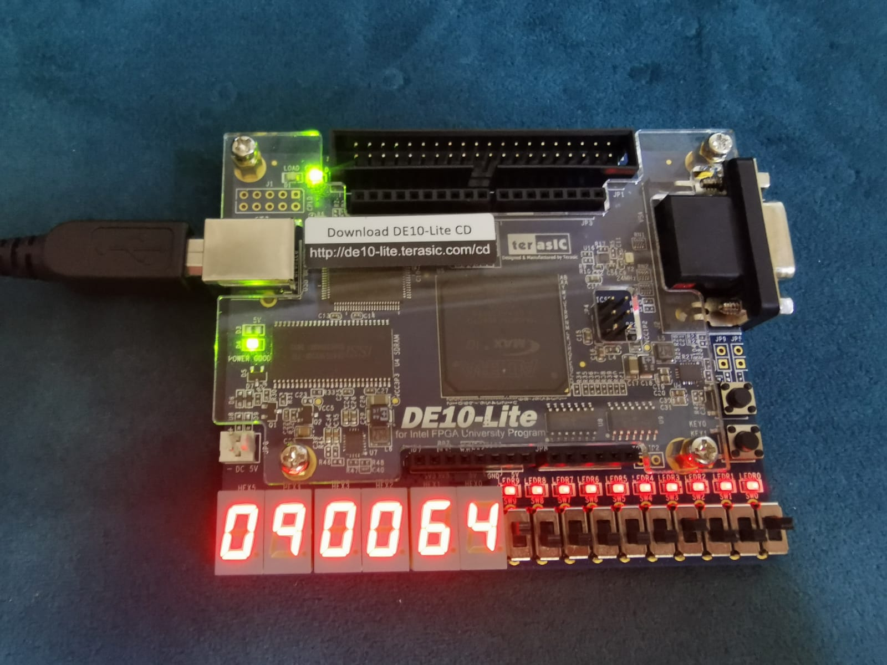

## Benchmark

### **Test case one**

#### Instruction memory and data memory

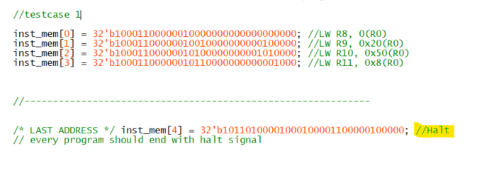

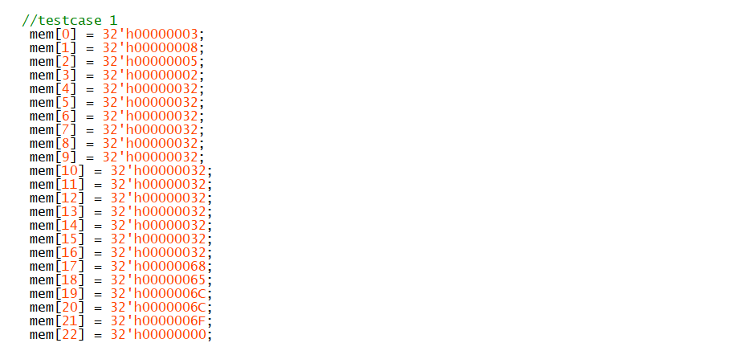

#### First interaction **LW R8, 0(R0) (CPU before execution**

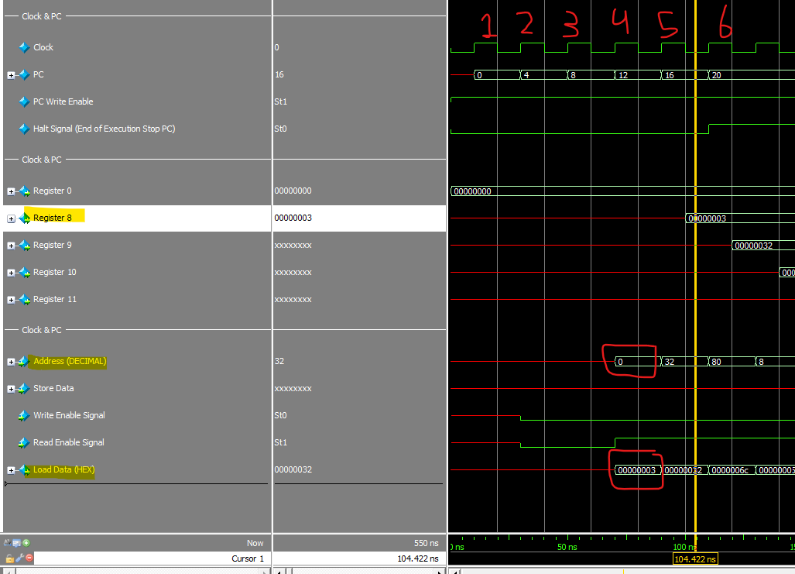

#### Halt

#### after execution the final values

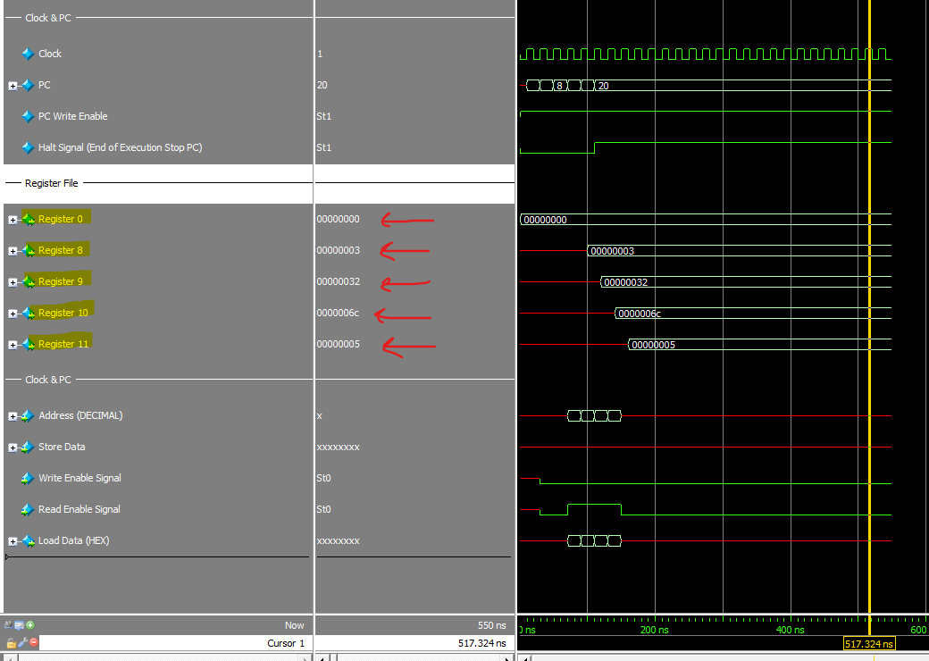

## **Test case 2**

### Data memory and instruction memory

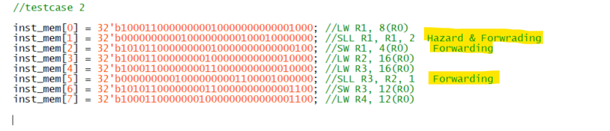

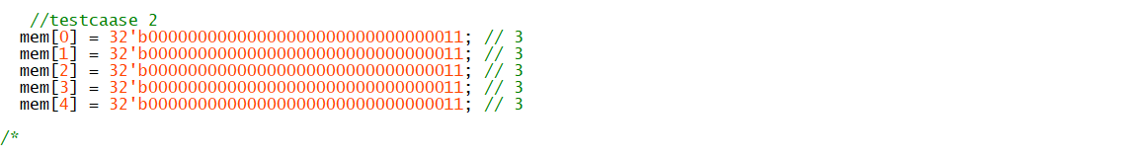

### Second Instruction SLL R1, R1, 2 Hazard Catch with stall cycle

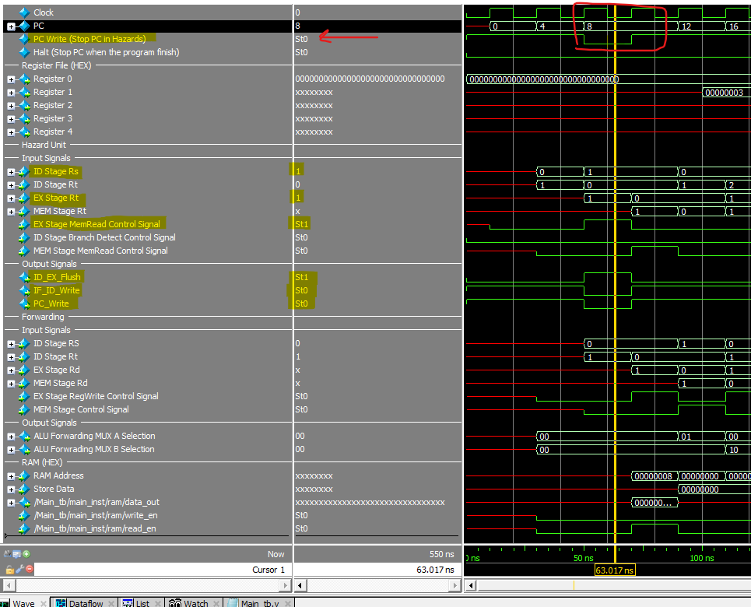

### Second Instruction SLL R1, R1, 2 MEM Stage Forwarding Catch

## 

## 

### CPU Stage After Execution

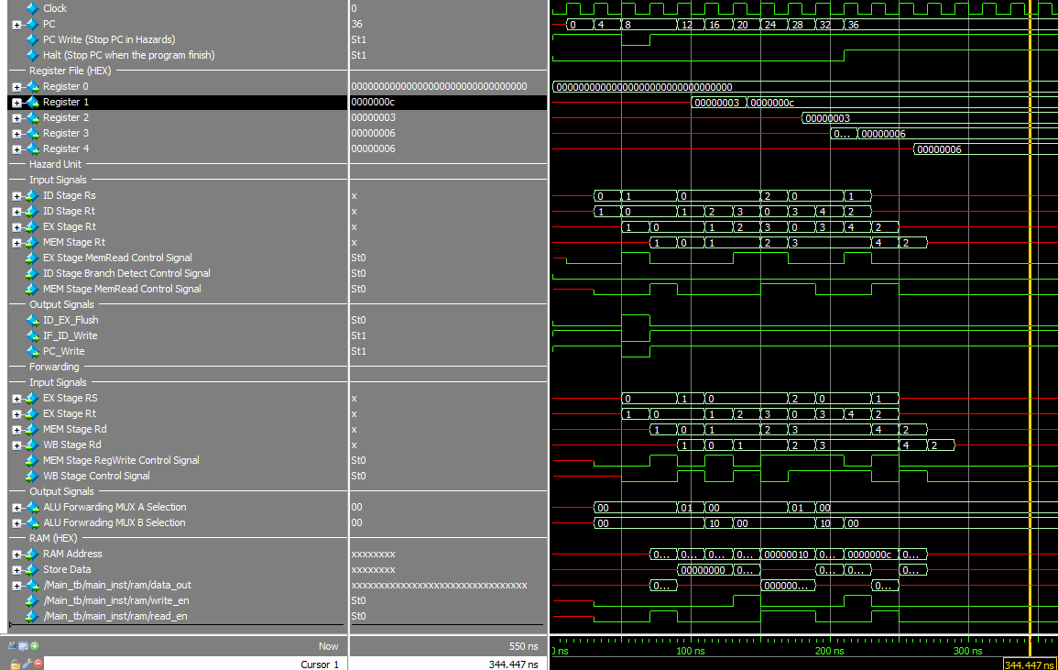

## Test case 3

### Instruction memory and data memory

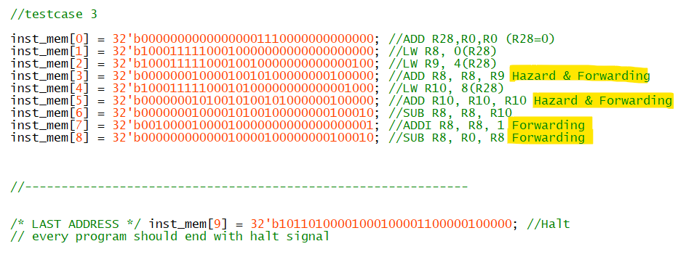

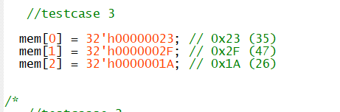

### First Three Instruction Execution.

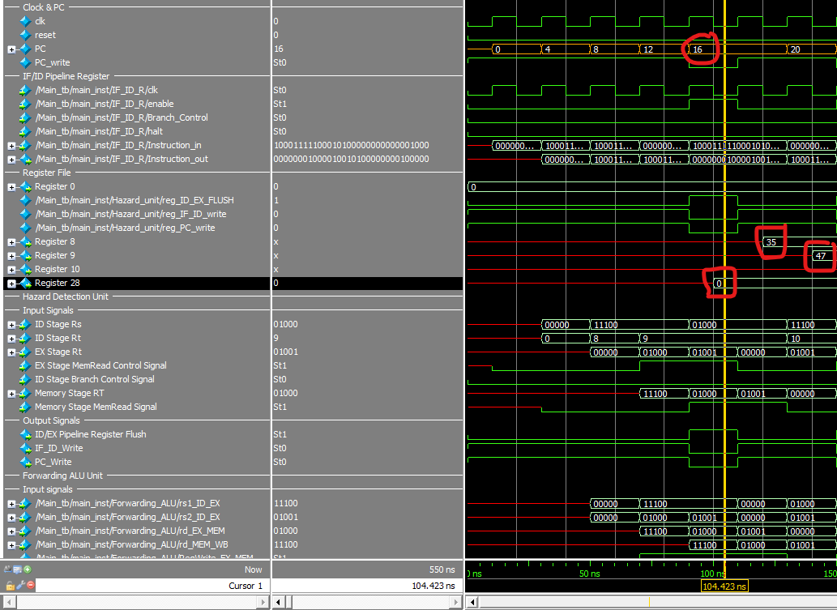

### Fourth Instruction ADD R8, R8, R9 Load_Use_Hazard Catch

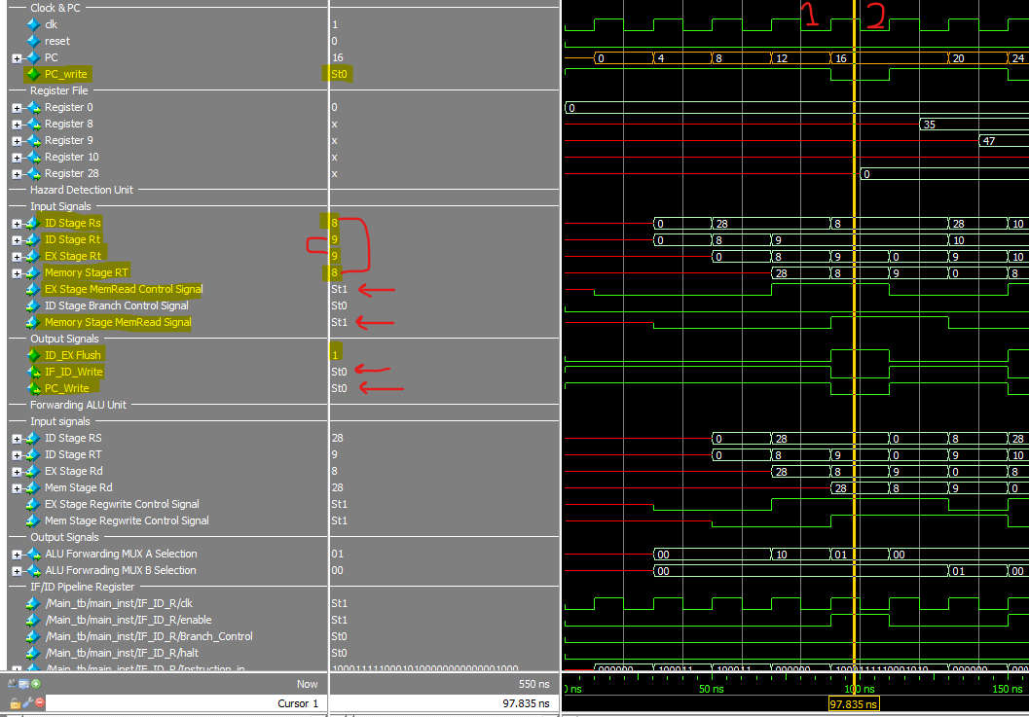

### Fourth Instruction Hazard End

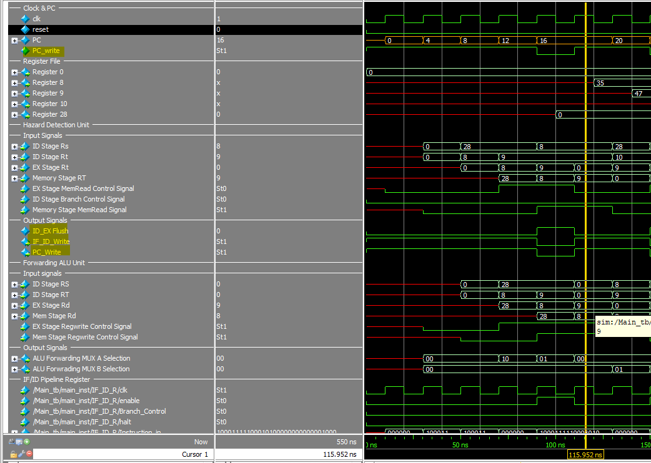

### eightest instruction ADDI R8, R8, 1 Forwarding EX Stage ALU Forwarding.

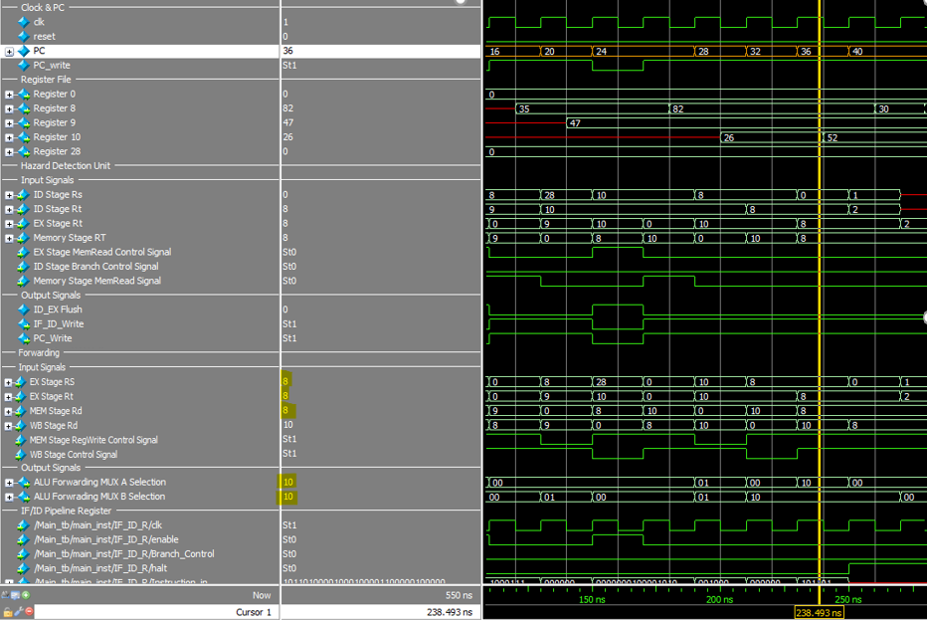

### the CPU after execution

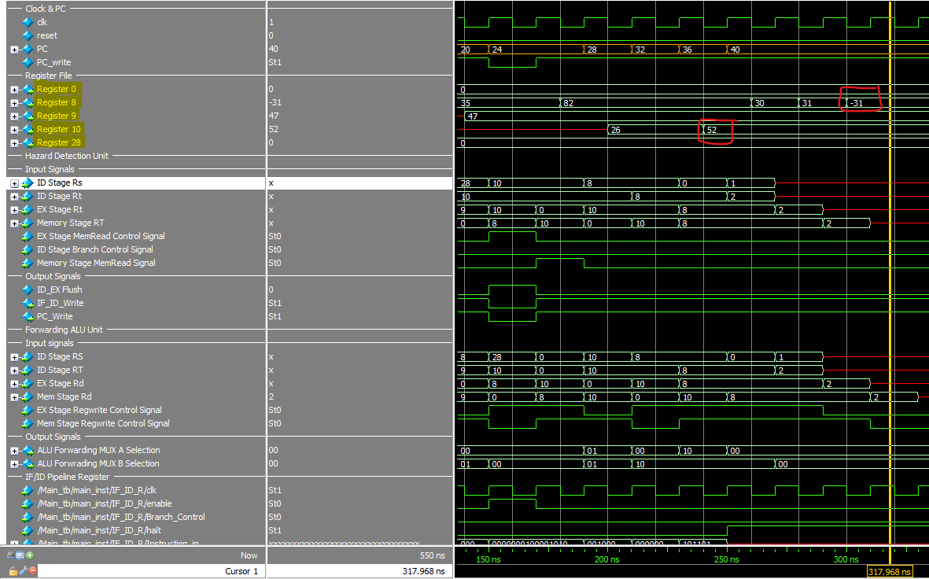

## **Test case 4**

### Instruction memory and data memory

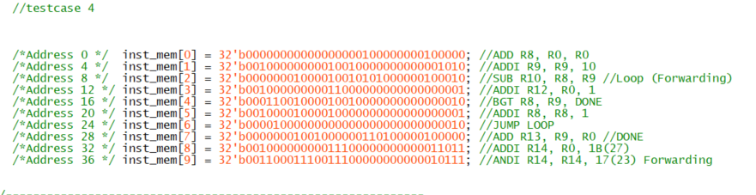



### First Jump Instruction Branch not Taken

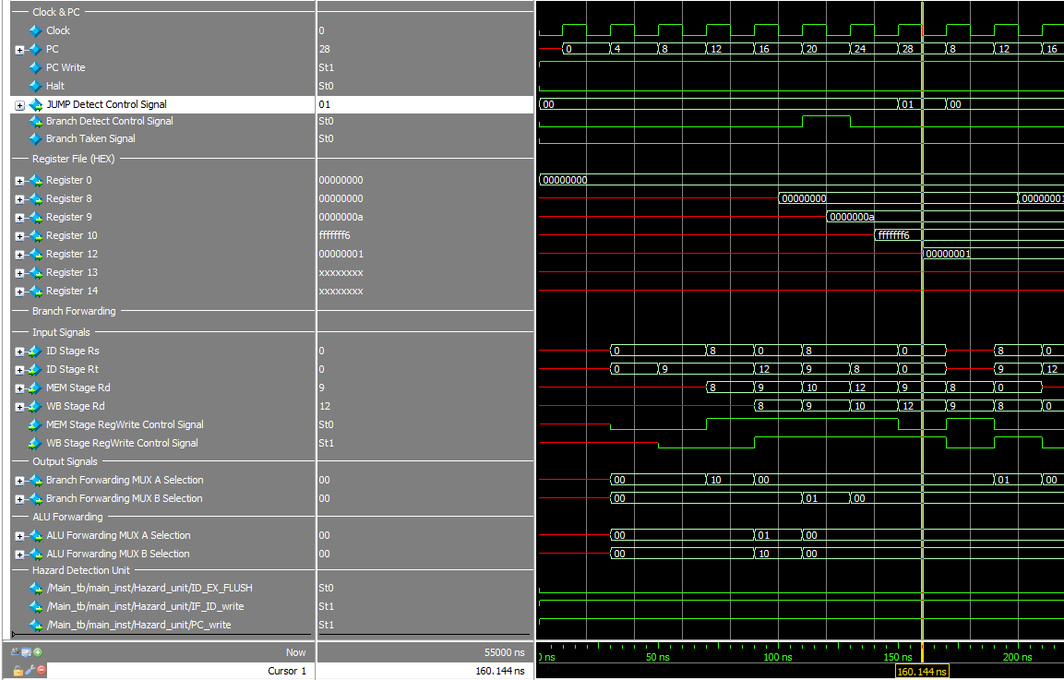

### Branch Taken last Branch Instruction

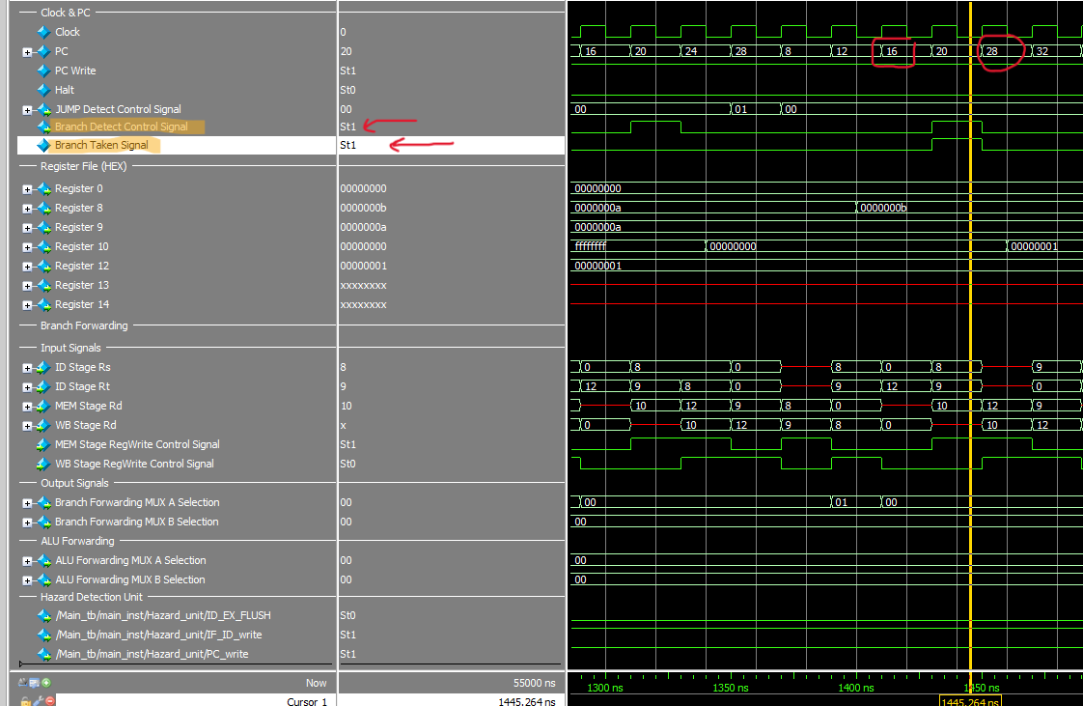

### CPU Status after execution

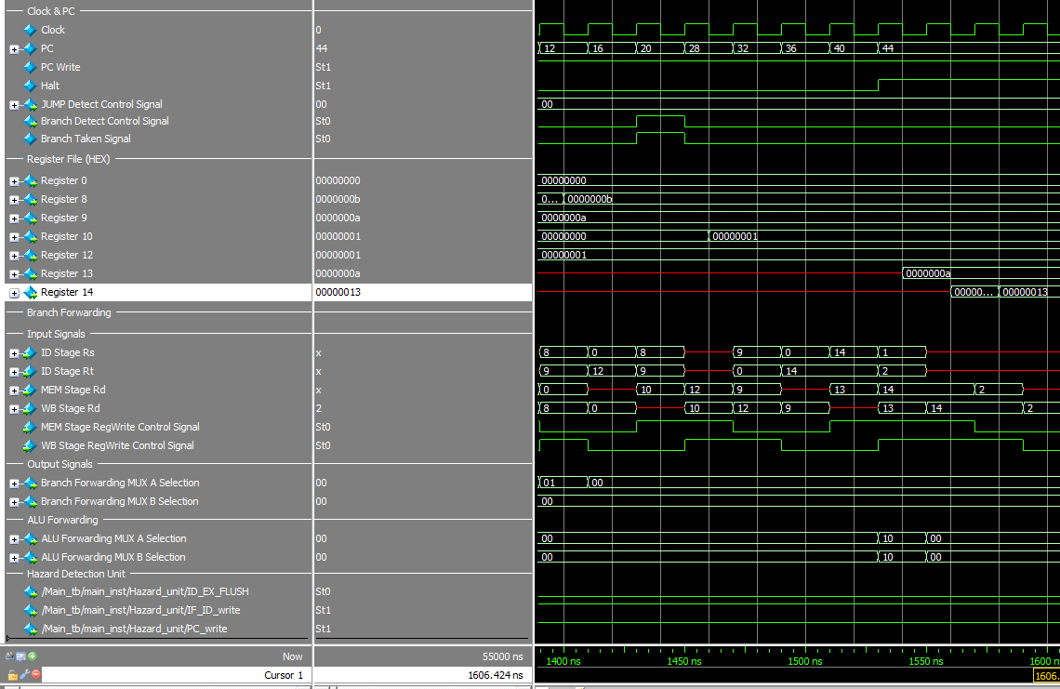

## **Test case 5**

### Instruction memory and data memory

### **No need for RAM**

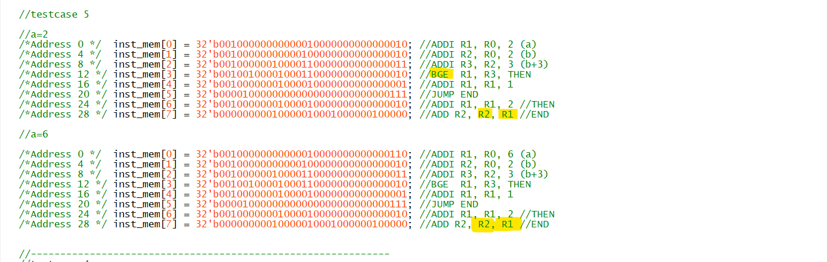

### When a =2

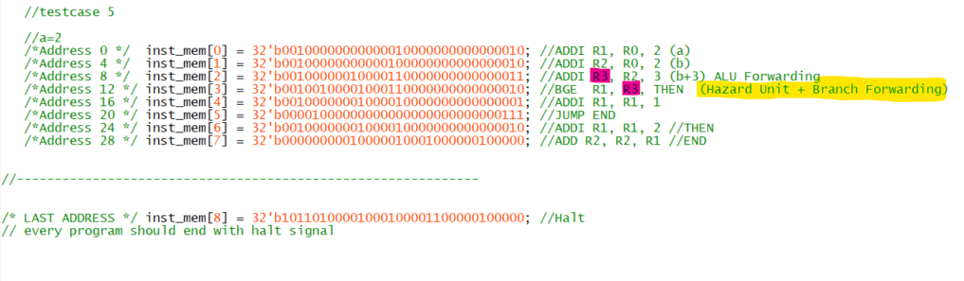

#### Fourth Instruction BGE R1, R3, THEN Hazard Detect

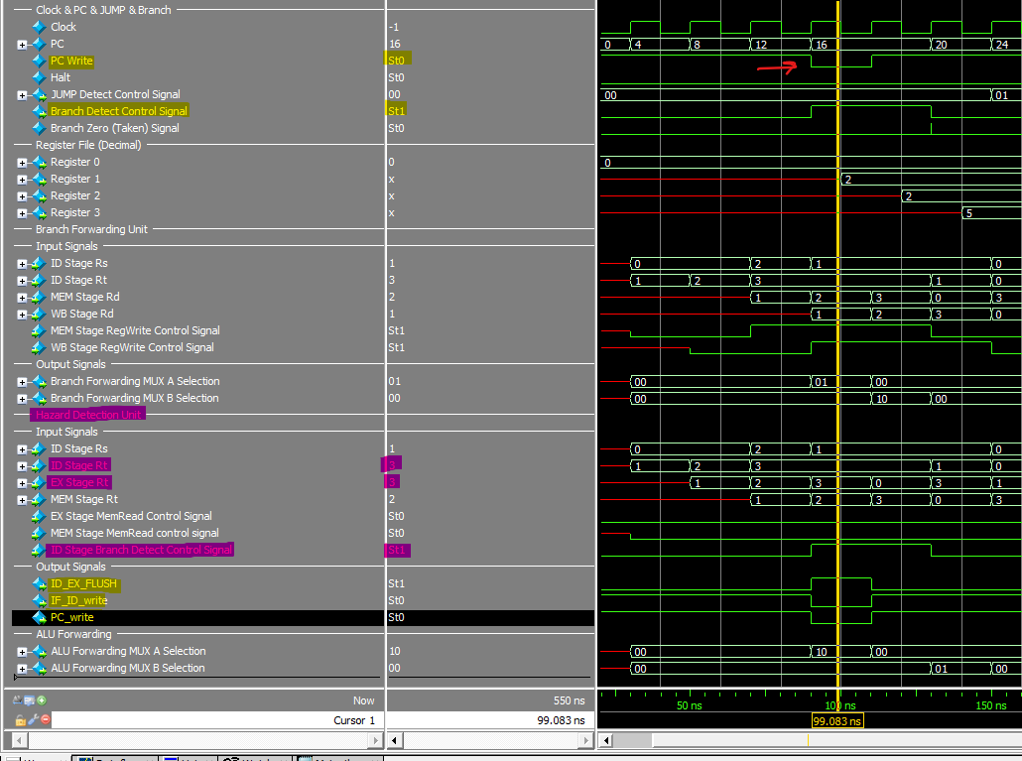

#### fourth Instruction BGE R1, R3, THEN Branch Not Taken with Branch Forwarding

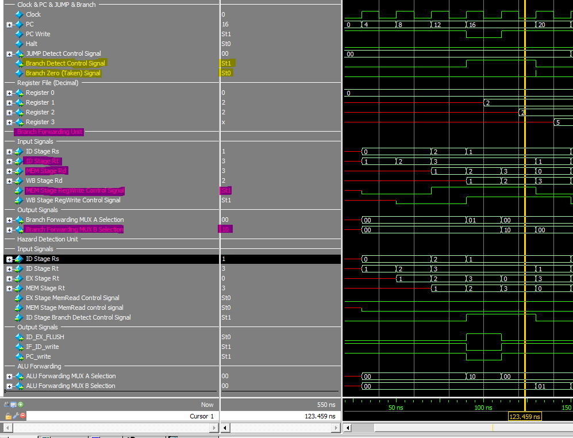

#### **CPU Status After execution**

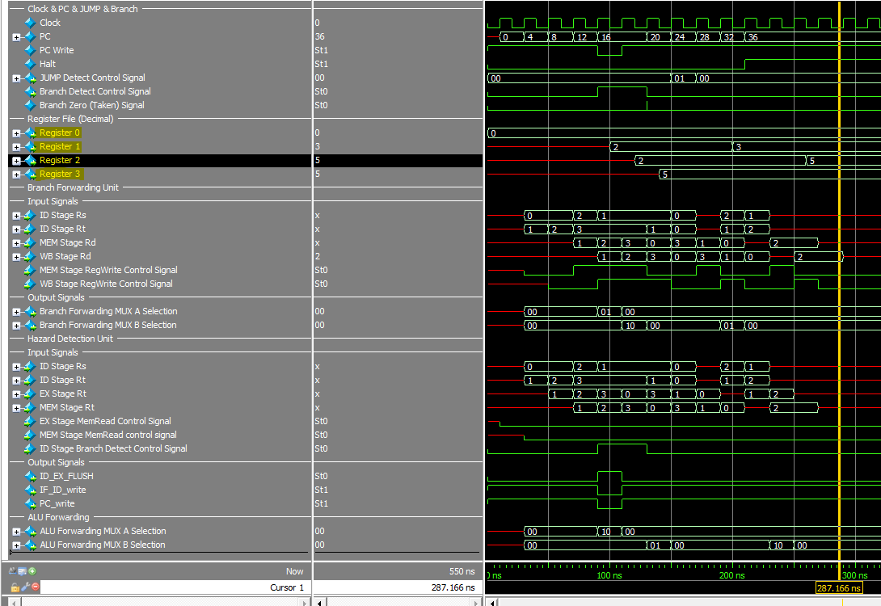

### When a =6

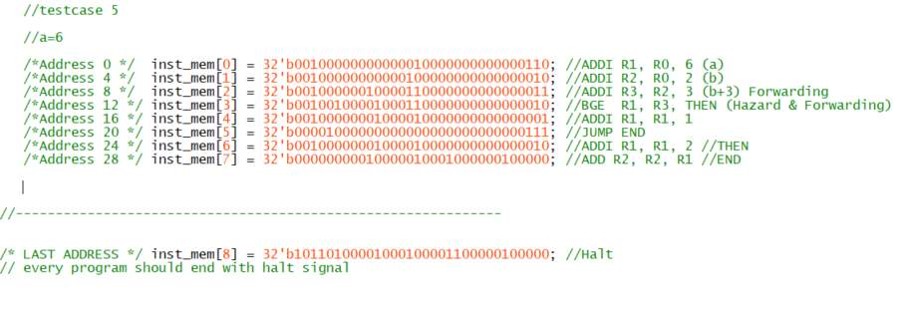

#### Fourth Instruction BGE R1,R3,Then Branch Taken Branch Forwarding Catch

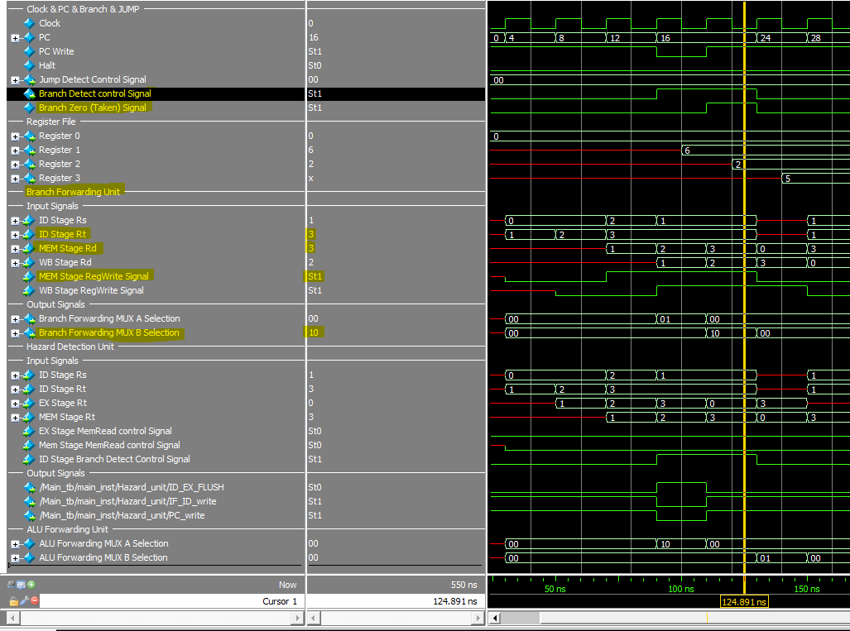

#### Fourth Instruction BGE R1, R3,THEN Hazard Catch

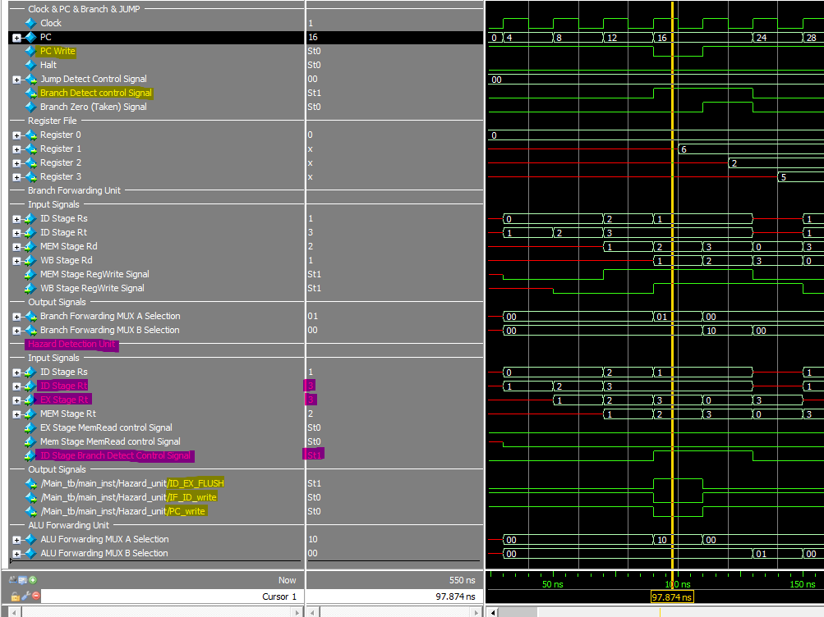

#### **CPU Status After execution**

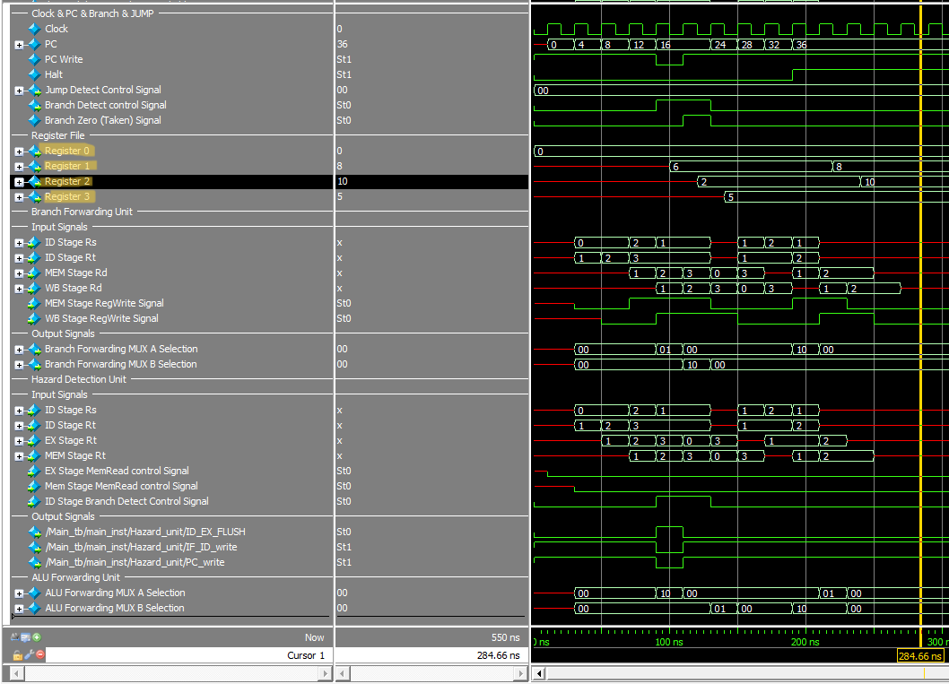

## **Test case 6**

### Instruction memory

**No need for RAM**

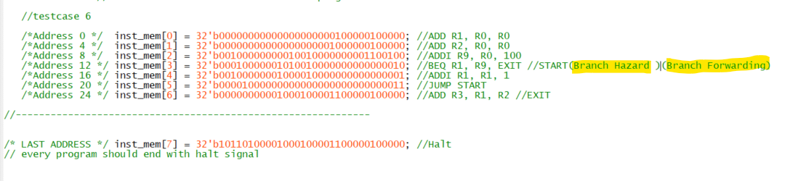

### First Branch BEQ R1, R9, EXIT Instruction Catch Branch Forwarding

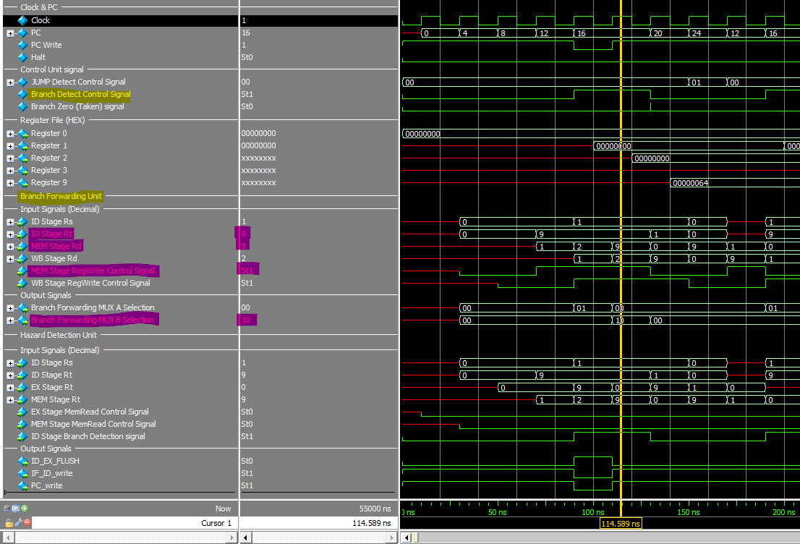

### First Branch BEQ R1, R9, EXIT Instruction Catch Branch Hazard

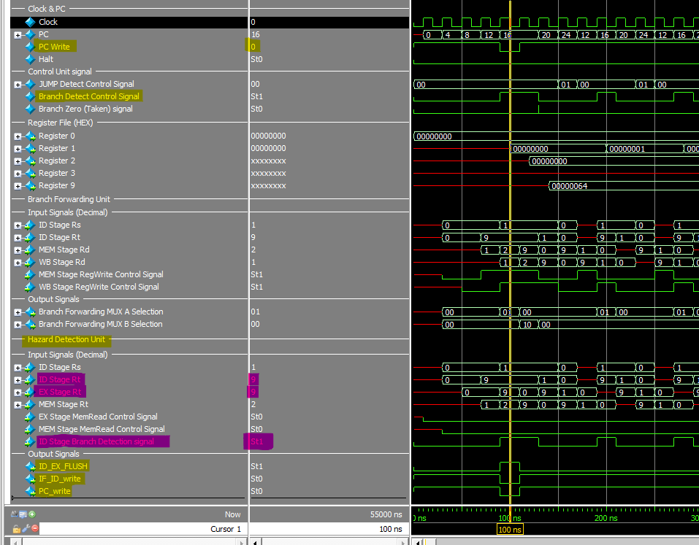

### the lase Iteration Branch Taken.

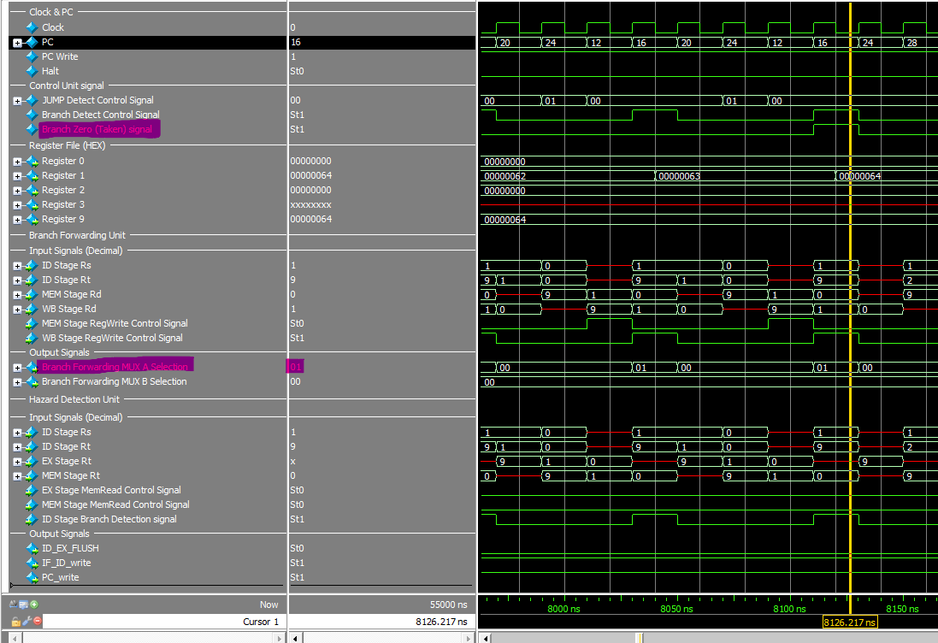

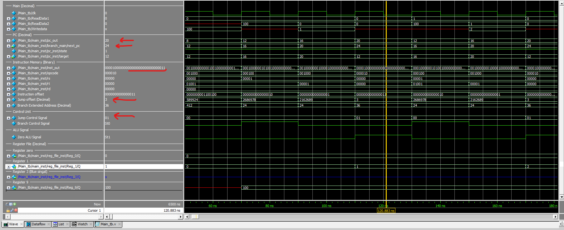

### The CPU Status After execution

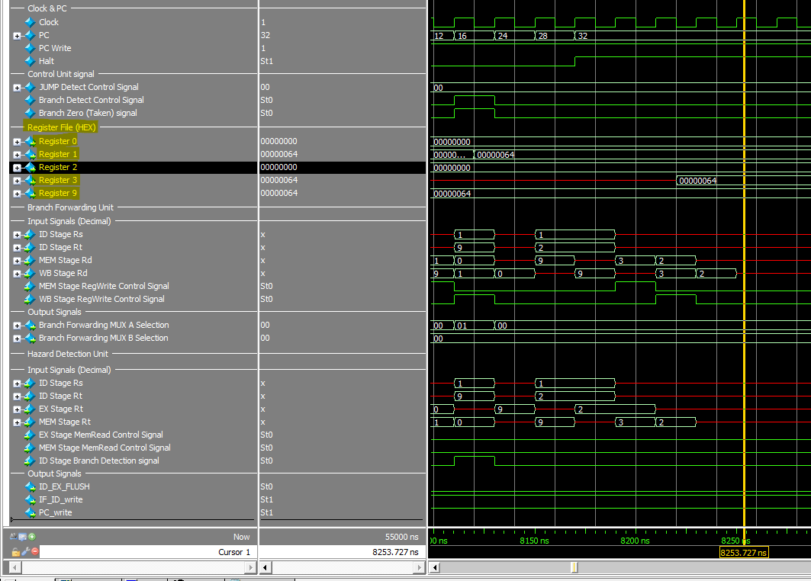

## special case JAL & JS

### Instruction Memory Values.

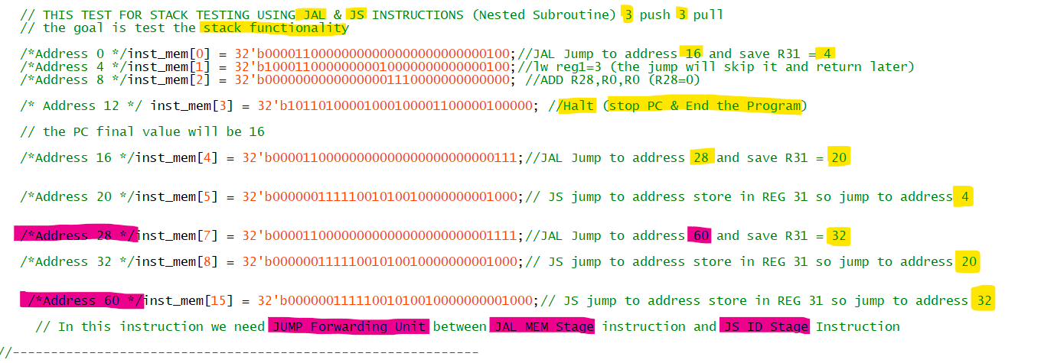

### Initial Value First Cycle

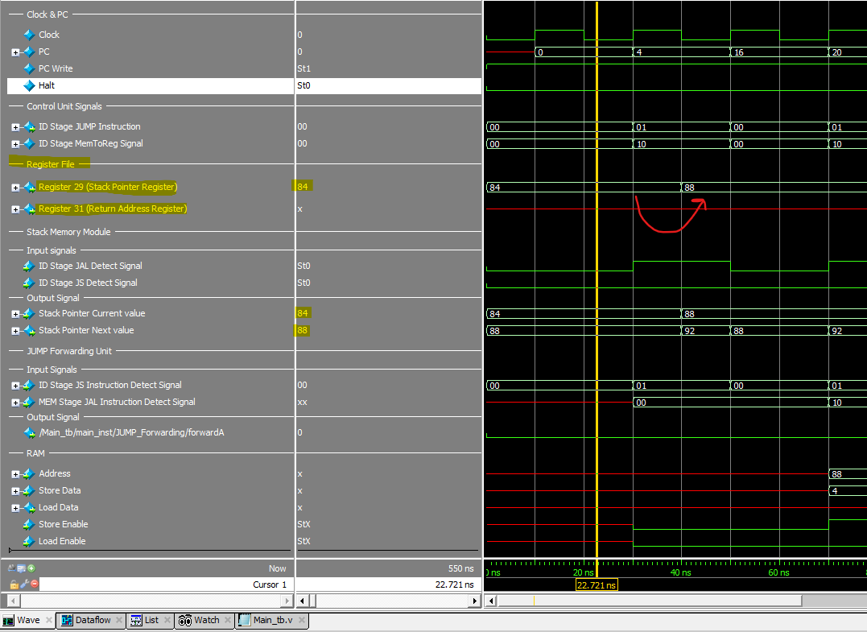

### First JAL Instruction

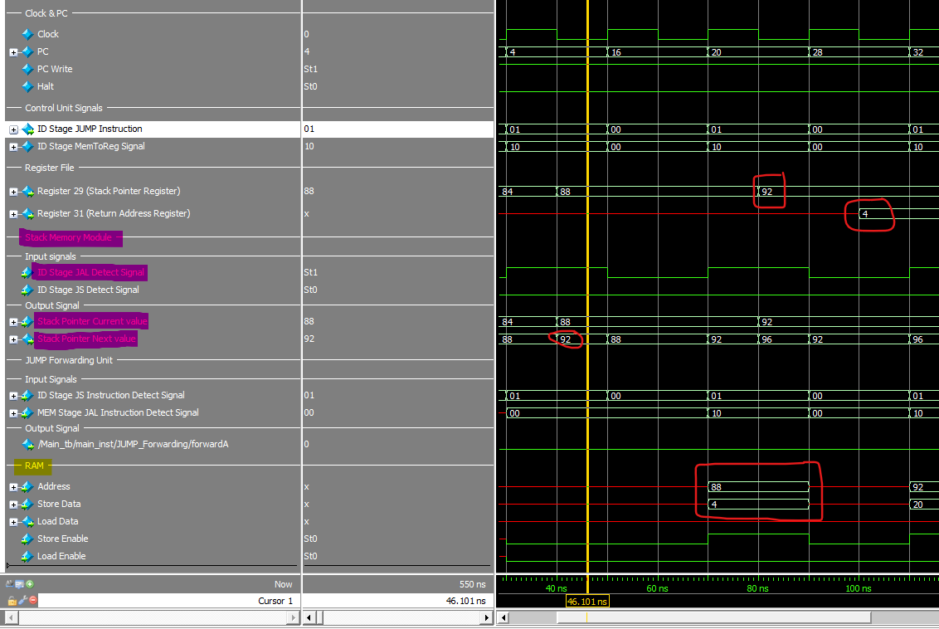

### First JS Instruction JUMP Forwarding

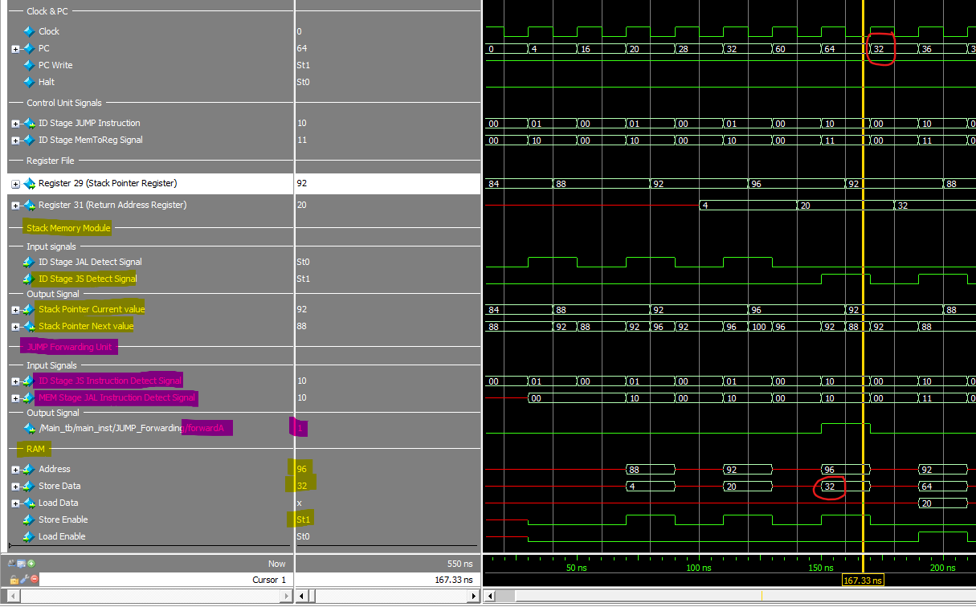

### First JAL Instruction



### Last JS Instruction

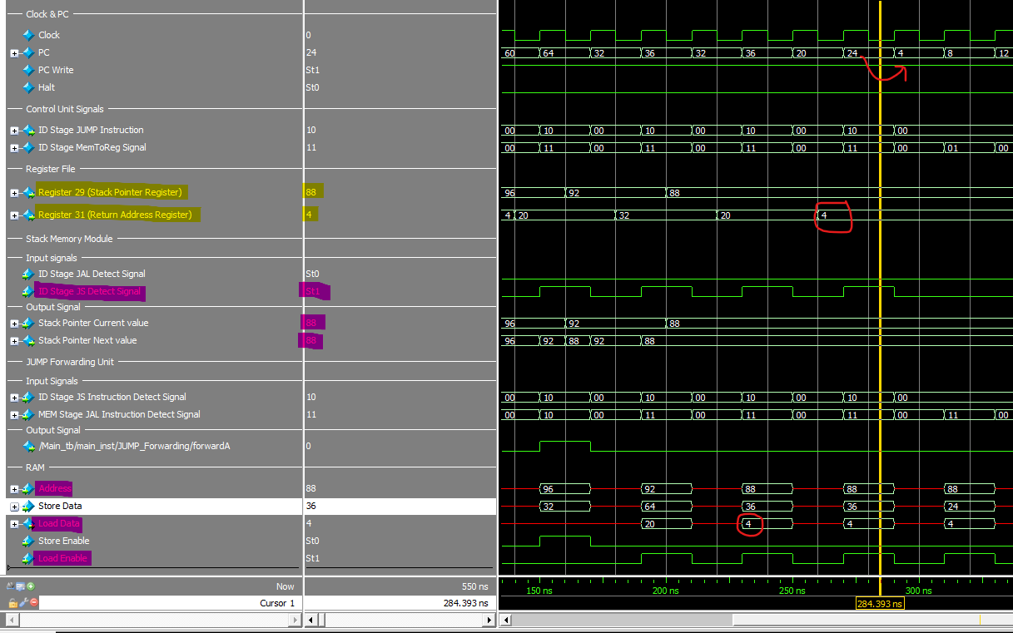

### CPU Status After Execution.

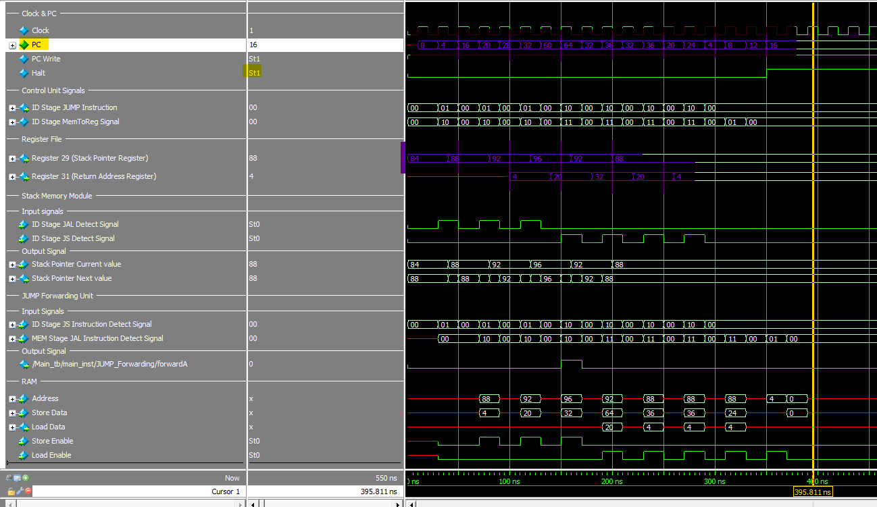

## **Clock testing**

As I mentioned earlier, this has been the most challenging part, but I'm proud that we've reached this point

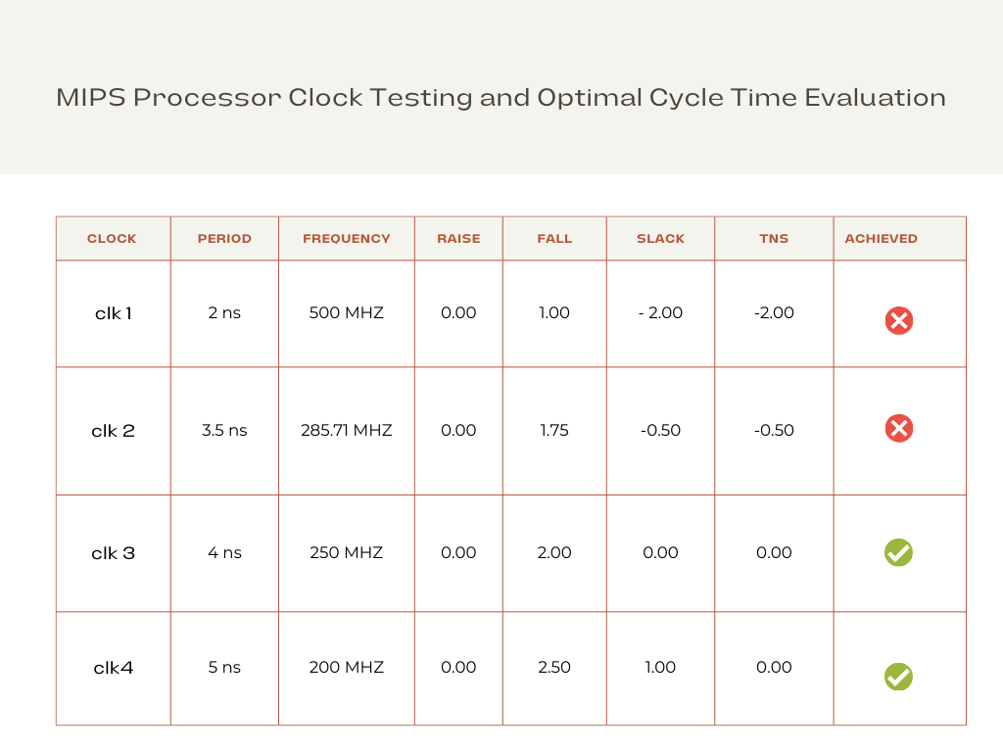

We have successfully finished the initial phase of constructing the single-cycle CPU. However, the branch component is still pending. We've complemented this phase with a robust testbench to ensure accuracy and functionality.

# Conclusion

The journey to design a single-cycle CPU, inspired by the venerable MIPS architecture, has led us to a comprehensive exploration of computer architecture, instruction execution, and the intricacies of CPU design. This endeavor has not only enriched our understanding of these fundamental concepts but has also yielded insights and a valuable educational resource for students and enthusiasts alike.

### Key Findings and Implications

Through this project, we have made several key findings and drawn implications:

1. Educational Resource: We have successfully created an educational resource that unravels the intricacies of CPU design. The project offers a detailed, step-by-step account of how a single-cycle CPU operates, emphasizing simplicity and clarity, making it accessible to a broad audience.
2. Simplicity and Efficiency: The MIPS-inspired single-cycle design demonstrates the power of simplicity and efficiency in CPU architecture. We have observed that by adhering to a reduced instruction set and single-cycle execution, it is possible to achieve transparency in the execution of instructions.
3. Performance Analysis: Our performance analysis revealed that the single-cycle CPU's execution time is generally quicker compared to other designs. However, this speed comes at the expense of resource utilization, and it may not be the most efficient choice for all applications.

### Project’s objectives achieved.

While our project has achieved its primary objectives(**build pipeline cpu with good cycle time),** there are avenues for future work and exploration:

1. Advanced Instructions: Expanding the instruction set to include more complex operations, such as floating-point arithmetic or SIMD instructions, would further enrich the educational value of the CPU model.
2. Out of order processor: Out-of-order processors are often found in high-performance computing environments and modern microprocessors where speed and efficiency are paramount.
3. TLB cache

# Appendix A: CODE

## PC (finite state machine)

­ module PC #(

parameter first_address = 0,

parameter pc_inc = 4

)(

input wire clk,

input wire reset,

input wire [31:0] target,

input wire pc_load,

output reg [31:0] pc

);

reg state = 1'b0;

always @(posedge clk or posedge reset) begin

if (reset) begin

pc <= 32'bxxxxxxxxxxxxxxxxxxxxxxxxxxxxxxxx;

state=1'b0;

end else begin

case (state)

1'b0: begin

state <= 1'b1;

pc <= first_address;

end

1'b1: begin

if (pc_load) begin

pc <= target;

end

end

default: begin

state <= 1'b0;

pc <= 32'h00000000;

end

endcase

end

end

endmodule

## ALU

module ALU(

input clk,

input [31:0] A, // 32-bit input A

input [31:0] B, // 32-bit input B

input [3:0] ALUControl, // 4-bit ALU control

input [4:0] ShiftAmount, // 5-bit input for shift amount

input [2:0] branch_type,

output reg [31:0] ALUOut, // 32-bit output

output reg Zero // Zero flag

// output reg Overflow, // Overflow flag

// output reg CarryOut // Carry-out flag

);

reg Overflow;

reg CarryOut;

//reg [31:0] ALUOut;

/*

addu

subu

*/

always @(*) begin

case(ALUControl)

4'b0000: ALUOut <= A + B; // Addition (signed)

4'b0001: ALUOut <= A - B; // Subtraction (signed)

4'b0010: ALUOut <= A * B; // Multiplication (signed)

4'b0011: ALUOut <= A / B; // Division (signed/unsigned)

4'b0100: ALUOut <= A << ShiftAmount; // Logical shift left

4'b0101: ALUOut <= A >> ShiftAmount; // Logical shift right

4'b0110: ALUOut <= A + B; // addu

4'b0111: ALUOut <= A - B; // subu

4'b1000: ALUOut <= A & B; // Logical AND

4'b1001: ALUOut <= A | B; // Logical OR

4'b1010: ALUOut <= A ^ B; // Logical XOR

4'b1011: ALUOut <= ~(A | B); // Logical NOR

4'b1100: ALUOut <= (branch_type == 3'b101) ? (A >= B) ? 32'b1 : 32'b0 :

(branch_type == 3'b110) ? (A <= B) ? 32'b1 : 32'b0 : 32'b0;

4'b1101: ALUOut <= (A < B) ? 32'b1 : 32'b0; // less than

4'b1110: ALUOut <= (A > B) ? 32'b1 : 32'b0; // greater than

// 4'b1111: ALUOut <= (A == B) ? 32'b1 : 32'b0; // Equal comparison ERROR

default: ALUOut <= 32'b0; // Default operation

endcase

end

always @(*) begin

if (ALUControl == 4'b0000) begin // Addition (signed)

Overflow <= (A[31] == B[31] && A[31] != ALUOut[31]);

CarryOut <= (A[31] & B[31]) | (A[31] & ALUOut[31]) | (B[31] & ALUOut[31]);

end else if (ALUControl == 4'b0001) begin // Subtraction (signed)

Overflow <= (A[31] != B[31] && A[31] != ALUOut[31]);

CarryOut <= (A[31] & B[31]) | (A[31] & ALUOut[31]) | (B[31] & ALUOut[31]);

end else if (ALUControl == 4'b0010) begin // Multiplication (signed)

Overflow <= (A[31] == B[31] && A[31] != ALUOut[31]);

CarryOut <= 1'b0; // No carry-out for multiplication

end else if (ALUControl == 4'b0011) begin // Division (signed/unsigned)

Overflow <= (B == 32'b0); // Detect division by zero

CarryOut <= 1'b0;

end else if ((ALUOut < A) && (ALUOut < B) && (ALUControl == 4'b0110)) begin

Overflow <= 1'b0;

CarryOut <= 1'b1;

end else begin

Overflow <= 1'b0;

CarryOut <= 1'b0;

end

end

/*

always @* begin

if (Overflow && (ALUControl != 0110) && (ALUControl != 0111)) begin //signed overflow check

ALUOut = 32'bx;

end else if(CarryOut && ((ALUControl == 4'b0110) || (ALUControl == 4'b0111))) begin //unsigned overflow check

ALUOut = 32'bx;

end

end*/

always @(*) begin

case(branch_type)

3'b001: Zero <= (ALUOut == 32'b0) ? 1'b1 : 1'b0; // beq

3'b010: Zero <= (ALUOut != 32'b0) ? 1'b1 : 1'b0; // bne

3'b011: Zero <= (ALUOut == 32'b1) ? 1'b1 : 1'b0; // bgt

3'b100: Zero <= (ALUOut == 32'b1) ? 1'b1 : 1'b0; // blt

3'b101: Zero <= (ALUOut == 32'b1) ? 1'b1 : 1'b0; // bge

3'b110: Zero <= (ALUOut == 32'b1) ? 1'b1 : 1'b0; // ble

default: Zero <= 1'b0;

endcase

end

endmodule

## Control unit

module ControlUnit(Clock,Reset,opcode,RegDst,ALUSrc,MemtoReg,MemWrite,MemRead,ALUOp,RegWrite,Branch,Jump,funct,pc_load,PC_Store);

input wire [5:0] opcode;

input Clock , Reset ; // Reset : 1 --> on | 0--> off

input wire [5:0] funct;

// wires

output wire ALUSrc,MemWrite,MemRead,RegWrite,Branch,PC_Store;

output wire [3:0] ALUOp;

output wire [1:0] Jump;

output wire [1:0] MemtoReg;

output wire [1:0] RegDst;

output wire pc_load;

// reg type

reg reg_ALUSrc,reg_MemWrite,reg_MemRead,reg_RegWrite,reg_Branch,reg_PC_Store;

reg [3:0] reg_ALUOp;

reg [1:0] reg_Jump;

reg [1:0] reg_MemtoReg;

reg [1:0] reg_RegDst;

reg reg_pc_load;

reg [5:0] reset_opcode ;

// opcode, // 6-bit opcode from the instruction

// RegDst, // Control signal for selecting the destination register

// ALUSrc, // Control signal for ALU source selection (0 for register, 1 for immediate)

// MemtoReg, // Control signal for selecting the source for register write data

// MemWrite, // Control signal for memory write

// MemRead, // Control signal for memory read

// Branch, // Control signal for branching

// ALUOp, // Control signal for ALU operation

// RegWrite // Control signal for register write

// reset_reg // will handle the default value if the reset is on

// pc_load (0->stall),(1->load)

always @(*)

begin

if(Reset==1'b1)

reset_opcode <=6'b111000; // this bits will call the default value and make the control unit reset

else

reset_opcode <=opcode;

end

always @(*)

if(Reset==1'b1)begin

// defualt value we can use it if we will implement reset or unsupported instructions

reg_ALUSrc = 1'b0;

reg_RegWrite = 1'b0;

reg_MemtoReg = 2'b00;

reg_MemWrite = 1'b0;

reg_MemRead = 1'b0;

reg_ALUOp = 4'b0000;

reg_RegDst = 2'b00;

reg_Branch = 1'b0;

reg_Jump = 2'b00;

reg_pc_load = 1'b0;

reg_PC_Store = 1'b0;

end

else begin

case(opcode)

6'b000000:begin

if(funct == 6'b001000)begin

//Jump Register instruction

reg_ALUSrc = 1'bx;

reg_RegWrite = 1'b0;

reg_MemtoReg = 2'bxx;

reg_MemWrite = 1'b0;

reg_MemRead = 1'bx;

reg_ALUOp = 4'bxxxx;

reg_RegDst = 2'bxx;

reg_Branch = 1'bx;

reg_Jump = 2'b10;

reg_pc_load = 1'b1;//load

reg_PC_Store = 1'b0;

end

else begin

// R-type instruction

reg_ALUSrc = 1'b0;

reg_RegWrite = 1'b1;

reg_MemtoReg = 2'b00;

reg_MemWrite = 1'b0;

reg_MemRead = 1'b0;

reg_ALUOp = 4'b0010;

reg_RegDst = 2'b01;

reg_Branch = 1'b0;

reg_Jump = 2'b00;

reg_pc_load = 1'b1;

reg_PC_Store = 1'b0;

end

end

6'b100011:begin

// load instruction

reg_ALUSrc = 1'b1;

reg_RegWrite = 1'b1;

reg_MemtoReg = 2'b01;

reg_MemWrite = 1'b0;

reg_MemRead = 1'b1;

reg_ALUOp = 4'b0000;

reg_RegDst = 2'b00;

reg_Branch = 1'b0;

reg_Jump = 2'b00;

reg_pc_load = 1'b1;

reg_PC_Store = 1'b0;

end

6'b101011:begin

// store instruction

reg_ALUSrc = 1'b1;

reg_RegWrite = 1'b0;

reg_MemtoReg = 2'b00; //error (should be 0 ) i am an idiot ...*****

reg_MemWrite = 1'b1;

reg_MemRead = 1'b0;

reg_ALUOp = 4'b0000;

reg_RegDst = 2'b00; //don't care

reg_Branch = 1'b0;

reg_Jump = 2'b00;

reg_pc_load = 1'b1;

reg_PC_Store = 1'b0;

end

6'b001000:begin

//immediate instruction (addi)

reg_ALUSrc = 1'b1;

reg_RegWrite = 1'b1;

reg_MemtoReg = 2'b00;

reg_MemWrite = 1'b0;

reg_MemRead = 1'b0;

reg_ALUOp = 4'b0000;

reg_RegDst = 2'b00;

reg_Branch = 1'b0;

reg_Jump = 2'b00;

reg_pc_load = 1'b1;

reg_PC_Store = 1'b0;

end

6'b001100:begin

//immediate instruction (andi)

reg_ALUSrc = 1'b1;

reg_RegWrite = 1'b1;

reg_MemtoReg = 2'b00;

reg_MemWrite = 1'b0;

reg_MemRead = 1'b0;

reg_ALUOp = 4'b0001;

reg_RegDst = 2'b00;

reg_Branch = 1'b0;

reg_Jump = 2'b00;

reg_pc_load = 1'b1;

reg_PC_Store = 1'b0;

end

6'b001101:begin

//immediate instruction (ori)

reg_ALUSrc = 1'b1;

reg_RegWrite = 1'b1;

reg_MemtoReg = 2'b00;

reg_MemWrite = 1'b0;

reg_MemRead = 1'b0;

reg_ALUOp = 4'b0011;

reg_RegDst = 2'b00;

reg_Branch = 1'b0;

reg_Jump = 2'b00;

reg_pc_load = 1'b1;

reg_PC_Store = 1'b0;

end

6'b000010:begin

//Jump instruction (j)

reg_ALUSrc = 1'bx;

reg_RegWrite = 1'b0;

reg_MemtoReg = 2'bxx;

reg_MemWrite = 1'b0;

reg_MemRead = 1'bx;

reg_ALUOp = 4'bxxxx;

reg_RegDst = 2'bxx;

reg_Branch = 1'b0;

reg_Jump = 2'b01;

reg_pc_load = 1'b1;

reg_PC_Store = 1'b0;

reg_PC_Store = 1'b0;

end

6'b000011:begin

//Jump and link instruction (jal)

reg_ALUSrc = 1'bx;

reg_RegWrite = 1'b1;

reg_MemtoReg = 2'b10;

reg_MemWrite = 1'b0;

reg_MemRead = 1'bx;

reg_ALUOp = 4'bxxxx;

reg_RegDst = 2'b10;

reg_Branch = 1'bx;

reg_Jump = 2'b01;

reg_pc_load = 1'b1;

reg_PC_Store = 1'b1;

end

6'b000100:begin

//branch equal

reg_ALUSrc = 1'b0;

reg_RegWrite = 1'b0;

reg_MemtoReg = 2'bxx;

reg_MemWrite = 1'b0;

reg_MemRead = 1'bx;

reg_ALUOp = 4'b0100;

reg_RegDst = 2'bxx;

reg_Branch = 1'b1;

reg_Jump = 2'b00;

reg_pc_load = 1'b1;

reg_PC_Store = 1'b0;

end

6'b000101:begin

//branch not equal

reg_ALUSrc = 1'b0;

reg_RegWrite = 1'b0;

reg_MemtoReg = 2'bxx;

reg_MemWrite = 1'b0;

reg_MemRead = 1'bx;

reg_ALUOp = 4'b0101;

reg_RegDst = 2'bxx;

reg_Branch = 1'b1;

reg_Jump = 2'b00;

reg_pc_load = 1'b1;

reg_PC_Store = 1'b0;

end

6'b000110:begin

//branch greater than

reg_ALUSrc = 1'b0;

reg_RegWrite = 1'b0;

reg_MemtoReg = 2'bxx;

reg_MemWrite = 1'b0;

reg_MemRead = 1'bx;

reg_ALUOp = 4'b0110;

reg_RegDst = 2'bxx;

reg_Branch = 1'b1;

reg_Jump = 2'b00;

reg_pc_load = 1'b1;

reg_PC_Store = 1'b0;

end

6'b000111:begin

//branch less than

reg_ALUSrc = 1'b0;

reg_RegWrite = 1'b0;

reg_MemtoReg = 2'bxx;

reg_MemWrite = 1'b0;

reg_MemRead = 1'bx;

reg_ALUOp = 4'b0111;

reg_RegDst = 2'bxx;

reg_Branch = 1'b1;

reg_Jump = 2'b00;

reg_pc_load = 1'b1;

reg_PC_Store = 1'b0;

end

6'b001001:begin

//branch greater or equal

reg_ALUSrc = 1'b0;

reg_RegWrite = 1'b0;

reg_MemtoReg = 2'bxx;

reg_MemWrite = 1'b0;

reg_MemRead = 1'bx;

reg_ALUOp = 4'b1000;

reg_RegDst = 2'bxx;

reg_Branch = 1'b1;

reg_Jump = 2'b00;

reg_pc_load = 1'b1;

reg_PC_Store = 1'b0;

end

6'b001010:begin

//branch less or equal

reg_ALUSrc = 1'b0;

reg_RegWrite = 1'b0;

reg_MemtoReg = 2'bxx;

reg_MemWrite = 1'b0;

reg_MemRead = 1'bx;

reg_ALUOp = 4'b1001;

reg_RegDst = 2'bxx;

reg_Branch = 1'b1;

reg_Jump = 2'b00;

reg_pc_load = 1'b1;

reg_PC_Store = 1'b0;

end

default : begin

// defualt value we can use it if we will implement reset or unsupported instructions

reg_ALUSrc = 1'b0;

reg_RegWrite = 1'b0;

reg_MemtoReg = 2'b00;

reg_MemWrite = 1'b0;

reg_MemRead = 1'b0;

reg_ALUOp = 2'b00;

reg_RegDst = 2'b00;

reg_Branch = 1'b0;

reg_Jump = 2'b00;

reg_pc_load = 1'b1;

reg_PC_Store = 1'b0;

end

endcase

end

// assign the output wires

assign RegDst = reg_RegDst;

assign ALUSrc = reg_ALUSrc;

assign MemtoReg = reg_MemtoReg;

assign MemWrite = reg_MemWrite;

assign MemRead = reg_MemRead;

assign RegWrite = reg_RegWrite;

assign ALUOp = reg_ALUOp;

assign Branch= reg_Branch;

assign Jump = reg_Jump;

assign pc_load = reg_pc_load;

assign PC_Store = reg_PC_Store;

endmodule

## Register file

module RegisterFile(Clock,Reset,ReadReg1,ReadReg2,WriteReg,WriteData,Reg_write_Control,ReadData1,ReadData2,PC_Store);

input Clock , Reset;

input [4:0] ReadReg1 , ReadReg2 , WriteReg;

input Reg_write_Control;

input PC_Store;

input [31:0] WriteData;

output [31:0] ReadData1;

output [31:0] ReadData2;

// define bus (wires)

wire [31:0] Reg_Enable;

wire [31:0] Registers_Read [31:0];

// to get the register enable we want to write on

RegFile_decoder dex(WriteReg,Reg_write_Control,Reg_Enable);

// we first write then we read from register file

//write on Register file

RegFile_regn Reg_0(WriteData, 1'b1, Reg_Enable[0], Clock,Registers_Read[0]);

RegFile_regn Reg_1(WriteData, Reset, Reg_Enable[1], Clock,Registers_Read[1]);

RegFile_regn Reg_2(WriteData, Reset, Reg_Enable[2], Clock,Registers_Read[2]);

RegFile_regn Reg_3(WriteData, Reset, Reg_Enable[3], Clock,Registers_Read[3]);

RegFile_regn Reg_4(WriteData, Reset, Reg_Enable[4], Clock,Registers_Read[4]);

RegFile_regn Reg_5(WriteData, Reset, Reg_Enable[5], Clock,Registers_Read[5]);

RegFile_regn Reg_6(WriteData, Reset, Reg_Enable[6], Clock,Registers_Read[6]);

RegFile_regn Reg_7(WriteData, Reset, Reg_Enable[7], Clock,Registers_Read[7]);

RegFile_regn Reg_8(WriteData, Reset, Reg_Enable[8], Clock,Registers_Read[8]);

RegFile_regn Reg_9(WriteData, Reset, Reg_Enable[9], Clock,Registers_Read[9]);

RegFile_regn Reg_10(WriteData, Reset, Reg_Enable[10], Clock,Registers_Read[10]);

RegFile_regn Reg_11(WriteData, Reset, Reg_Enable[11], Clock,Registers_Read[11]);

RegFile_regn Reg_12(WriteData, Reset, Reg_Enable[12], Clock,Registers_Read[12]);

RegFile_regn Reg_13(WriteData, Reset, Reg_Enable[13], Clock,Registers_Read[13]);

RegFile_regn Reg_14(WriteData, Reset, Reg_Enable[14], Clock,Registers_Read[14]);

RegFile_regn Reg_15(WriteData, Reset, Reg_Enable[15], Clock,Registers_Read[15]);

RegFile_regn Reg_16(WriteData, Reset, Reg_Enable[16], Clock,Registers_Read[16]);

RegFile_regn Reg_17(WriteData, Reset, Reg_Enable[17], Clock,Registers_Read[17]);

RegFile_regn Reg_18(WriteData, Reset, Reg_Enable[18], Clock,Registers_Read[18]);

RegFile_regn Reg_19(WriteData, Reset, Reg_Enable[19], Clock,Registers_Read[19]);

RegFile_regn Reg_20(WriteData, Reset, Reg_Enable[20], Clock,Registers_Read[20]);

RegFile_regn Reg_21(WriteData, Reset, Reg_Enable[21], Clock,Registers_Read[21]);

RegFile_regn Reg_22(WriteData, Reset, Reg_Enable[22], Clock,Registers_Read[22]);

RegFile_regn Reg_23(WriteData, Reset, Reg_Enable[23], Clock,Registers_Read[23]);

RegFile_regn Reg_24(WriteData, Reset, Reg_Enable[24], Clock,Registers_Read[24]);

RegFile_regn Reg_25(WriteData, Reset, Reg_Enable[25], Clock,Registers_Read[25]);

RegFile_regn Reg_26(WriteData, Reset, Reg_Enable[26], Clock,Registers_Read[26]);

RegFile_regn Reg_27(WriteData, Reset, Reg_Enable[27], Clock,Registers_Read[27]);

RegFile_regn Reg_28(WriteData, Reset, Reg_Enable[28], Clock,Registers_Read[28]);

RegFile_regn Reg_29(WriteData, Reset, Reg_Enable[29], Clock,Registers_Read[29]);

RegFile_regn Reg_30(WriteData, Reset, Reg_Enable[30], Clock,Registers_Read[30]);

RegFile_regn Reg_31(WriteData, Reset, PC_Store, Clock,Registers_Read[31]);

// Read from Register file

// MUX1: Read first operand

//always @(posedge Clock) begin

assign ReadData1= Registers_Read[ReadReg1];

//end

// MUX2: Read second operand

assign ReadData2= Registers_Read[ReadReg2];

endmodule

///////////////*******************Register File Modules ******************************************

//******************************** 1 - decoder 5 --> 32 bit*****************************************///////////

module RegFile_decoder(inputs,enable,outputs);

input [4:0] inputs;

input enable;

output [31:0] outputs;

reg [31:0] decoder_output;

always @ (*) begin

if (enable == 1'b1) begin

case (inputs)

5'b00000: decoder_output = 32'b00000000000000000000000000000001;

5'b00001: decoder_output = 32'b00000000000000000000000000000010;

5'b00010: decoder_output = 32'b00000000000000000000000000000100;

5'b00011: decoder_output = 32'b00000000000000000000000000001000;

5'b00100: decoder_output = 32'b00000000000000000000000000010000;

5'b00101: decoder_output = 32'b00000000000000000000000000100000;

5'b00110: decoder_output = 32'b00000000000000000000000001000000;

5'b00111: decoder_output = 32'b00000000000000000000000010000000;

5'b01000: decoder_output = 32'b00000000000000000000000100000000;

5'b01001: decoder_output = 32'b00000000000000000000001000000000;

5'b01010: decoder_output = 32'b00000000000000000000010000000000;

5'b01011: decoder_output = 32'b00000000000000000000100000000000;

5'b01100: decoder_output = 32'b00000000000000000001000000000000;

5'b01101: decoder_output = 32'b00000000000000000010000000000000;

5'b01110: decoder_output = 32'b00000000000000000100000000000000;

5'b01111: decoder_output = 32'b00000000000000001000000000000000;

5'b10000: decoder_output = 32'b00000000000000010000000000000000;

5'b10001: decoder_output = 32'b00000000000000100000000000000000;

5'b10010: decoder_output = 32'b00000000000001000000000000000000;

5'b10011: decoder_output = 32'b00000000000010000000000000000000;

5'b10100: decoder_output = 32'b00000000000100000000000000000000;

5'b10101: decoder_output = 32'b00000000001000000000000000000000;

5'b10110: decoder_output = 32'b00000000010000000000000000000000;

5'b10111: decoder_output = 32'b00000000100000000000000000000000;

5'b11000: decoder_output = 32'b00000001000000000000000000000000;

5'b11001: decoder_output = 32'b00000010000000000000000000000000;

5'b11010: decoder_output = 32'b00000100000000000000000000000000;

5'b11011: decoder_output = 32'b00001000000000000000000000000000;

5'b11100: decoder_output = 32'b00010000000000000000000000000000;

5'b11101: decoder_output = 32'b00100000000000000000000000000000;

5'b11110: decoder_output = 32'b01000000000000000000000000000000;

5'b11111: decoder_output = 32'b10000000000000000000000000000000;

default: decoder_output = 32'b00000000000000000000000000000000;

endcase

end

else begin

decoder_output = 32'b00000000000000000000000000000000;

end

end

assign outputs = decoder_output;

endmodule

/////***************************************** 3 - register 32-bit *************************************//////

// don't forget to change the parameter when you do not 32 bit register

module RegFile_regn(R, Resetn, Rin, Clock, Q);

parameter n = 32;

input [n-1:0] R;

input Resetn, Rin, Clock;

output [n-1:0] Q;

reg [n-1:0] Q;

always @(posedge Clock)

if (Resetn)

Q <= 0;

else if (Rin)

Q <= R;

Endmodule

## Sign extend

module sign_extend (

input wire [15:0] extend,

output wire [31:0] extended

);

assign extended[15:0] = extend[15:0];

assign extended[31:16] = {16{extend[15]}};

endmodule

## Main

module Main (

input clk,

input reset,

output wire [31:0] ReadData1,

output wire [31:0] ReadData2,

output wire [31:0] Writedata

);

//PC

wire [31:0] pc_final;//input

wire [31:0] pc_out;//output

wire [31:0] next_pc;//pc+4

wire [31:0] pc_inc;//4

assign pc_inc = 32'b00000000000000000000000000000100;

wire pc_load;//control

PC #(.first_address(0), .pc_inc(4) )

pc_inst (

.clk(clk),

.reset(reset),

.target(pc_final),

.pc_load(pc_load),

// .branch_condition(Branch&zero),

.pc(pc_out)

);

//end of PC

//------------------------------------

//inst_mem

wire[31:0] inst_out;

wire [5:0] opcode;

wire [4:0] rs;

wire [4:0] rt;

wire [4:0] rd;

wire [4:0] shamt;

wire [5:0] funct;

wire [15:0] addrs;

wire [25:0] jump_offset;

INST_MEM #(.size(32),.data_width(32) )

inst_mem (

// .clk(clk),

.reset(reset),

.address(pc_out),

.inst_out(inst_out),

.opcode(opcode),

.rs(rs),

.rt(rt),

.rd(rd),

.shamt(shamt),

.funct(funct),

.addr(addrs),

.jump(jump_offset)

);

//end of inst_mem

//------------------------------------

//sign extend

wire [31:0] immediate_value;

sign_extend extender (

.extend(addrs),

.extended(immediate_value)

);

//end of sign extend

//------------------------------------

//ControlUnit

wire ALUSrc, MemWrite, MemRead, RegWrite,Branch;

wire [3:0] ALUOp;

wire [1:0] RegDst;

wire [1:0] MemtoReg;

wire [1:0] Jump_signal;

ControlUnit control_inst (

.Clock(clk),

.Reset(reset),

.opcode(opcode),

.RegDst(RegDst),

.ALUSrc(ALUSrc),

.MemtoReg(MemtoReg),

.MemWrite(MemWrite),

.MemRead(MemRead),

.RegWrite(RegWrite),

.ALUOp(ALUOp),

.Branch(Branch),

.Jump(Jump_signal),

.funct(funct),

.pc_load(pc_load)

);

//end of ControlUnit

//------------------------------------

// Reg_File

wire [4:0] write_reg_input;

MUX5bit mux_inst (

.a(rt),

.b(rd),

.select(RegDst),

.out(write_reg_input)

);

//reg [31:0] ReadData0;

/* output wire [31:0] ReadData1;

output wire [31:0] ReadData2;

output wire [31:0] Writedata;*/

RegisterFile reg_file_inst (

.Clock(clk),

.Reset(reset),

.ReadReg1(rs),

.ReadReg2(rt),

.WriteReg(write_reg_input),

.Reg_write_Control(RegWrite),

.WriteData(Writedata), //still error // Writedata

.ReadData1(ReadData1),

.ReadData2(ReadData2)

//.Reg_Enable(Reg_Enable), // Connect Reg_Enable signal

//.Registers_Read(Registers_Read) // Connect Registers_Read signals

);

/* always @(posedge clk) begin

assign ReadData0 = ReadData1 ;

end*/

//end of Reg_File*/

//------------------------------------

//alu_cntrl

wire [3:0] Operation;

wire [2:0] branch_type;

alu_control alu_ctrl (

.clk(clk),

.FuncField(funct),

.ALUOp(ALUOp),

.Operation(Operation),

.branch_type(branch_type)

);

//end of alu_cntrl

//------------------------------------

// MUX2_1 alu_sec_input

wire [31:0] alu_second_input;

MUX2_1 alu_sec_input (

.a(ReadData2),

.b(immediate_value),

.select(ALUSrc),

.out(alu_second_input)

);

//end of MUX2_1 alu_sec_input

//------------------------------------

//ALU

wire [31:0] alu_output;

wire zero ;

ALU alu (

.clk(clk),

.A(ReadData1),

.B(alu_second_input),

.ALUControl(Operation),

.ShiftAmount(shamt),

.branch_type(branch_type),

.ALUOut(alu_output),

.Zero(zero)

);

//end of ALU

//------------------------------------

// DATA MAM

wire [31:0] Read_data;

RAM #(

.size(32),

.data_width(32)

) ram (

.clk(clk),

.reset(reset),

.address(alu_output),

.data_write(ReadData2),

.write_en(MemWrite),

.read_en(MemRead),

.data_out(Read_data)

);

//end of DATA_MEM

//------------------------------------

//Write back

MUX4_1 Write_back (

.a(alu_output),

.b(Read_data),

.c(next_pc),

.select(MemtoReg),

.out(Writedata)

);

//------------------------------------

//handling jump instruction

adder add(

.a(pc_inc),

.b(pc_out),

.c(next_pc)

);

wire [31:0] jump_target;

assign jump_target = {next_pc[31:28], jump_offset, 2'b00};

//---------------------------------

//branch

wire [31:0] branch;

branch_control branch_main(

.extended_address(immediate_value),

.next_pc(next_pc),

.branch(branch)

);

//--------------------------------

wire [31:0] pc_branch;

MUX2_1 pc_target(

.a(next_pc),

.b(branch),

.select((Branch & zero)),

.out(pc_branch)

);

MUX4_1 pc_final_main(

.a(pc_branch),

.b(jump_target),

.c(ReadData1),

.select(Jump_signal),

.out(pc_final)

);

Endmodule

## ALU control

module alu_control(

input clk,

input [5:0] FuncField,

input [3:0] ALUOp,

output reg [3:0] Operation,

output reg [2:0] branch_type

);

always @(ALUOp , FuncField) begin

if (ALUOp == 4'b0000) begin

Operation = 4'b0000;

end

else if(ALUOp == 4'b0010) begin

case (FuncField)

6'b100000: Operation = 4'b0000; // add

6'b100010: Operation = 4'b0001; // sub

6'b011000: Operation = 4'b0010; //mul

6'b011010: Operation = 4'b0011; //div

6'b000000: Operation = 4'b0100; //sll

6'b000010: Operation = 4'b0101; //srl

6'b100100: Operation = 4'b1000; // and

6'b100101: Operation = 4'b1001; // or

6'b100110: Operation = 4'b1010; //xor

6'b100111: Operation = 4'b1011; //nor

6'b101010: Operation = 4'b1110; // SLT

6'b100001: Operation = 4'b0110; //addu

6'b100011: Operation = 4'b0111; //subu

default: Operation <= 4'b0000; // Default add operation

endcase

end

else if(ALUOp == 4'b0001)begin

Operation = 4'b1000; // andi

end

else if(ALUOp == 4'b0011)begin

Operation = 4'b1001; // ori

end

else if(ALUOp == 4'b0100)begin

Operation = 4'b0001; // beq

branch_type = 3'b001;

end

else if(ALUOp == 4'b0101)begin

Operation = 4'b0001; // bne

branch_type = 3'b010;

end

else if(ALUOp == 4'b0110)begin

Operation = 4'b1110; // bgt

branch_type = 3'b011;

end

else if(ALUOp == 4'b0111)begin

Operation = 4'b1101; // blt

branch_type = 3'b100;

end

else if(ALUOp == 4'b1000)begin

Operation = 4'b1100; // bge

branch_type = 3'b101;

end

else if(ALUOp == 4'b1001)begin

Operation = 4'b1100; // ble

branch_type = 3'b110;

end

else begin Operation = 4'b1111;

end

end

endmodule

## Adder

module adder (

input wire [31:0] a,

input wire [31:0] b,

output wire [31:0] c

);

assign c = a + b;

endmodule

## Branch control

module branch_control(

input wire [31:0] extended_address,

input wire [31:0] next_pc,

output wire [31:0] branch

);

assign branch = (extended_address << 2) + next_pc;

endmodule

## RAM

module RAM #(

parameter size = 32,

parameter data_width = 32

// parameter once=1

)(

input clk,

input reset, // Reset signal

input [31:0] address,

input [data_width-1:0] data_write,

input write_en,

input read_en,

output wire [data_width-1:0] data_out

// output reg error

);

reg [31:0] mem [0:31];

reg error;

// reg first=once;

// Declare a memory array with parameterized size and data width.

// reg [data_width-1:0] mem [0:size - 1];

initial begin

//testcase 1

// mem[0] = 32'h00000003;

// mem[1] = 32'h00000008;

// mem[2] = 32'h00000005;

// mem[3] = 32'h00000002;

// mem[4] = 32'h00000032;

// mem[5] = 32'h00000032;

// mem[6] = 32'h00000032;

// mem[7] = 32'h00000032;

// mem[8] = 32'h00000032;

// mem[9] = 32'h00000032;

// mem[10] = 32'h00000032;

// mem[11] = 32'h00000032;

// mem[12] = 32'h00000032;

// mem[13] = 32'h00000032;

// mem[14] = 32'h00000032;

// mem[15] = 32'h00000032;

// mem[16] = 32'h00000032;

// mem[17] = 32'h00000068;

// mem[18] = 32'h00000065;

// mem[19] = 32'h0000006C;

// mem[20] = 32'h0000006C;

// mem[21] = 32'h0000006F;

// mem[22] = 32'h00000000;

//testcase 4 & 5 & 6

//no need for RAM

//testcase 3

//

// mem[0] = 32'h00000023; // 0x23 (35)

// mem[1] = 32'h0000002F; // 0x2F (47)

// mem[2] = 32'h0000001A; // 0x1A (26)

//

//testcaase 2

// mem[0] = 32'b00000000000000000000000000000011; // 3

// mem[1] = 32'b00000000000000000000000000000011; // 3

// mem[2] = 32'b00000000000000000000000000000011; // 3

// mem[3] = 32'b00000000000000000000000000000011; // 3

// mem[4] = 32'b00000000000000000000000000000011; // 3

/*

mem[0] = 32'b00000000000000000000000000000011; // 3

mem[1] = 32'b00000000000000000000000000000101; // 5

mem[2] = 32'b00000000000000000000000000001000; // 8

mem[3] = 32'b00000000000000000000000000001100; // 12

mem[4] = 32'b00000000000000000000000000000110; // 6

mem[5] = 32'b00000000000000000000000000010100; // 20

mem[6] = 32'b00000000000000000000000000011000; // 24

mem[7] = 32'b00000000000000000000000000011100; // 28

mem[8] = 32'b00000000000000000000000000100000; // 32

mem[9] = 32'b00000000000000000000000000100100; // 36

//mem[10]= 32'b00000000000000000000000000001110; // from insrtuction sw =>14

mem[11]= 32'b01111111111111111111111111111111; // big number

mem[12]= 32'b00000000000000000000000000000111; // 7

mem[13]= 32'b00100000000000000000000000000000; // big number -for overflow check-

mem[14]= 32'b11110000000000000000000000000000; // big number -for overflow check-

*/

//$readmemh("data_memory_initialization", mem );

end

// assign data_out = mem[address >> 2];

// assign data_out = (reset)?8'h00000000:mem[address >> 2];

assign data_out=(read_en)? ((reset)?8'h00000000:mem[address >> 2]):32'bxxxxxxxxxxxxxxxxxxxxxxxxxxxxxxxx;

integer i;

always @(posedge clk) begin

if (reset) begin

for (i = 0; i < size; i = i + 1) begin

mem[i] <= 32'b0;

end

error <= 0;

end

else if (write_en) begin

// Write data

mem[address >> 2] <= data_write;

end

end

endmodule

## instruction memory

module INST_MEM #(

parameter size = 32,

parameter data_width = 32

)(

// input clk,

input reset,

input [31:0] address,

output reg [31:0] inst_out,

output reg [5:0] opcode,

output reg [4:0] rs,

output reg [4:0] rt,

output reg [4:0] rd,

output reg [4:0] shamt,

output reg [5:0] funct,

output reg [15:0] addr,

output reg [25:0] jump

);

reg [31:0] inst_mem [0:size - 1];

initial begin // this should be removed because it is NOT synthesizable

//-------------------------------------------------------------

//testcase 6

// /*Address 0 */ inst_mem[0] = 32'b00000000000000000000100000100000; //ADD R1, R0, R0

// /*Address 4 */ inst_mem[1] = 32'b00000000000000000001000000100000; //ADD R2, R0, R0

// /*Address 8 */ inst_mem[2] = 32'b00100000000010010000000001100100; //ADDI R9, R0, 100

// /*Address 12 */ inst_mem[3] = 32'b00010000001010010000000000000010; //BEQ R1, R9, EXIT //START

// /*Address 16 */ inst_mem[4] = 32'b00100000001000010000000000000001; //ADDI R1, R1, 1

// /*Address 20 */ inst_mem[5] = 32'b00001000000000000000000000000011; //JUMP START

// /*Address 24 */ inst_mem[6] = 32'b00000000001000100001100000100000; //ADD R3, R1, R2 //EXIT

//testcase 5

//a=2

// /*Address 0 */ inst_mem[0] = 32'b00100000000000010000000000000010; //ADDI R1, R0, 2 (a)

// /*Address 4 */ inst_mem[1] = 32'b00100000000000100000000000000010; //ADDI R2, R0, 2 (b)

// /*Address 8 */ inst_mem[2] = 32'b00100000010000110000000000000011; //ADDI R3, R2, 3 (b+3)

// /*Address 12 */ inst_mem[3] = 32'b00100100001000110000000000000010; //BGE R1, R3, THEN

// /*Address 16 */ inst_mem[4] = 32'b00100000001000010000000000000001; //ADDI R1, R1, 1

// /*Address 20 */ inst_mem[5] = 32'b00001000000000000000000000000111; //JUMP END

// /*Address 24 */ inst_mem[6] = 32'b00100000001000010000000000000010; //ADDI R1, R1, 2 //THEN

// /*Address 28 */ inst_mem[7] = 32'b00000000010000010001000000100000; //ADD R2, R2, R1 //END

//a=6

// /*Address 0 */ inst_mem[0] = 32'b00100000000000010000000000000110; //ADDI R1, R0, 6 (a)

// /*Address 4 */ inst_mem[1] = 32'b00100000000000100000000000000010; //ADDI R2, R0, 2 (b)

// /*Address 8 */ inst_mem[2] = 32'b00100000010000110000000000000011; //ADDI R3, R2, 3 (b+3)

// /*Address 12 */ inst_mem[3] = 32'b00100100001000110000000000000010; //BGE R1, R3, THEN

// /*Address 16 */ inst_mem[4] = 32'b00100000001000010000000000000001; //ADDI R1, R1, 1

// /*Address 20 */ inst_mem[5] = 32'b00001000000000000000000000000111; //JUMP END

// /*Address 24 */ inst_mem[6] = 32'b00100000001000010000000000000010; //ADDI R1, R1, 2 //THEN

// /*Address 28 */ inst_mem[7] = 32'b00000000010000010001000000100000; //ADD R2, R2, R1 //END

//

//-------------------------------------------------------------

//testcase 4

//

// /*Address 0 */ inst_mem[0] = 32'b00000000000000000100000000100000; //ADD R8, R0, R0

// /*Address 4 */ inst_mem[1] = 32'b00100000000010010000000000001010; //ADDI R9, R9, 10

// /*Address 8 */ inst_mem[2] = 32'b00000001000010010101000000100010; //SUB R10, R8, R9 //Loop

// /*Address 12 */ inst_mem[3] = 32'b00100000000011000000000000000001; //ADDI R12, R0, 1

// /*Address 16 */ inst_mem[4] = 32'b00011001000010010000000000000010; //BGT R8, R9, DONE

// /*Address 20 */ inst_mem[5] = 32'b00100001000010000000000000000001; //ADDI R8, R8, 1

// /*Address 24 */ inst_mem[6] = 32'b00001000000000000000000000000010; //JUMP LOOP

// /*Address 28 */ inst_mem[7] = 32'b00000001001000000110100000100000; //ADD R13, R9, R0 //DONE

// /*Address 32 */ inst_mem[8] = 32'b00100000000011100000000000011011; //ADDI R14, R0, 1B(27)

// /*Address 36 */ inst_mem[9] = 32'b00110001110011100000000000010111; //ANDI R14, R14, 17(23)

//-------------------------------------------------------------

//testcase 3

// inst_mem[0] = 32'b00000000000000001110000000000000; //ADD R28,R0,R0 (R28=0)

// inst_mem[1] = 32'b10001111100010000000000000000000; //LW R8, 0(R28)

// inst_mem[2] = 32'b10001111100010010000000000000100; //LW R9, 4(R28)

// inst_mem[3] = 32'b00000001000010010100000000100000; //ADD R8, R8, R9

// inst_mem[4] = 32'b10001111100010100000000000001000; //LW R10, 8(R28)

// inst_mem[5] = 32'b00000001010010100101000000100000; //ADD R10, R10, R10

// inst_mem[6] = 32'b00000001000010100100000000100010; //SUB R8, R8, R10

// inst_mem[7] = 32'b00100001000010000000000000000001; //ADDI R8, R8, 1

// inst_mem[8] = 32'b00000000000010000100000000100010; //SUB R8, R0, R8

//

//

//-------------------------------------------------------------

//testcase 2

// inst_mem[0] = 32'b10001100000000010000000000001000; //LW R1, 8(R0)

// inst_mem[1] = 32'b00000000001000000000100010000000; //SLL R1, R1, 2

// inst_mem[2] = 32'b10101100000000010000000000000100; //SW R1, 4(R0)

// inst_mem[3] = 32'b10001100000000100000000000000100; //LW R2, 4(R0)

// inst_mem[4] = 32'b10001100000000110000000000010000; //LW R3, 16(R0)

// inst_mem[5] = 32'b00000000010000000001100001000000; //SLL R3, R2, 1

// inst_mem[6] = 32'b10101100000000110000000000001100; //SW R3, 12(R0)

// inst_mem[7] = 32'b10001100000001000000000000001100; //LW R4, 12(R0)

//

//-------------------------------------------------------------

//testcase 1

// inst_mem[0] = 32'b10001100000010000000000000000000; //LW R8, 0(R0)

// inst_mem[1] = 32'b10001100000010010000000000100000; //LW R9, 0x20(R0)

// inst_mem[2] = 32'b10001100000010100000000001010000; //LW R10, 0x50(R0)

// inst_mem[3] = 32'b10001100000010110000000000001000; //LW R11, 0x8(R0)

//

//-------------------------------------------------------------

//THIS TEST FOR BLT

/*

inst_mem[0] = 32'b10001100000000010000000000000100;//lw reg1=3

inst_mem[1] = 32'b10001100001000100000000000000101;//lw reg2=8

inst_mem[2] = 32'b00011100001000100000000000000001;//bLt address=16 -->4*1+12 **should work**

inst_mem[3] = 32'b10001100001000110000000000010001;//lw reg3=20 **should not work**

inst_mem[4] = 32'b10001100010001000000000000000100;//lw reg4=12 **should work**

*/

//THIS TEST FOR BLT not working

/*

inst_mem[0] = 32'b10001100000000010000000000000100;//lw reg1=3

inst_mem[1] = 32'b10001100001000100000000000000101;//lw reg2=8

inst_mem[2] = 32'b00011100010000010000000000000001;//bLt address=16 -->4*1+12 **should not work**

inst_mem[3] = 32'b10001100001000110000000000010001;//lw reg3=20 **should work**

inst_mem[4] = 32'b10001100010001000000000000000100;//lw reg4=12 **should work**

*/

//THIS TEST FOR BGT

/*

inst_mem[0] = 32'b10001100000000010000000000000100;//lw reg1=3

inst_mem[1] = 32'b10001100001000100000000000000101;//lw reg2=8

inst_mem[2] = 32'b00011000010000010000000000000001;//bgt address=16 -->4*1+12 **should work**

inst_mem[3] = 32'b10001100001000110000000000010001;//lw reg3=20 **should not work**

inst_mem[4] = 32'b10001100010001000000000000000100;//lw reg4=12 **should work**

*/

//THIS TEST FOR BGT not working

/*

inst_mem[0] = 32'b10001100000000010000000000000100;//lw reg1=3

inst_mem[1] = 32'b10001100001000100000000000000101;//lw reg2=8

inst_mem[2] = 32'b00011000001000100000000000000001;//bgt address=16 -->4*1+12 **should not work**

inst_mem[3] = 32'b10001100001000110000000000010001;//lw reg3=20 **should work**

inst_mem[4] = 32'b10001100010001000000000000000100;//lw reg4=12 **should work**

*/

//THIS TEST FOR BNE

/*

inst_mem[0] = 32'b10001100000000010000000000000100;//lw reg1=3

inst_mem[1] = 32'b10001100001000100000000000000101;//lw reg2=8

inst_mem[2] = 32'b00010100001000100000000000000001;//bne address=16 -->4*1+12 **should not work**

inst_mem[3] = 32'b10001100001000110000000000010001;//lw reg3=20 **should not work**

inst_mem[4] = 32'b10001100010001000000000000000100;//lw reg4=12 **should work**

*/

//THIS TEST FOR BNE not working

/*

inst_mem[0] = 32'b10001100000000010000000000000100;//lw reg1=3

inst_mem[1] = 32'b10001100000000100000000000000100;//lw reg2=3

inst_mem[2] = 32'b00010100001000100000000000000001;//bne address=16 -->4*1+12

inst_mem[3] = 32'b10001100001000110000000000010001;//lw reg3=20 **should work**

inst_mem[4] = 32'b10001100010001000000000000001001;//lw reg4=12 **should work**

*/

//THIS TEST FOR BEQ

/*

inst_mem[0] = 32'b10001100000000010000000000000100;//lw reg1=3

inst_mem[1] = 32'b10001100000000100000000000000100;//lw reg2=3

inst_mem[2] = 32'b00010000001000100000000000000001;//beq address=16 -->4*1+12

inst_mem[3] = 32'b10001100001000110000000000010001;//lw reg3=20 **should not work**

inst_mem[4] = 32'b10001100010001000000000000001001;//lw reg4=12 **should work**

*/

//THIS TEST FOR BEQ not working

/*

inst_mem[0] = 32'b10001100000000010000000000000100;//lw reg1=3

inst_mem[1] = 32'b10001100001000100000000000000101;//lw reg2=8

inst_mem[2] = 32'b00010000001000100000000000000001;//beq address=16 -->4*1+12 **should not work**

inst_mem[3] = 32'b10001100001000110000000000010001;//lw reg3=20 **should work**

inst_mem[4] = 32'b10001100010001000000000000000100;//lw reg4=12 **should work**

*/

/* THIS TEST FOR JUMP INSTRUCTIONS

inst_mem[0] = 32'b10001100000000010000000000001100;//load 12 in reg1

inst_mem[1] = 32'b00001100000000000000000000000011;//jump to inst_mem[3] and save pc+1 in reg31 (jal)

// inst_mem[1] = 32'b00000000001000000000000000001000;//jump to content of reg1 (pc=12)

// inst_mem[1] = 32'b00001000000000000000000000000100;//jump to inst_mem[4] and skip inst_mem[3]

inst_mem[2] = 32'b10001100000000100000000000010100;//load 20 in reg2

inst_mem[3] = 32'b10001100000000110000000000001000;//load 8 in reg3

*/

/*

inst_mem[0] = 32'b10001100000000010000000000000100; //LW $1 , $4(0) -> load the content of address (content of reg 0 + 4=4) in ram to reg1 =3

inst_mem[1] = 32'b10001100001000100000000000000101; //LW $2 , $5(1) -> load the content of address (content of reg 3 + 5=8) in ram to reg2 =8

inst_mem[2] = 32'b00000000001000100101000000100000; //add $10,$1,$2 -> add the content of reg 1 and 2 then store it in reg 10 = 11

inst_mem[3] = 32'b10001100001000110000000000010001; //LW $3 , $17(1) -> load the content of address (content of reg 1(3) + 17=20) in ram to reg3 =20

inst_mem[4] = 32'b00100000010001010000000000000110; //addi $5,$2,6 -> add the content of reg2 to 6 (8+6 =14) then store it in reg5 =14

inst_mem[5] = 32'b10001100010001000000000000000100; //LW $4 , $4(3) -> load the content of address (content of reg2 (8) + 4=12) in ram to reg4 =12

inst_mem[6] = 32'b00000000101000010011000000100010; //sub $6,$5,$1 -> sub the content of reg1 from reg5 (14-3=11) then store it in reg6=11

inst_mem[7] = 32'b00000000001000100011100000100010; //sub $7,$1,$2 -> sub the content of reg10 from reg1 (3-8=-5) then store it in reg7=-5

inst_mem[8] = 32'b00000000001010100100000000100100; //and $8,$1,$10 -> and the content of reg10 with reg2 (ans:3) then store it in reg8=3

inst_mem[9] = 32'b00000000001010100100100000100101; //or $9,$1,$10 -> or the content of reg10 with reg2 (ans:11) then store it in reg9=11

inst_mem[10] = 32'b00000000110001000101100000100110; //xor $11,$4,$6 -> xor the content of reg15 with reg10 (ans:3) then store it in reg11=7

inst_mem[11] = 32'b00000000010001100110000000100111; //nor $12,$2,$6 -> nor the content of reg15 with reg10 (ans:8) then store it in reg12=-12

inst_mem[12] = 32'b00000000001001110110100000011000; //mul $13,$1,$7 -> mul the content of reg1 with reg7 (ans:-5*3=-15) then store it in reg13=-15

inst_mem[13] = 32'b00000000100010000111000000011010; //div $14,$4,$8 -> div the content of reg4 by reg8 (ans:12/3=4) then store it in reg14 = 4

inst_mem[14] = 32'b00000001000000000100000010000000; //sll $8 ,$0,$8 -> reg8=3*4=12

inst_mem[15] = 32'b00000001000000000100000010000010; //slr $8 ,$0,$8 -> reg8=12/4=3

inst_mem[16] = 32'b10101100000001010000000000101000; //sw $5,$40($0) -> sw {m[40]=14}

inst_mem[17] = 32'b10001100000011110000000000101000; //lw $15,$40($0) -> reg15 = m[40] = 14

inst_mem[18] = 32'b00110100100100000000000000000101; //ori $16,$4,5 -> or the content of reg4 (1100) with 5(0101) and sw in reg16=13

inst_mem[19] = 32'b00110000100100010000000000000101; //andi $17,$4,5 -> and the content of reg4 (1100) with 5(0101) and sw in reg17=4

inst_mem[20] = 32'b10001100000100100000000000101100; //LW $18,$44($0) -> reg18=big num

inst_mem[21] = 32'b10001100000100110000000000101100; //LW $19,$44($0) -> reg19=big num

inst_mem[22] = 32'b00000010010100111010000000100000; //add $20,$18,$19 -> reg20= 32'bxxxxxxxxxxxxxxxxxxxxxxxxxxxxxxxx

inst_mem[23] = 32'b10001100000101010000000000110100; //LW $21,$0(0)

inst_mem[24] = 32'b10001100000101100000000000111000; //Lw $22,$40(0)

inst_mem[25] = 32'b00000010101101101011100000100001; //addu $23,22,21 -> should do unsigned overflow !

inst_mem[26] = 32'b00000000111011011100000000100001; //addu $24,$7,$13 -> reg24= should do unsigned overflow !

inst_mem[27] = 32'b00000000111011011100100000100000; //add $25,$7,$13 -> reg25= -20

inst_mem[28] = 32'b00000000111011011101000000100011; //subu $26,$7,$13 -> reg26= 10

inst_mem[29] = 32'b00000000111011011101100000100010; //sub $27,$7,$13 -> reg27= 10*/

/*

checking LW muliable times

inst_mem[0] = 32'b10001100000000010000000000000100; //reg1=3

inst_mem[1] = 32'b10001100001000100000000000000101; //reg2=8

inst_mem[2] = 32'b10001100001000110000000000010001; //reg3=20

inst_mem[3] = 32'b10001100000011110000000000101000; //reg15=14

inst_mem[4] = 32'b10001100000100100000000000101100; //reg18=big

inst_mem[5] = 32'b10001100000100110000000000101100; //reg19=big

inst_mem[6] = 32'b10001100000101010000000000101100; //reg21=big_num

inst_mem[7] = 32'b10101100000101010000000000000000;// m[0]=big_num

inst_mem[8] = 32'b10001100000101100000000000000000;//reg22=big*/

end

integer i;

always @(*) begin

if (reset) begin

for (i = 0; i < size; i = i + 1) begin

inst_mem[i] <= 32'b0;

end

end

else begin

inst_out <= inst_mem[address >> 2];

opcode <= inst_out[31:26];

rs <= inst_out[25:21];

rt <= inst_out[20:16];

rd <= inst_out[15:11];

shamt <= inst_out[10:6];

funct <= inst_out[5:0];

addr <= inst_out[15:0];

jump <= inst_out[25:0];

end

end

/*

after doing this code the registers values are :

reg1 3

reg2 8

reg3 20

reg4 12

reg5 14

reg6 11

reg7 -5

reg8 3

reg9 11

reg10 11

reg11 7

reg12 -12

reg13 -15

reg14 4

reg15 14

reg16 13

reg17 4

reg18 (2^31)-1

reg19 (2^31)-1

reg20 don't care

reg21 big num -overflow check-

reg22 big num -overflow check-

reg23 don't care

*/

// ((I type -> load and store))

// Opcode | RS | RD | Offset/Immediate

// 6 5 5 16

// (( R type))

// Opcode | RS | RT | RD | Function Code

// 6 5 5 5 6

// RAM :

// add data

// 0 2

// 4 3

// 8 8

// 12 12

// 16 6

// 20 20

// 24 24

// 28 28

// 32 32

// 36 36

// 40 14

// 44 (2^31-1)

// 48 8'h2000000

// 52 8'hF000000

//$readmemh("./memfile_text.hex",mem,0,63);

/* 'initial begin' should be removed because it is NOT synthesizable

status register must be added

initialize memories after reset

subu overflow check !!!

*/

endmodule